This experiment was the first to be done in the more open form that most Junior Lab experiments are now done. I have left various comments that try to introduce this more open form.

- YOU ARE GOING TO WRITE YOUR OWN PROCEDURES. You do this between now and the meeting this week. Moreover, you hand this procedure in to me. (Actually we will go over them in class.)
- Next class we will meet and discuss these procedures. Based on these discussions we will then compile the procedure that you will follow.
- Over the following week you will perform “your Photo-Electric Experiment”.

Your lab book should include: answers to all questions, your original procedure, , the procedure after discussion, the procedure you actually followed, the data that you recorded, data analysis including error analysis, and discussions and conclusions. Lab notebooks are not perfect works of art, rather they represent a complete set of chronologically arranged notes on the experiment. You should be able to go back to your lab notes a year from now and be able to understand the experimental purpose, procedure, data, results and conclusions.

For this experiment, the packet consists of the three pages in the file HiLights_of_Pasco9368%2C9-3.pdf and the article entitled “The Photoelectric Effect,” from Great Experiments in Physics (part of the handout for the e/m experiment.) Read this material for next class. AND answer all the questions for next class.

As described below and in the packet, the photo-electric effect involves the process of light interacting with a metal surface under vacuum to produce electrons (photo-electrons) that escape from the surface. The most remarkable observation is that there is a cut-off frequency. Below this frequency and no photo-electrons are observed no matter how intense the light source used, while above this frequency photo-electrons are observed. This you will test in experiment #1. The other result is that the stopping potential depends linearly on the frequency of light. You will test this result in experiment #2. But first in experiment #0 you will investigate how long you must wait before you get an accurate stopping potential reading.

Below is a diagram of the apparatus Millikan used. Note that the surfaces are in vacuum and can be cleaned in situ. Why do you think this is important?
Make a simple schematic of the showing all the key elements necessary to observe the photo-electric effect (light in, sample, electron collector, voltmeters and ammeters etc.) Also make an electron-energy diagram that shows the energy of the electron throughout its “life as a photo-electron”. On this diagram you should label the work function W_{o} and the stopping potential V_{s} .

For your experiment you will use the Mercury light source, a lens/grating to disperse the light into different frequencies, green and yellow colored filters, a variable transmission filter to be able to adjust the light intensity, and the h/e apparatus. How do gratings separate different frequencies of light? The h/e apparatus includes a vacuum photo-tube in which the photo-electrons are generated and collected. Technical information on this apparatus can be found in the red book associated with the experiment.
Design experiment #0, #1, and #2.

Experiment #0 Investigate the time it takes to obtain a stable stopping potential. What is the functional dependence? Does the behavior change with intensity?

Experiment #1 This investigates the dependence of light intensity with stopping potential for the different wavelengths of light.

Experiment #2 This investigates the dependence of the stopping voltage with frequency. From this we measure h/e as well as the work function of the photo cathode.

Color versus wavelength or frequency for Mercury lamp.

Color | Freq. (x10¹⁴) | Approx. Wavelength
 | Hz | nm
Yellow | 5.18672 | 578
Green | 5.48996 | 546.074
aqua* | 6.18427 | 490.9545
"Blue" | 6.87858 | 435.835
Violet#1 | 7.40858 | 404.656
Violet #2 | 8.20264 | 365.483

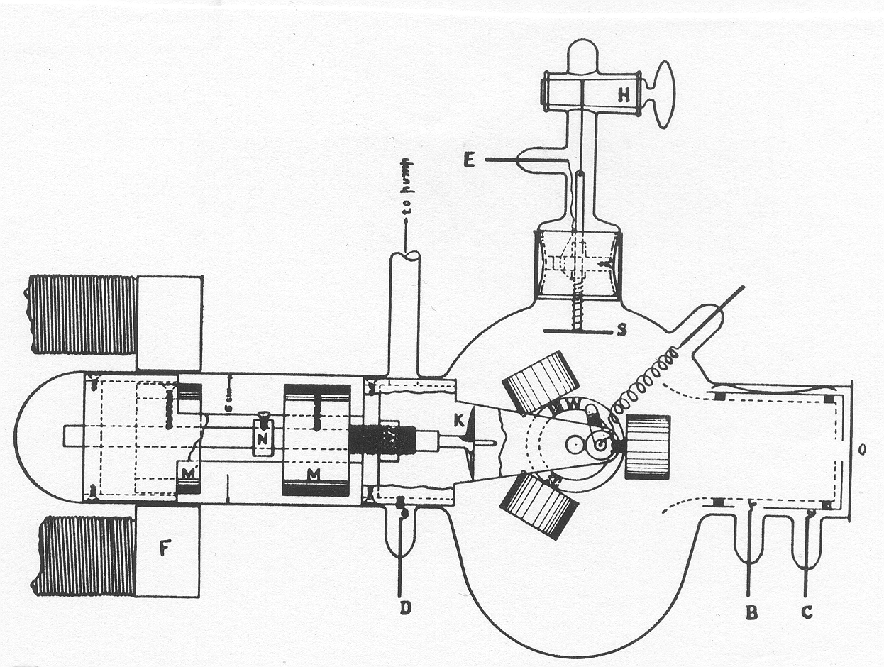
Original Caption The Photoelectric Effect. Cylinders of alkali metal placed on wheel, W, kept clean by knife, K, operated by electromagnet, F. A beam of light, let in at O, falls on the surface. From Physical Review 7 (1916):362.

