Solenoid Design for Low Temperature Resistance Measurements of Nanostructures
Jonathan Caddell

Abstract
To facilitate low temperature resistance measurements of nanostructures, it is desirable to alter the current experiment setup to allow for independent manipulation of the two necessary magnetic fields. This requires adding a second solenoid inside of the existing one. This paper examines design considerations to optimize this magnetic field and insure that resulting data is not inaccurate due to field non-uniformities across the sample.

Introduction: Experiment Theory
Solid state devices are increasingly used in electronics. Current technology utilizes the presence or absence of electrons for computations. However, if spin could also be harnessed in devices, computational power would increase. Before this can be done, a better understanding about fundamental spin behavior is needed. Weak Anti-Localization measurements of semiconductors further this knowledge of spin behavior.
Before we discuss Weak Anti-Localization, let’s first examine Weak Localization (with no spin-orbit). Current through a semiconductor consists of carriers (electrons or holes) flowing from one node to the other. In a crystalline semiconductor, carriers scatter off of defect sites in the crystal structure. There are an infinite number of possible trajectories. It is possible for the carrier, through these scattering events, to end up back where it started and not contribute to the current (increasing resistance). For this subset of paths that lead back to the origin, the carrier could also travel in the opposite direction to end up back at the origin.
For discussion’s sake, let us consider a trajectory that starts at the origin, scatters in the shape of a circle, and ends back at the origin. The probability of this happening in a classical sense is the probability of traveling clockwise around the circle plus the probability of traveling counter-clockwise around the circle: $P\text{cw}+P\text{ccw}=P\text{ClassTotal}$. When one takes into consideration the quantum mechanical behavior of the system, the probability changes: $Ψ{\text{cw}}^{2}+Ψ{\text{ccw}}^{2}+⟨Ψ\text{cw}|Ψ\text{ccw}⟩=P\text{QMTtotal}$. There is a cross-term that results from the interference. The quantum mechanical probability is thus greater than the classical probability of ending up back at the origin, which means the quantum mechanical resistance is greater than the classical resistance.
When one adds a magnetic field orthogonal to the plane of this trajectory, the Aharonov-Bohm Effect must be taken into consideration. The magnetic field causes the wavefunction to pick up a phase change. The phase change of Ψ_{cw} is opposite in sign to the phase change of Ψ_{ccw}. The interference term, $⟨Ψ\text{cw}|Ψ\text{ccw}⟩$, is now diminished as there is less constructive interference. A continued increase in the perpendicular magnetic field causes the interference term to completely disappear, and the resistance approaches the classical limit.
To transition from Weak Localization to Weak Anti-Localization, one must take into account spin-orbit coupling. Start again with no magnetic field. The quantum mechanical interference term is now destructive instead of constructive. The quantum mechanical probability of returning to the origin (and thus the quantum mechanical resistance) is now less than the classical probability of returning to the origin (and classical resistance). Addition of a perpendicular magnetic field similarly causes phase changes that destroy the interference. This results in the resistance approaching the classical limit for higher fields, but now the graph of resistance vs. perpendicular magnetic field is inverted.
Now let us discuss how to decouple spin and orbit. The orbit depends on the perpendicular magnetic field by the Lorentz Force Law: $\vec{F}=q\left(\vec{v}×\vec{B}\right)$. Increasing B_{perp.} shrinks the size of the orbit. The spin depends on the total magnetic field by the Zeeman Effect: $E=g μB B$, where g is the gyromagnetic ratio and μ_{B} is the Bohr magneton. When there is no magnetic field, spin up and spin down are equally energetically favorable. In the presence of a magnetic field, one spin becomes more energetically favorable than the other one. Applying a perpendicular magnetic field affects spin orbit and allows for the study of Weak Anti-Localization; applying a parallel magnetic field allows one to manipulate the total magnetic field to separate the spins from each other and from the orbital motion.

Apparatus Design: Experiment Setup
The experiment is already being conducted using one solenoid to supply both fields by tilting the plane of the sample. This means the total field desired is reached by controlling the current through the solenoid, and the perpendicular field desired is reached by tilting the sample to control how much of the field is parallel and how much is perpendicular.
The sample is placed on the end of a long rod, which is held in a frame so that the sample is inside of a large solenoid that supplies the magnetic fields. This frame is placed inside of a cryostat casing that contains liquid helium which cools the sample to low enough temperatures to conduct the experiment.
It is desirable to control the total magnetic field and the perpendicular magnetic field separately during the experiment. A second, smaller solenoid can be placed inside of the larger solenoid. The small solenoid would provide the perpendicular magnetic field on the order of milliTesla. The large solenoid would provide the parallel magnetic field (which then provides control over the total magnetic field) on the order of Tesla.
The new, small solenoid must fit inside of the large solenoid. The experiment requires the field to be spatially uniform (or acceptably close). Since the experiment is conducted at cryogenically low temperatures, there can be no resistive heating from the solenoid. This imposes the condition that the solenoid be superconducting.
In adding a second solenoid to the experiment setup, a number of considerations must be examined. The solenoid design and construction are being done in-house to avoid the financial burden of outside custom work. The best superconducting material for this experiment is NbTi wire, which will be ordered. The coil form can be machined in the department machine shop, then the coil wound and potted in a standard epoxy. There is the notable constraint that the solenoid must be fit inside the existing, large solenoid which has a diameter of two inches. This is an environmentally friendly project since there will be no power dissipation (superconducting wire) and all materials are recyclable (except the epoxy) and non-toxic.
Safety is a top priority. Since the experiment is being conducted at cryogenic temperatures, precautions must be taken. Superconducting materials dissipate no heat if operated under a critical current. When that critical current is exceeded, the material is no longer superconducting and will dissipate heat. Liquid helium has a low heat capacity and this heat will cause it to boil rapidly. When the helium undergoes the phase transition from liquid to gas, it expands by a factor of about 700. A quench valve is in place to open and relieve pressure if the critical current is exceeded and the liquid helium begins to boil to prevent the cryostat casing from exploding under the pressure. If there is a quench, the room might need to be evacuated as the influx of helium will cause the air’s oxygen content to drop.

Models and Calculations
The modeling of the magnetic field inside a solenoid is complicated, but it is more manageable when one takes advantage of certain symmetries of the problem. The desired magnetic field is the axial component, B_{z}. One can eliminate the radial component, B_{p}, of the magnetic field by placing the sample in the plane bisecting the coil in half. The very middle coil’s magnetic field, for any position in the plane of the middle coil, is completely in the z-direction. For each coil above and below this coil, the magnetic field in the radial direction is equal and opposite, canceling to leave only the z-component of the field, as can be seen in Figure 1. Thus, by examining the field only in the region cutting the solenoid in half, only the B_{z} component of the field is present.
Figure 1
Sum vectors
radial comp. cancel
One can model a solenoid treating each coil as a single current loop and superimposing all the magnetic fields. The magnetic field for a single current loop can be found from the Biot-Savart Law. Since the integration is not simply for the center axis of the loop, the integral involves elliptic integrals of the first and second kind. The equation for the z-component of the magnetic field can be found in Montgomery p. 34 and is of the form:
$$Hz=\frac{2I}{\sqrt{Q}}\left[F\left(k\right)+\frac{a^{2}−p^{2}−z^{2}}{Q}S\left(k\right)\right]$$
where a = the loop radius, p = the radial distance to the point of measurement, z = the distance out of the plane of the loop to the point of measurement (Figure 2), $Q={\left(a+p\right)}^{2}+z^{2},$ $k=\sqrt{\frac{4\text{ap}}{{\left(a+p\right)}^{2}+z^{2}}}$, F(k) = Elliptic Integral of the first kind, $S\left(k\right)=\frac{E\left(k\right)}{1−k^{2}}$, and E(k)=Elliptic Integral of the second kind.
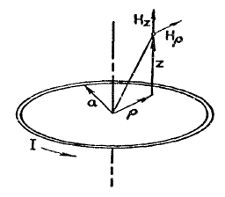Figure 2¹

If one takes the $\frac{a^{2}−p^{2}−z^{2}}{Q}$ term and the $1−k^{2}$ term from S(k) and combine them, one gets: $\frac{a^{2}−p^{2}−z^{2}}{{\left(a+p\right)}^{2}+z^{2}}\frac{1}{1−\frac{4\text{ap}}{{\left(a+p\right)}^{2}+z^{2}}}$ and distribute in the denominator to get $\frac{a^{2}−p^{2}−z^{2}}{{\left(a+p\right)}^{2}+z^{2}−4\text{ap}}$ then expand the ${\left(a+p\right)}^{2}$ term, combine with the -4ap term, and factor again to get $\frac{a^{2}−p^{2}−z^{2}}{{\left(a−p\right)}^{2}+z^{2}}$.
Thus, $Hz=\frac{2I}{\sqrt{{\left(a+p\right)}^{2}+z^{2}}}\left[F\left(k\right)+E\left(k\right)\frac{a^{2}−p^{2}−z^{2}}{{\left(a−p\right)}^{2}+z^{2}}\right]$.
To make the parameters dimensionless, merely pull an a² term out, letting α= p/a and β= z/a to get:
$Hz=\frac{2I}{a\sqrt{{\left(1+α\right)}^{2}+β^{2}}}\left[F\left(k\right)+E\left(k\right)\frac{1^{2}−α^{2}−β^{2}}{{\left(1−α\right)}^{2}+β^{2}}\right]$.
It is now quite simple to write a mathematica notebook superimposing as many loops as one may wish. For the center loop, β= 0; for the loops above and below, z = wire diameter * how many loops away it is from the center loop.
There is, however, a more direct approach that is available. Montgomery presents an equation that specifically models a uniform-current density solenoid on p.38. This equation is of the form: $Hz=H0\left[1+e2{\left(\frac{r}{a1}\right)}^{2}p2\left(u\right)+e4{\left(\frac{r}{a1}\right)}^{4}p4\left(u\right)+e6{\left(\frac{r}{a1}\right)}^{6}p6\left(u\right)+…\right]$ where $u=\text{cos}\left(θ\right)$, θ= angle from the center axis of the solenoid to the point of measurement (in our case, since in the center plane of the solenoid, θ is always π/2), p_{j}(u) = Legendre Polynomials, e_{j} = functions of c_{j} given in Table 1 of Montgomery, p.39, where c_{j} = functions of alpha and beta, alpha = a₂/a₁, beta = b/a₁, a₁ = inner coil radius, a₂ = outer coil radius, b = ½ coil length, r = distance to the point of measurement (since we are only interested in the center plane of the solenoid, r then corresponds to the radial distance to the point of measurement), and $H0=G\sqrt{\frac{Wλ}{ρa1}}$. Rho is the resistivity, lambda is the space factor (fraction of the coil occupied by conducting material), W is from Bitter and is W = (ρ * current density² * volume of the conducting material). In Bitter, $W=ρ i^{2}2b π\left(a2^{2}−a1^{2}\right)$; 2b being the length of the solenoid, πa₂² – πa₁² being the cross sectional area of the solenoid occupied by the wire, the two combined giving the volume of the wire. This, however, assumes square wires, which can be seen more clearly if the volume is calculated another way. Let the volume of the wire be the cross sectional area of the wire times the length of the wire. The cross sectional area is π r², or $\frac{π}{4}$ wire diameter², or $\frac{π}{4}$(a₂² – a₁²). The length of the wire is the circumference of a loop times the number of loops, or 2πr x 2b/wire diameter, or another way $\frac{2π\left(a2+a1\right)}{2}\frac{2b}{\left(a2−a1\right)}$. Then the volume is now $V=\frac{π}{4}{\left(a2−a1\right)}^{2}2π\frac{\left(a2+a1\right)}{2}\frac{2b}{a2−a1}$, which simplifies to $V=\frac{π}{4}2bπ\left(a2^{2}−a1^{2}\right)$ and so it can be seen that the π/4 is the term to be added for circular wires instead of square wires.
Substituting W into H, the resistivity cancels out. One is now left with:
$H=G\sqrt{\frac{λ}{a1}i^{2}\frac{π}{4}2bπ\left(a2^{2}−a1^{2}\right)}$.
Now G is the geometry factor and is given by equation 3 in Bitter:
$G=\frac{\sqrt{2π}}{5}\sqrt{\frac{β}{α^{2}−1}}\text{ln}\left[\frac{α+\sqrt{β^{2}+α^{2}}}{1+\sqrt{β^{2}+1}}\right]$. Now to simplify, realize a₂ = a₁+wire diameter, and d=2b/n, meaning alpha = a₂ / a₁ = 1 + d/a₁, beta = b / a₁ = nd/2a₁. Substituting and simplifying, one gets the result: $G=\frac{\sqrt{2π}}{5}\sqrt{\frac{\text{na}1}{2\left(d+2a1\right)}}\text{ln}\left[\frac{2\left(a1+d\right)+\sqrt{4a1^{2}+8\text{da}1+d^{2}\left(n^{2}+4\right)}}{2a1+\sqrt{{\left(2a1\right)}^{2}+{\left(\text{nd}\right)}^{2}}}\right]$.
There are now two methods for modeling the axial magnetic field of the plane bisecting a solenoid as a function of such parameters as position, current, coil length, coil diameter, and wire diameter.

Results
The magnetic field profile as a function of position increases when moving from the center of the solenoid towards the edge (Figure 3). This is the chief interesting characteristic, since this profile means the sample will not experience the same magnetic field across it.
Figure 3

Since the conductivity is a function of magnetic field, this means the conductivity at the edge of the sample will be incorrect, since it is experiencing a higher magnetic field than expected.
The two methods have a similar profile when plotted as a function of position (distance from the center of the coil). There is a scaling difference of about one tenth, but it is a constant multiplicative factor. As the number of coils increases, the prefactor converges to 0.1128. Even for a small number of coils (our size limitations require the length to be less than 2”, or 5cm, so the maximum number of coils using the 0.0753cm wire diameter is about 65, so on Figure 4, numb = 32, where numb is the maximum coil number from the center coil) it can be considered constant since the variation over a whole range of lengths is less than 1 percent.
Figure 4
When this prefactor is taken into account, the agreement between the two methods (the equation using Elliptic Integrals, and the equation using Legendre Polynomials) is very good. The match up is excellent, as can be seen in Figure 5 (I = 4 Amps, coil diameter = 3cm, 1 loop, wire diameter = 0.0753cm).
Figure 5
One can also compare this to an ideal solenoid. An ideal solenoid has the equation
$B=μ0 I\frac{N}{l}$, which using the given values predicts B=6.7mT.
Making the coil longer, the changes to the profile can be seen in Figure 6 (I = 4 Amps, coil diameter = 3cm, coil length 5cm, wire diameter = 0.0753cm).
Figure 6
The variation for a short solenoid is about 191% with an absolute variation of 4.2mT. The variation for the long solenoid is less than 4% with an absolute variation of 2.8mT. Both exhibit a shallow climb close to the center, and a steep climb at the edge of the coil. If one considers that the sample will not fill the entire coil, looking at only half the distance to the edge shows a variation of about 1.4%. Making the solenoid longer greatly reduces its variation as well as greatly increasing the maximum possible magnetic field.
The magnetic field can now be described as a function of distance from the center and current. To do low temperature resistance measurements, the magnetic field is ramped and the conductivity measured. From that data fit, the spin orbit parameter and phase parameter are determined. We want to minimize the error due to B variation in those parameters when the fit is done. Since conductivity is a function of B, and B is a function of radius and current, we can now examine conductivity as a function of radius and current. As can be seen in Figure 7, the conductivity as current varies has the correct checkmark-shape, but it is difficult to see the conductivity variation with the radius.
Figure 7
When there is no magnetic field, current is zero and there is a given conductivity. As the current increases, the magnetic field increases, and the conductivity falls to a minimum and then increases again. To make the conductivity variation as a function of position more visible, the partial derivative of conductivity with respect to the normalized radius is taken (Figure 8).
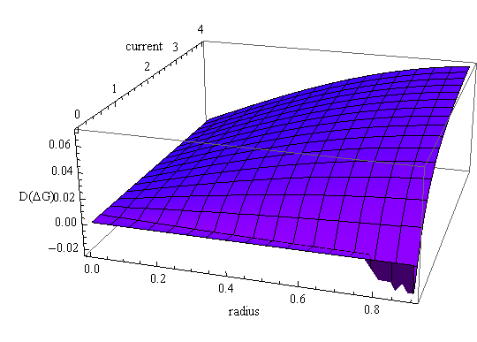Figure 8
For low magnetic fields, and low current, the conductivity has a negative slope, which are the negative values shown for low current in Figure 8. As magnetic field increases, so increasing current, the slope increases, as shown by the positive values in the figure. However, farther from the center, the magnetic field is greater, so as the current increases, the magnetic field increases faster at the edges of the solenoid than at the center, as shown by higher positive values in Figure 8 for higher currents at higher radius. This is more easily seen in a contour graph of the derivative of the conductivity with respect to normalized radius, seen in Figure 9.
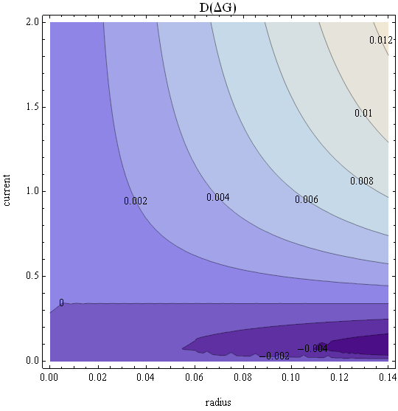Figure 9
Figure 9 just shows the region of interest. The data used in the fit does not go out to the maximum magnetic fields; it is the data out to just past the minimum in conductivity that is used, so about half the maximum magnetic field or about 2 Amps. The sample is only about 2,000μm long, so the normalized radius only needs to go out to about 0.14. The zero contour shows that the conductivity is constant up to around 0.3 Amps and 0.055 of the normalized radius. Farther out on the sample for low currents (magnetic fields), the conductivity begins to fall off. At higher currents (magnetic fields), the conductivity increases as you go out on the sample.
Examination of the fitting routine reveals a rough estimate of acceptable conductivity variation. If the magnetic field varies by 3% or less, then the error in calculating the spin orbit parameter and the phase parameter is about 1/70, which is acceptable. From Figure 6, it is seen that the variation in B is 4% over the whole range, and 1.4% halfway out (the region the sample would be within), which is within the acceptable 4% smearing.

Discussion
Examination of parameters revealed trends for optimizing the magnetic field. One parameter that can be altered is the wire diameter. A quick internet search revealed available wire diameters for NbTi (superconducting material selected) to be 0.0753, 0.0643, 0.0540, 0.0430, and 0.0330. A plot of magnetic field vs. wire diameter while holding the other parameters constant (current = 4Amps, α = 0, coil length = 5cm, coil diameter = 3cm) is shown in Figure 10.
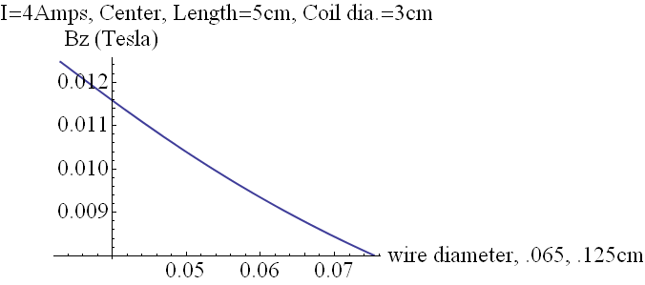Figure 10
The thinner wire diameter results in a higher magnetic field. To maximize the possible magnetic field, the thinnest wire diameter, 0.0330cm, could be used. Evaluation of magnetic field while varying the coil diameter and holding other parameters constant (current = 4Amps, α = 0, coil length = 5cm, wire diameter = 0.0753cm) can be seen in Figure 11.
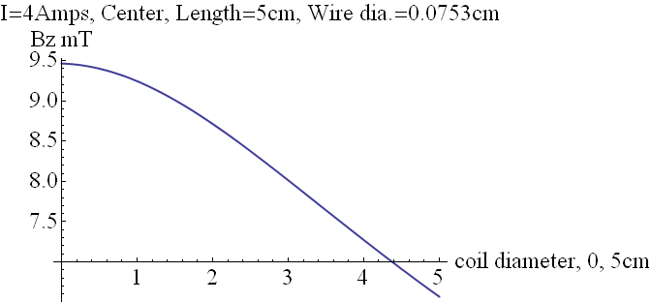Figure 11
A smaller coil diameter results in a higher magnetic field. The advantage of shrinking the coil diameter begins to dwindle at about one centimeter. Related to the coil diameter, is the coil length. We saw earlier that increasing the length from a short solenoid to a long solenoid increased the magnetic field. Figure 12 plots the two while holding everything else constant (current = 4Amps, α = 0, wire diameter = 0.0753cm, coil diameter = 3cm).
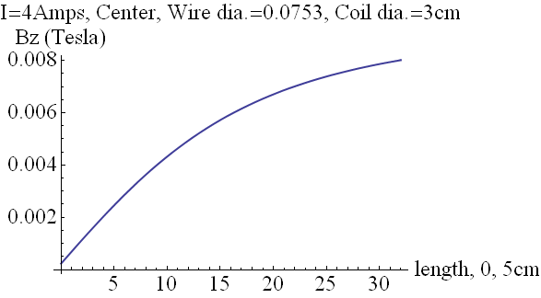Figure 12
As expected, increasing the coil length increases the magnetic field. Since we are placing this small solenoid inside the existing large solenoid so that the fields are orthogonal, the coil length and coil diameter are constrained. Increasing the coil diameter forces the coil length to shrink, and vice versa. The constraint is the diameter of the large solenoid, 5cm, giving: (5cm /2)² = (coil diameter /2)² + (coil length /2)².
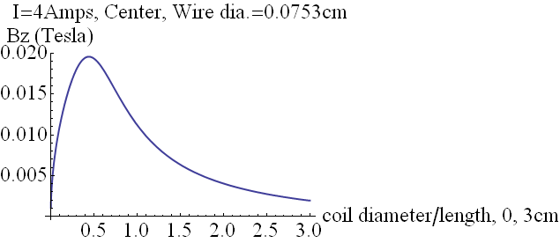Figure 13
Figure 13 shows the magnetic field vs. the coupled coil diameter & coil length. Decreasing the coil diameter (which allows an increase in the coil length) is now only beneficial up to a point.
Parameters in the equation describing the magnetic field are current, distance from the center, wire diameter, coil diameter, and coil length. Current is what is used to ramp the magnetic field. The spatial dependence is what we are trying to minimize. Examination of the remaining parameters revealed that the largest magnetic field is obtained for the smallest wire diameter and picking a coil length and coil diameter such that the field is maximized using a plot such as Figure 13.

Summary
The magnetic field is greatest for the smallest wire diameter, 0.033cm. The optimum field for the coil diameter and coil length for a current of 4 Amps, α = 0, and wire diameter of 0.033cm requires the coil diameter = 0.29cm and the coil length = 4.99cm. The coil length and coil diameter are coupled, and the maximum value of the magnetic field for these parameters is determined graphically. The resulting profile at 4 Amps is shown in Figure 14. The variation over the whole range is 0.0015%, and the variation over half the range is 0.00065%.
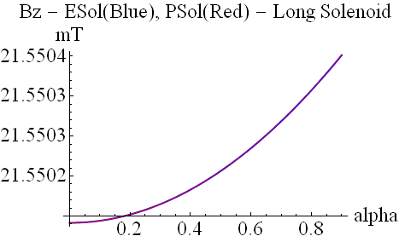Figure 14
It should also be noted that this is for the maximum B field, current = 4 Amps, and that for lower fields the smearing would be even less. This variation in B should result in a variation in the conductivity that does not significantly affect the spin orbit parameter and the phase parameter during data fitting of low temperature measurements.

Acknowledgements
I would like to thank my capstone advisor, Dr. Murphy, as well as the graduate students Ruwan Dedigama and Dilhani Jayathilaka for all of their help and guidance.

Appendix
Economic: Coil design and construction are in-house to avoid costly outside custom work.
Environmental: Since the coil is superconducting, there is no power dissipation. The materials are recyclable (except the epoxy) and non-toxic.
Sustainability: The coil model and design are well documented. Future coils can be made for future design constraints and needs.
Manufacturability: The materials are off-the-shelf NbTi wire, standard epoxy, and the coil form can be machined and the coil wound in-house.
Ethical: The analysis of the field uniformity and of the effect on the accuracy of resulting data is to insure data and conclusions are as accurate as possible.
Health and Safety: The experiment is done at cryogenic temperatures. If the critical current is exceeded, the coil will cease to be superconducting and will dissipate heat. The influx of heat will boil the liquid helium, causing a sudden increase in the volume it requires. A quench valve is in place to prevent an unsafe buildup of pressure should that happen. For a small room, a quench of helium can cause the oxygen content to drop requiring the room to be evacuated.
Social: No obvious social considerations for the design and construction of the solenoid for this experiment come to mind.
Political: A better understanding of spin behavior could allow the construction of more powerful computers. Technological advantage is a consideration in politics.

References

D. Bruce Montgomery, J. Terrell, “Some Useful Information for the Design of Air-Core Solenoids”, Air Force Contract AF 19(604)-7344 (1961)
F. Bitter, “The Design of Powerful Electromagnets, Part II. The Magnetizing Coil”, R.S.I. 7, (1936)

