Capstone Research Paper

Molecular Self-assembled Monolayers on Au{111} Surface

Sung Chou
Advisors: Dr. Lloyd Bumm, Dr. Abhjit Biswas
Homer L. Dodge Department of Physics and Astronomy
May 14, 2009

List of Contents
I. Introduction
II. Self-assembled Monolayer (SAM) preparation
- Centrifuge process
- Immersing of gold substrate
III. Scanning tunneling microscope technique
IV. The results of the STM image
V. The UV-Visible Test
VI. PTCDI/Melamine network revisit
VII. Discussion and conclusions
VIII. Future work
IX. Acknowledgements
X. References
- Introduction
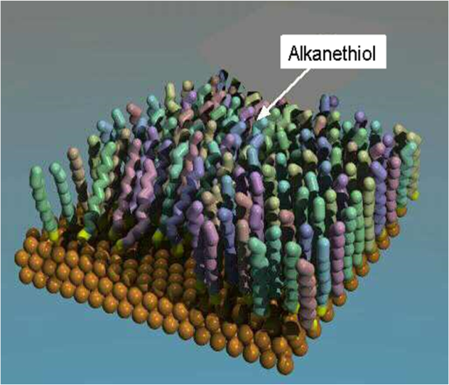

A key challenge in nanotechnology is the development of flexible and efficient methods for nanostructures of an extended length scale. Molecular self-assembled monolayers (SAMs) represent promising nanotechnology-based platforms to study the molecular surfaces and interfaces for many potential applications ranging from molecular electronics, nanophotonics to biology. SAM systems can act as a robust, large-scale platform templates to fabricate flexible nanostructures [1-5]. Figure 1 shows molecular self organization of alkanthiol molecules. These SAMs can be used as a platform for Nano and Microelectromechanical systems (MEMs) and other nano applications. Figure 2 shows an example of MEMs structure. One can also make hydrophobic coatings for automobile windshields to repel water or to protect metals from harsh substances. Also it may act as a chemical sensor [6].
Fig 1. Sample of the SAM structure in 3D. Source: http://www.nd.edu/~djacobs/sam.jpg
Fig 2. MEMs ratcheting mechanism ~50 µm across. Source: www.memx.com/images/ratchet.jpg
In this work, we have tried to fabricate PTCDI (perylene-3,4,9,10-tetracarboxylic di-imide) and melamine (melamine: 1,3,5-triazine-2,4,6-triamine) SAM structures and analyze the structures by scanning tunneling microscope (STM). My work focuses on the reproduction and the study of PTCDI and melamine SAM net working structure that was reported in a publication [7].
Figures 3 and 4 show the molecular structures of PTCDI and melamine.
Fig 4. melamine: 1,3,5-triazine-2,4,6-triamine

Fig 3. PTCDI: perylene-3,4,9,10-tetracarboxylic di-imide

II. The SAM preparation
- Centrifuge process
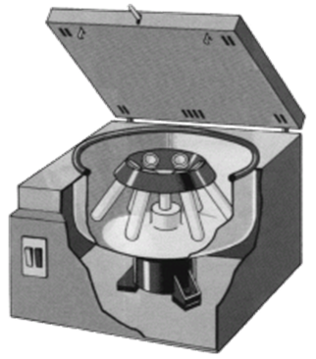
Two mixtures of solutions are needed to mix the vial for the substrate. The first solution is 10 mg of PTCDI the dissolved with DMF (N,N-dimethylformamide) and the second is 10 mg of melamine dissolved with DMF. Both are put into separate test tubes and fill with DMF until a full test tube amount is reached.
Fig 5. An example of a centrifuge.
Both mixtures are then put into the test tube shaker over the night to ensure both solutions dissolved evenly. After the solutions have been dissolved evenly the test tubes are then put into the centrifuge machine for 30 min. The centrifuge machine is to separate the particles that were not dissolved in the test tube which will be in the bottom of the test tube. Figure 5 shows an example of a centrifuge set up. The dissolved mixture of the solution is then extracted and put into a new test tube and repeat centrifuge process as many times as needed until there are no undissolved particle can be seen. Figure 6 shows and example of what the centrifuge process does.
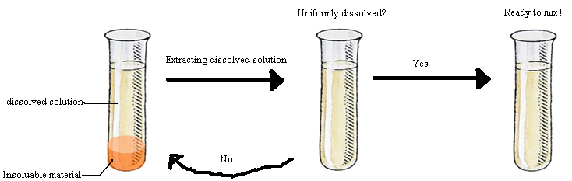
Fig 6. Example of the centrifuge process.
The melamine/DMF solution appears to be clean the first time after centrifuge but for accuracy it was put back into the centrifuge process again for 2 more times and both times it appears clear. The PTCDI/DMF solution is repeated as much as 25 times before the undissolved particle is unseen and sometimes it still isn’t enough.
- Immersing of the gold substrate
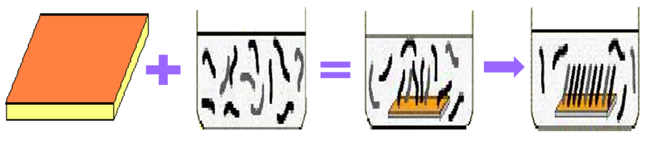
After centrifuging, both mixtures are combined to a single test tube with a ratio of 1:4, PTCDI:melamine. The gold substrate is then immersed into the new vial and put into the heater and heated it on 100° for 5 min to speed up the chemibsorption process. Figure 7 shows a schematic example of the SAM formation process. The substrate after heating in the heater is then rinsed with DMF and blow dry with nitrogen to ensure there is nothing unnecessary sticking on the surface and imaged using a technique call scanning tunneling microscopy (STM).
Fig 7. Example of formation of SAM network.

III. Scanning tunneling microscopy technique
The STM technique is a very powerful tool for probing surfaces at an atomic level.
In STM microscopy, a sharp metal tip is scanned over a sample surface. It takes advantage of tunneling phenomena described in quantum mechanics to image conductive surfaces with atomic resolution. The operating mechanism of STM is as follows: A bias voltage (mV to 3 V) is applied between an atomically sharp probe tip and the sample. The position of the probe tip when the tip is brought very close (<10 Å) but without physical contact a tunneling current (pA to nA) flows acroos the gap. The tunneling current is the result of the overlapping wave functions between the atoms on the tip atoms on the surface. Typically the probe tip is mounted on a piezoelectric actuator (z axis). Negative feedback is used to hold the tunneling current constant (at a operator selected set point) by controlling the tip-sample gap. If the tunneling current becomes greater that the set point current, the tip is pulled away from the sample. If the tunneling current becomes too low, the tip is pushed toward the sample. Feedback is always active when the STM is in operation. An image is obtained by raster scanning the tip and measuring the z position of the tip (at constant tunneling current) as a function of x-y position. This is the most commonly used STM imaging mode. The resulting image is called an STM topographic image. If the sample is atomically flat and the system has adequate vibrational, thermal, electrical isolation, this technique can be used to obtain atmically resolved images [8]. Figure 8 shows the operation of an STM.
IV. The results of the STM image
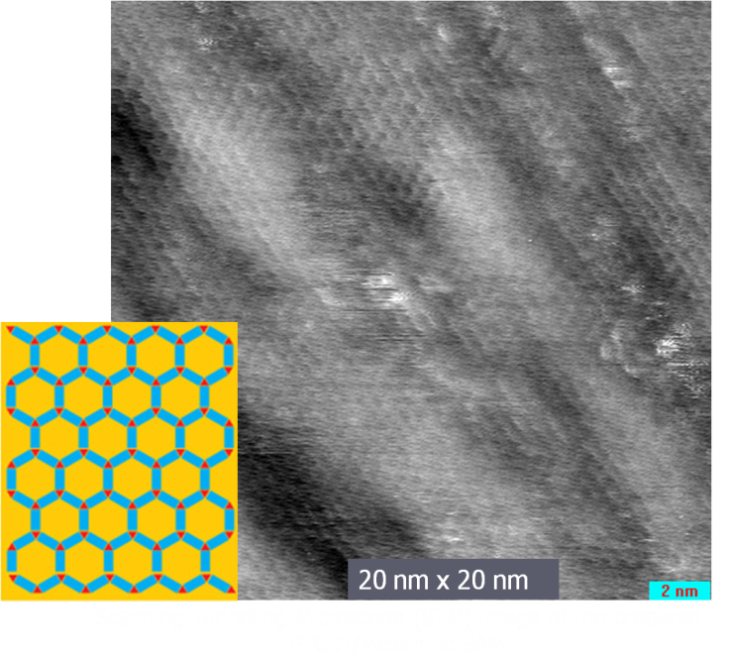
The gold substrate is then imaged using the STM and the images are analyzed. The first attempt to create the ideal SAM structure failed. The nearest neighbor spacing is about 0.5 nm while the ideal spacing is 3.5nm apart according to the Nature article. Figure 9 shows an STM image of SAM along with a schematic of the molecular structure of PTCDI/melamine network [7].
Fig 9. First scan of the STM image on gold substrate
The dark regions of the image indicate deep areas while the light regions indicate the shallow areas of the surface. While there is the expected honeycomb structure, the spacing is not 3.5nm as expected from the Nature paper [7].
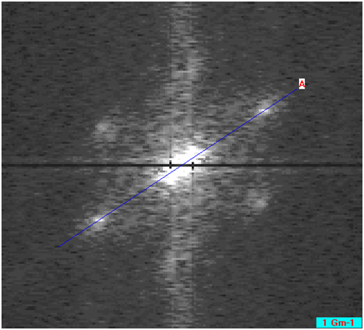
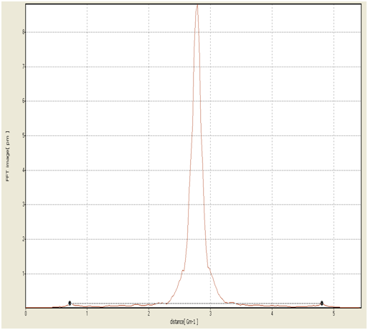
The spacing between each cell is measure by the Fourier transform, in which we measure the change in X between the 2 points then divide by ½ to get the spacing. Figure 10 shows the Fast Fourier Transform (FFT) image following by the periodicity analysis that indicates the periodicity is about 0.5 nm.
Fig 10. Honey comb structure and its spacing
Since the spacing doesn’t quite match what we expected the experiment was repeated again. We suspect that there are some contaminations as well as some human errors so this time we are more careful and make sure everything is clean as possible such as always use a new test tube every time. But 2nd and the 3rd attempt also yielded the same results and by the 3rd time we decide to go on ahead and do the UV visible (ultra violet visible) test since the time to prepare a solution can be extremely long and one does not have that much time to be stuck on the same stage.

V. The UV-Visible Test
The UV-Visible test is being used to determine if the particle in the solution is dissolving properly. The UV light will shine on a substance and the chromophore in each substance will absorb the UV wavelength and gave off characteristic gave off its own color and spectrum. The resulting spectrum can be also used to determine the properties of a sample.
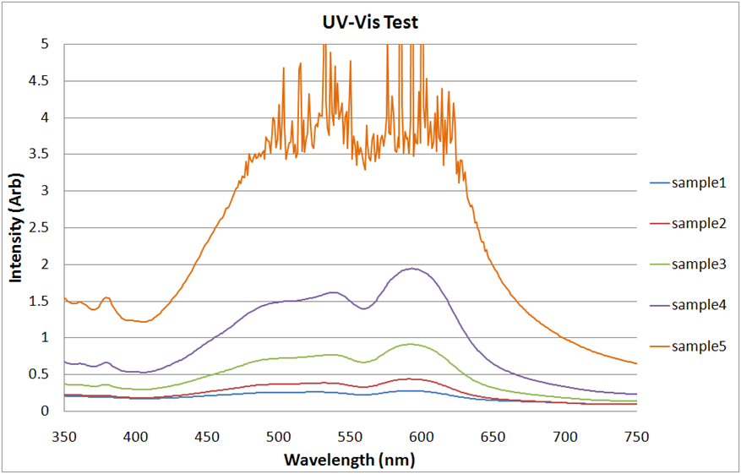
Also while the same time the UV-Visible test is being conducted the 4th attempt of trying to produce the ideal PTCDI/melamine structure is also underway.
Fig 11. UV-Visible test on all 5 samples of PTCDI
We suspect that the substance PTCDI is not dissolving properly with DMF so a UV-visible test is being conducted.
We have 5 different concentrations of PTCDI. The first PTCDI is the densest mixture and has the most intensity which is numbered sample 5 in the graph on the right. Then we extracted half amount from sample 5 and mixed with half DMF in a new test tube label it as sample 4, and then we repeat the process until sample 1 is reached. Figure 11 shows the 5 samples with PTCDI with different intensity.
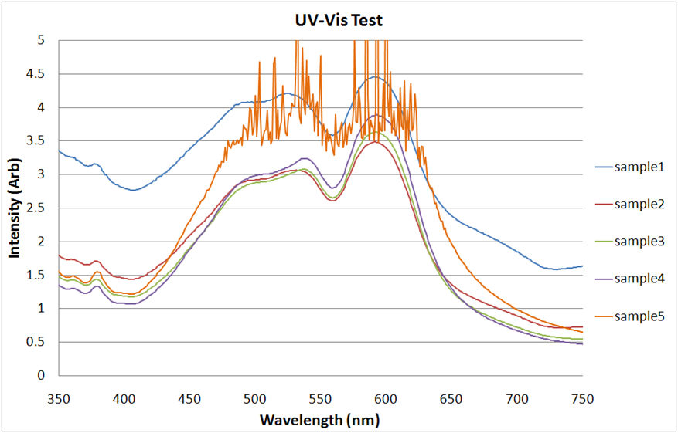
If PTCDI is dissolving properly in DMF the intensity in theory should go down by half amount each time the sample is diluted. After we have the raw data we scaled the samples from by succession of 2 and they should all line up on the same line if the concentrations is indeed diluted by half each time and if the PTCDI is dissolving correctly.
Fig 12. UV-Visible test on all 5 samples of PTCDI after scaling
From the looks of the graph it shows that the PTCDI is dissolving the way we expected. The lines are very close to one another with the exception of sample 1 which was the most diluted sample. The reason sample one is so off the expected value might be due to human errors, as I might have not clean the tube well enough. But most of the samples falls in to place and proves that the PTCDI is dissolving correctly. Sample 5, which is the densest solution have some wavelength that cannot be read because it’s giving off too much intensity that’s why the graph looks all squashed together. Figure 12 shows all 5 samples when brought up to scale.

VII. PTCDI/Melamine network revisit
The 4th time of the PTCDI/Melamine network took the most time to prepare since it went through the processes the most thorough. For 3 days this PTCDI/DMF mixture was in the shaking machine and for 25 times it was centrifuged. When the sample is finally finished we scanned it using STM.
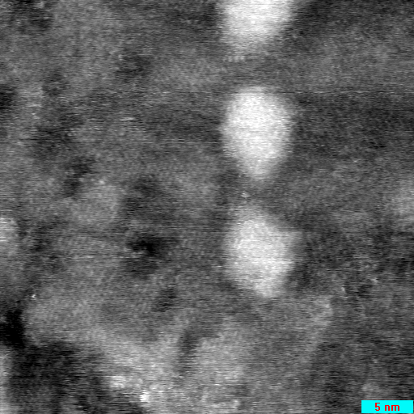
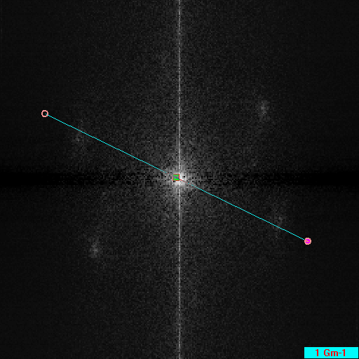
Again here the light region indicates shallow area while the dark regions are the deep area. Figure 13 shows the STM image of sample 4 and figure 14 its fourier transform.
Fig 13. STM image of sample 4
Fig 14. Fourier transform of the sample 4

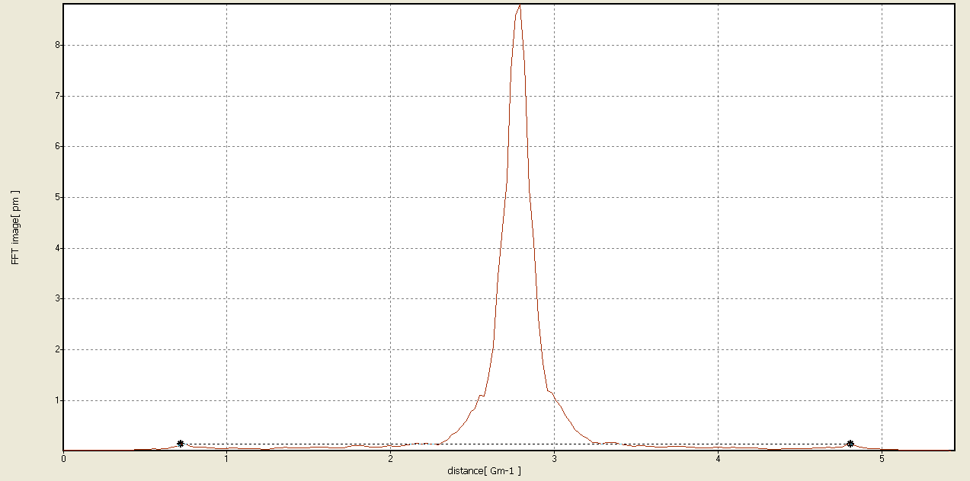
Fig 15. Fourier transform of sample 4
After we analyzed the spacing between each cells we found that the spacing is about 0.488 nm which is still far away from the 3.5 nm needed. Figure 15 shows the FFT analysis of the periodicity of sample 4.
VII. Discussion and conclusions
While we were able to produce saturated solutions of PTCDI-Melamine along with their optical characterization, we could not reproduce the reported SAM network between the PTCDI-Melamine with the desired molecular periodicity. We tried eliminating all possible sources of error as much as possible but that only got us to 0.488 nm spacing compared to 3.5 nm as reported in the literature. The PTCDI and melamine were both dissolving properly as indicated by the UV-visible test. The equipment failure/error is unlikely the main cause since it works for other experiments.
VIII. Future work
More research is needed in order to understand the mechanism of formation of hybrid SAM such as PTCDI-melamine networks. The insertion of alkanethiol and other less-studied thiols and functional molecules (e.g. octylthiocyanates or alkyl azides) into the PTCDI/melamine network and their properties can be studied
IX. Acknowledgements
I would like to thank Dr. Bumm for letting me work on this project and all Bumm labbers for their time and comments, especially Dr. Biswas for guiding me through most of the project and editing my paper.

X. References
[1] Schonenberger, C.; Jorritsma, J.; Sondag-Huethorst, J. A. M.; Fokkink, L. G. J., Domain Structure of Self-Assembled Alkanethiol Monolayers on Gold. J. Phys. Chem. 1995, 99, 3259-3271.
[2] Bumm, L. A.; Arnold, J. J.; Cygan, M. T.; Dunbar, T. D.; Burgin, T. P.; Jones, L., II; Allara, D. L.; Tour, J. M.; Weiss, P. S., Are Single Molecular Wires Conducting? Science 1996, 271, 1705-1707.
[3] Tour, J. M., Molecular Electronics. Synthesis and Testing of Components. Acc. Chem. Res. 2000, 33, 791-804.
[4] Marcia, A, et.al., Characterization of highly hydrophobic coatings deposited onto pre-oxidized silicon from water dispersible organosilanes, Thin Solid Films, 2003, 423, 77-87.

[5] DAS. A. K, et. al., The use of an organic self-assembled monolayer coating to promote dropwise condensation of steam on horizontal tubes, 2000, 122, 278-286.
[6] Desikan, et, al. Effect of chain length on nanomechanics of alkanethiol self-assembly, Nanotechnology 2007, 18, 424028.
[7] Rafael et. al. , Functionalizing hydrogen-bonded surface networks with self-assembled monolayers, Nature, 2008, 454, 618-620.
[8] D.H. Dahanayaka, J.X. Wang, S. Hossain, and L.A. Bumm, Journal of the American Chemical Society 2006, 128, 6052–6053.

