Single defect scattering in InSb/Al_{x}In_{1-x}Sb single quantum wells
Daniel Brunski
11 May, 2009
Introduction
From the year 2002 to the year 2007, the average size of a transistor on a consumer computer chip decreased from 90nm in size to 45nm. Indeed, this reflects the 70% scaling in size of transistors every two to three years. As this trend continues, the smaller and smaller transistors will begin to push the limits of our current understanding of the properties of semiconductor materials. One such material, InSb, is an attractive choice for high speed electronics applications, as it has the highest electron mobility of any known semiconductor, with the possible exceptions of devices based on carbon nanotubes and graphene. This allows operation into the hundreds of gigahertz range. Another useful aspect of InSb is its ability to form quantum well structures when sandwiched between AlInSb layers. Such a construction leads to the creation of more efficient semiconductor lasers and lower power devices.
However, as there is no closely lattice matched substrate material available, the growth of high-quality low-defect InSb based structures remains a challenge. A number of techniques, such as buffer layers, nucleation layers, and superlattices, can be employed to lessen the appearance of these defects, which may come in the form of stacking faults, threading dislocations, and others. The 2002 paper “Mobility anisotropy in InSb/Al_{x}In_{1-x}Sb single quantum wells” by M.A. Ball et al. showed that as the density of these defects increase, electron mobility decreases. However, it remains to be known what the effects of a single defect have on charge carriers. As electronic devices continue their downward trend in size, these effects will become more significant. What we have set out to do in this experiment is to isolate a single defect in a InSb/AlInSb single quantum well and measure its effect on a current flow by way of a Hall bar device.
Quantum Wells
A quantum well is a structure that confines charges in certain dimensions. Specifically, in the case of the single quantum well structure in our InSb semiconductors, charges are confined to a two dimensional plane. The boundary conditions set up by this confinement lead to a quantized wavefunction, giving discrete energy levels. As electrons are now only able to obtain specific energy states, this unique property allows more electrons to be confined to higher energy states than would be allowed in the continuous energy regime present in bulk semiconductor material. This is a benefit, for example, in semiconductor lasers, where more electrons can be confined to energies above the lasing threshold, thus requiring less current to operate.
The single quantum wells in our semiconductors are constructed by sandwiching lower bandgap InSb layer between two higher band gap 9%AlInSb layers, where band gap refers to the gap in energy between the valence band and conduction bands in each material. The typical structure of these single quantum well InSb semiconductors can be seen in Figure 1.
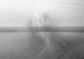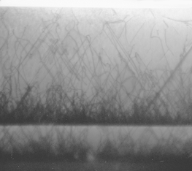
50nm
9%AlInSb
InSb Quantum Well
Defect
1μm
GaSb
QW
GaAs
AlSb
9%AlInSb
9%AlInSb
Figure 1. Typical structure of an InSb/Al_{x}In_{1-x}Sb quantum well.
The thickness of the quantum well in our sample is around 30nm, and the 9%AlInSb barrier layers immediately next to the quantum well are around 60nm. Also visible in Figure 1 is the high density of defects at the interfaces between different materials.
The Hall Effect
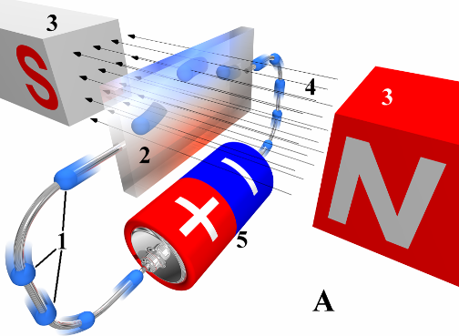
When a magnetic field is applied to a moving charge, that charge experiences a force perpendicular to both the direction of travel and the magnetic field. This force is called the Lorentz force, labeled F in Figure 2. This phenomenon can be exploited to produce what is known as the Hall effect. If the moving charge, v in Figure 2, is in a conductor with a perpendicular magnetic field applied, B in Figure 2, then the charges will experience a Lorentz force and move to one side. The accumulation of charges on one side will leave an equal but opposite charge on the other side, and this separation of charges will create an electric potential, the Hall voltage.
v
B
F
Figure 2. Hall Effect
This effect can be used to create non-intrusive current sensors and solid-state position and motion sensors, among other things. Hall conductivity at low temperatures becomes quantized, leading to a standard for resistance.

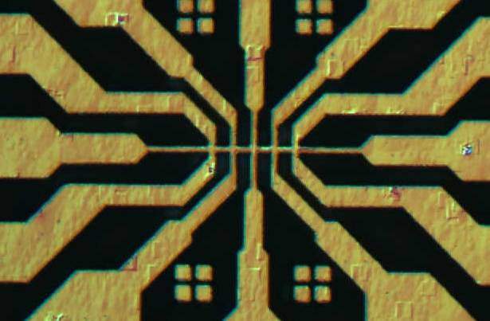
Single Defect Measurements
Figure 4. Optical image of an etched Hall bar mesa. The nominal thickness of the center bar is 2μm.
In order to perform measurements on a single defect, a device called a Hall bar is used. It consists of a lengthwise running conduction path, with several intermediate contact points for measurements. An example of a Hall bar device being used in this experiment can be seen in Figure 4. Current is applied across the horizontal bar, with voltage measurements taken at any other terminal. The magnetic field would point in or out of the page. The difference in Hall voltage measurements taken from terminals before and after the defect will be plotted against the current, and any non-linear behavior in this graph could be attributed to scattering, tunneling, or other unexpected phenomena.
Hall Bar Plan
The device patterns are transferred to the surface of the semiconductor via photolithography, and then etched with reactive ion etching (RIE) to produce the mesa. Ideally, the Hall bar would be positioned such that a single defect lies at the intersection of two terminals, as shown in Figure 5. These terminals could then be used for gating purposes, while other terminals used for Hall voltage measurements before and after the defect. The gates would allow for more control, such as scanning the current across the defect, but would also add effective resistance that would need to be taken into account.

The dashed box in Figure 5 indicates the area in which the trenches could reasonably be extended to accommodate non-ideal placement of a defect. Electron beam lithography (EBL) and RIE would be used to create the trenches that isolate the gates from the conduction channel.

Applied magnetic field
e
V_{G1}
V_{G2}
V_{H2}⁺
V_{H2}⁻
Hall bar mesa
I_{S}
Defect
Gate
-
-
-
-
+
+
+
+
Substrate and buffer layers
V_{H1}⁺
V_{H1}⁻
Etched trench
Figure 5. Top down view of the planned layout for the Hall bar device.

As of currently, the size of the square mound defects on our InSb single quantum well sample is great enough such that they span the entire width of the 2μm Hall bar. However, if required, the above mentioned procedure could be used to narrow the conduction path around smaller defects, forcing current to flow through them. In order to ensure validity of the measurements, the quantum well needs to be fully electrically isolated from surrounding layers. This means etching down to the GaAs substrate. In our current samples, this entails greater than a 4μm etch depth. Obtaining an RIE recipe that had a high enough material to resist etch ratio proved to be challenging and was the primary focus of our work as of the present.
Photolithography
The first step in creating these Hall bars is to use photolithography to place a pattern of photoresist on top of the InSb sample. Our first choice in resist was AZ5214, based on familiarity. However, there was poor adhesion, resulting in the loss of some small patterns. Also, excess resist left over after development prompted for longer exposure and development times, which lead to an even greater loss of features. A switch to S1818 positive photoresist resolved these issues.
Samples are subjected to a standard cleaning procedure: a 5 minute ultrasonic in each of acetone, methanol, and isopropanol, followed by a 10 minute dehydration bake at 150°C. This is done to promote resist adhesion to the sample surface. The resist is applied by a spin-on procedure at 4500rpm for 48 seconds which should give a nominal thickness of 1.8μm, however our thickness was typically in the range of 2 to 2.2μm. A post spin bake at 115°C for 60 seconds is then performed. The recipe for S1818 calls for a 8 to 9 second exposure time, followed by a 60 second development. The results between the two exposure times are very similar, with slightly more features being visible in the resolution tests at a 9 second exposure time, but also slightly more rounded corners. The recipe also suggests slight agitation during development, but we opted for no agitation in an effort to prevent small features from being lifted off the surface.
An issue that needed to be addressed was the formation of a resist edge bead. This build up of resist on the edge of the sample can be 10μm in height or larger, and prevents the mask from coming into contact with the resist surface. The gap left between the mask and the surface effectively lessens our maximum resolution. In order to deal with this, the sample was covered, leaving only about 1mm of the edge to be exposed for 60 seconds. After all four edges were exposed, the resist was developed for 60 seconds and rinsed in deionized water, then baked at 115°C for 60 seconds. Figure 6 shows a comparison in the resolution obtained in a 2μm line and grid test with and without the edge bead removal.

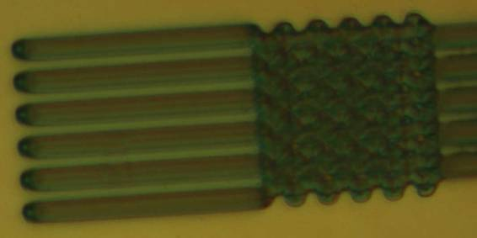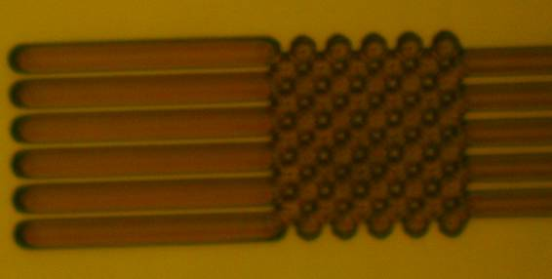
Figure 6. Comparison in a 2μm resolution test of no edge bead removal (left) with edge bead removal (right).
Etching
A number of etching trials on bulk 3μm InSb samples were performed before obtaining a recipe that could give the desired etch depth. Based on results from a prior experiment, a 24 minute etch with a 2:8 BCl₃:Ar plasma should have given at least a 3μm etch depth. The results however were drastically lower at approximately 1.5μm. All depth measurements were performed with a profilometer. Top-down SEM images showed a grainy etch surface dotted by small cones. The reason for this slow down in the etch rate was attributed to the formation of InCl on the etch surface and redeposition of etched products. A 30 second Ar sputter phase was added in between 5 minute BCl₃ + Ar phases in an attempt to mechanically clean the surface of etch residues, for a total of 5 steps of BCl₃ + Ar and 5 steps of Ar. This resulted in approximately the same etch depth at 1.4μm. Top-down SEM images showed much broader features on the etch surface as compared to the previous recipe. Both recipes had black, non-reflecting etched surfaces when viewed optically.
We next tried doubling the etch time, for a total of 10 steps of BCl3 + Ar and 10 steps of Ar. This resulted in an etch depth of 2.2μm. A comparison of the surfaces created by the BCl₃ + Ar recipe versus the BCl₃ + Ar / Ar recipe can be seen in the cross-sectional SEM images in Figure 7. Adding in the 30 second Ar phases acted to flatten down the spiky surface, but did not result in a greater etch depth.

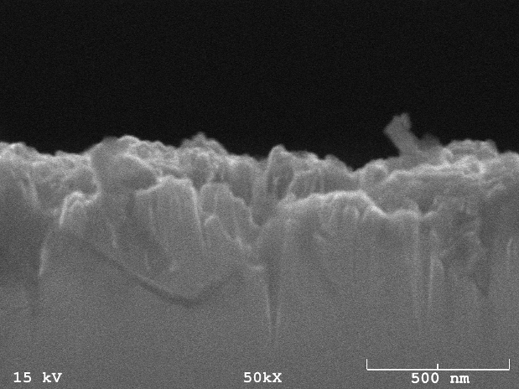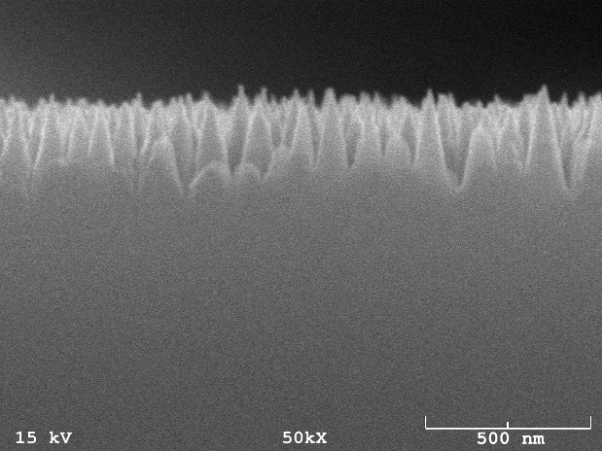
Figure 7. Etch profile comparison of 24 minutes BCl₃ + Ar (left) with 55 minutes BCl₃ + Ar / Ar
In an attempt to inhibit the formation of InCl residues, the next etching trial was performed at elevated temperature. The RIE chamber was preheated to ~150°C with the sample loaded 2 minutes prior to starting the etch process. Using the same alternating gas BCl₃ + Ar / Ar recipe as before for 5 steps of each, this resulted in a 1.7μm etch depth. An attempt at repeating this result, but allowing 30 minutes to preheat before starting the process, gave a 764nm etch depth. This was most likely due to malfunction of the RIE.
While the BCl₃ + Ar / Ar recipe might have attained the proper etch depth if run long enough, it was clear that the etch rate was slowing down and that the time needed for a full etch would have been impractical. A 12:9 BCl₃:SF₆ recipe showed to have good etch characteristics, however the material to etch ratio was too low for the depth required. The next etching trial supplanted the 30 second Ar sputter phase with a 15 second BCl₃ + SF₆ phase. This proved to be profitable, resulting in a 3.3μm etch depth, however the resist had charred and flaked off during the etch, resulting in a heavily damaged InSb surface.
Based on work done by J.W. Lee et al. in “Plasma Etching of III-V Semiconductors in BCl₃ Chemistries”, a 4:11 BCl₃:Ar recipe at higher RIE and ICP powers was performed for 5 minutes. This resulted in a 1.7μm etch depth, 5 times the etch rate of the previous 2:8 BCl₃:Ar recipe, and a high material to resist etch ratio. The surface was very reflective optically. It has yet to be determined if this is due mostly to the increased total flow rate, the increased flow rate of the BCl₃, or the increased powers.
Following this, a 5 step 3 minute 4:11 BCl₃:Ar, 5 step 15 second 12:9 BCl₃:SF₆, 4 step 1 minute 0 power Ar etch was performed on a 1μm bulk InSb sample, resulting in a 3.7μm etch depth. The 1 minute 0 power Ar phase was added after the BCl₃ + Ar and BCl₃ + SF₆ phases in an attempt to keep the resist from overheating and flaking. The resist did brown, but stayed intact during the etch. It is still unclear whether the Ar cooling phases allowed the resist to maintain, or if the resist had flaked in the previous etch due to expired film life. The etched surface was a dull gray when viewed optical. Figure 8 shows a cross sectional SEM micrograph of this etch. The rough etch surface is typically undesirable, but is acceptable for this experiment.
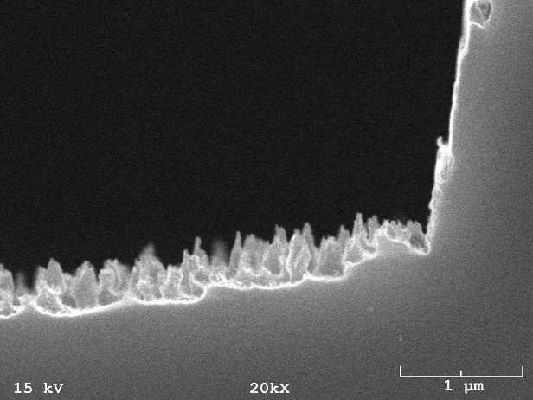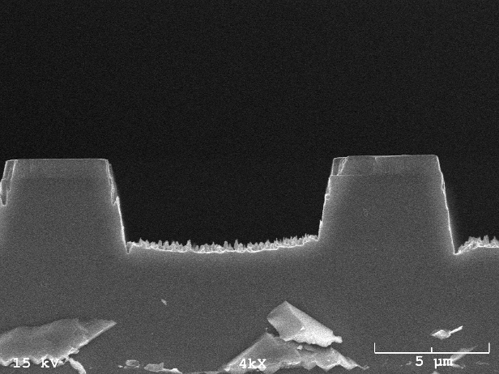
Figure 8. Side profile of 3.7 μm deep etch with BCl₃ + Ar / BCl₃ + SF₆ recipe
A 15 minute 4:11 BCl₃:Ar etch was also performed, resulting in a 7μm etch. The surface was reflective optically, but microscope images showed the formation of thin pillars, particularly in narrow regions. This prompted the decision to use the BCl₃ + Ar / BCl₃ + SF₆ recipe over BCl₃ + Ar.
The final etch on the InSb quantum well sample used a 3 minute 4:11 BCl₃:Ar, 15 second 12:9 BCl₃:SF₆, 2 minute 0 power Ar alternative gas recipe. 15 Hall bars were successful etched with this recipe at a depth of 5μm.
Contacts
In order to ensure good ohmic electrical contact with the quantum well, the contact pads need to be modified. Specifically, indium is deposited onto the pads and then annealed. To do this, the sample first needs to be coated with resist. We used AZ5214 in order to perform a positive to negative reversal. A pattern just containing darkened contact pads was aligned over the sample and exposed. The reversal is done by heating the sample to 120°C for 1.5 minutes, then doing a flood exposure for 50 seconds. When developed, only the resist on the contact pads and alignment marks is removed, which are the areas initially not exposed.
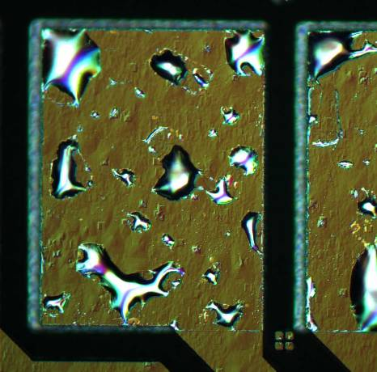
The next step was to deposit indium onto the sample. This was done in the thermal evaporator. Approximately 300-350nm of indium was deposited. After removing the resist, the sample was the annealed at 230°C for 5 minutes, in order to allow the indium to diffuse down into the quantum well. The formation of indium globules, as shown in Figure 9, on the surface of the contact made suspect that the annealing process wasn’t entirely successful. Analysis with a curve tracer showed that the I-V behavior was in fact linear, and a resistance of around 9-11kOhms between contact pads was measured. This is about what would be expected. There was infinite resistance between the contact pads and substrate, confirming good electrical isolation of the quantum well from surrounding layers.
Figure 9. Annealed contact pads
Sometime after the contact pad photolithography step but before annealing, a number of the devices were damaged. Specifically, the 2μm leads had broken, as seen in Figure 10.

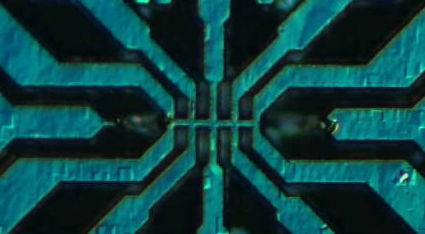
Figure 10. Broken leads
While inconvenient, this does not pose a significant hindrance. Current can be run through other paths, with measurements taken using the remaining terminals. It may be interesting to note that the breaks occur in the range of 4 to 5μm, around the same location as the GaAs / AlSb interface. As there is a high defect density at these material interfaces, it is a source of structural weakness.
Future Work
The above mentioned has been the current progress to date. Several hurdles still remain, in particular the electron beam lithography. A procedure has been worked out in other projects as to how to align patterns using the NPGS software, but has not yet been tested in an actual write. An improper alignment of the electron beam has the potential of irreparably damaging a sample, and thus much work needs to be done to ensure consistent results. Several Hall bar devices as of currently however, have defect placements such that the electron beam lithography step is not necessary for obtaining preliminary measurements.

References
M. A. Ball, J. C. Keay, et al., “Mobility anisotropy in InSb/Al_{x}In_{1-x}Sb single quantum wells.” Applied Physics Letters 80.12 (2002) 2138-2140

J. W. Lee, J. Hong, et al., “Plasma etching of III-V Semiconductors in BCl3 Chemistries: Part II: InP and Related Compounds.” Plasma Chemistry and Plasma Processing 17.2 (1997) 169-179

J. C. Keay, T. D. Mishima, et al., “TEM Study of InSb/AlInSb Quantum Wells Grown on GaAs (001) Substrates.” (2003)

