Comparison of Loading Methods for a Mirror Magneto-Optical Trap
C. Erin Savell
May 14, 2009
Shaffer Lab
University of Oklahoma Department of Physics and Astronomy

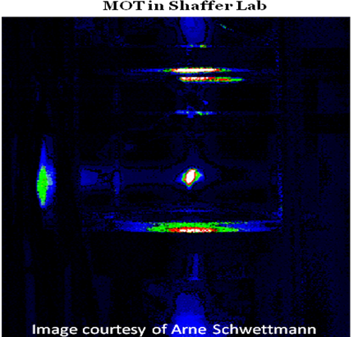
ABSTRACT
The primary aim of this experiment is to compare three different methods of loading a mirror magneto-optical trap (MOT) with ⁸⁵Rb: continuous current applied to the ⁸⁵Rb source, pulsed current applied to the ⁸⁵Rb source, and ultra-violet light induced adsorption desorption (UV-LIAD)of the ⁸⁵Rb atoms from the vacuum chamber walls. Trapping atoms from the background pressure will be used as a control for these experiments.
The intensity of the MOT (measured with a power meter), along with constant factors, was used to calculate the number of atoms in the MOT throughout the loading phase.
It was found that the pulsed source scheme of 10A for 2s was the fastest method with the highest atom number yielded in the MOT. A direct correlation between current applied to the source and loading rate is observed. The UV LIAD method appears to double the atom number yielded in a MOT. Further experimentation is necessary to confirm or disprove this hypothesis.
INTRODUCTION
The goal of these experiments is to compare various methods of loading a mirror MOT with ⁸⁵Rb atoms. The methods considered will be ultra-violet light induced adsorption desorption (UV-LIAD), continuous current through the ⁸⁵Rb source, and pulsed current through the ⁸⁵Rb source. Various current magnitudes and pulse times will be considered. Trapping atoms from the background pressure will be used as a control for these experiments.
The characteristics of the mirror MOT that will be considered in these experiments include background pressure in the chamber, number of atoms in the trap, trap density, intensity of light emitted, and trap lifetime. If the background pressure is too low, it will be difficult to capture enough atoms to make a sufficient MOT. If the background pressure is too high, atom collisions will increase the number of atoms lost from the MOT. It is desirable to obtain the highest number of atoms possible in the MOT. Trap density can be determined from the number of atoms contained inside and the volume of the MOT. Intensity of light emitted from the MOT can be used to determine the number of atoms trapped inside. The lifetime of the MOT is determined by a combination of background pressure, trap density, and laser lock.
There are ongoing efforts to make more compact, resilient, and efficient MOT chambers. The results of this work may be used to make steps in this direction.
MOT chambers may be used in a number of applications, one of which is atom interferometry. Interferometers are instruments that may be used to measure acceleration. Improvements in interferometry will directly contribute to improvements in the accuracy and precision of guidance systems in aircraft, satellites, and guided missiles.
This work is important because optimal loading rates allow for faster repetition of experiments, which in turn allows for more accurate data.
APPARATUS AND DESIGN
During all measurements, ambient lighting in the room was reduced as much as possible. Lights were turned off, poster board was placed around segments of the bench, and computer monitors were switched off.
The vacuum chamber is supported by two turbo pumps and a mechanical pump. Pressure is maintained near 2x10⁻¹⁰ Torr, as read by an ion gauge. A pair of anti-Helmholtz coils create a magnetic field which is used to form the magnetic portion of the MOT, compressing the cooled atoms together. A CCD camera, used to image the MOT, is placed in front of an unobscured chamber window. Two Toptica DL 100 diode lasers are used to create the “optical molasses” that slows and cools the ⁸⁵Rb atoms in the main chamber. One laser is detuned to act as the “trapper”, while the other is detuned to act as a “repumper”. The lasers are shown below.
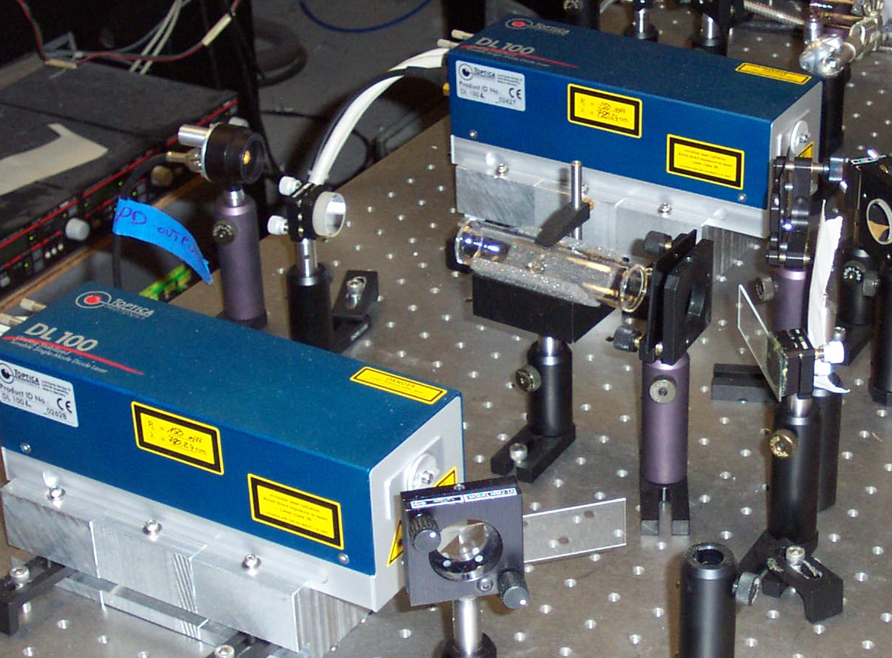
The ⁸⁵Rb sources operate much like a conventional incandescent light bulb. Except when current is passed through the filament, heat and ⁸⁵Rb are emitted instead of light. The filament and source assembly are pictured below. Note that three source filaments are attached to the assembly. Only one source is used at a time during this experiment.
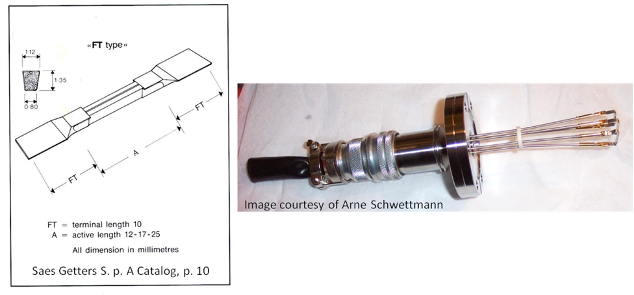
We calibrated the photodiode with the following setup:
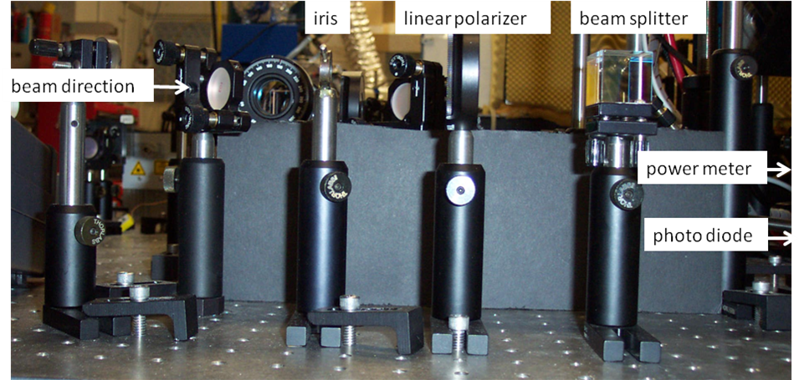
The beam of detuned laser light passed through an iris, a linear polarizer, a beam splitter, and then the power meter. The power meter was connected to an oscilloscope with a BNC cable. The oscilloscope recorded voltage readings from the photodiode.
We measured intensity of light (power, P) emitted from the MOT with the power meter in the following setup:
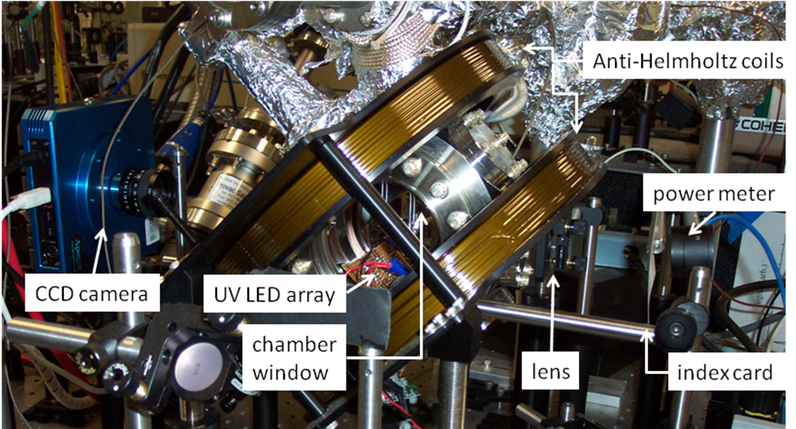
There is a hole equal in size to the diameter of the MOT cut into the index card. This serves to filter out any ambient light that may give false power meter readings. The light emitted from the MOT is passed through the chamber window to the lens. The purpose of the lens is to focus the image of the MOT onto the power meter. The light passes through the lens and the hole in the index card to the power meter. The data signal from the power meter is recorded in volts with an oscilloscope and floppy disk.
PROCEDURE
To calibrate the photodiode, readings were taken from the power meter and the oscilloscope simultaneously. Each data point was taken after turning the dial on the linear polarizer a few degrees (this adjusts the intensity of light passed through each side of the beam splitter). The following linear relationship between voltage and power was obtained:
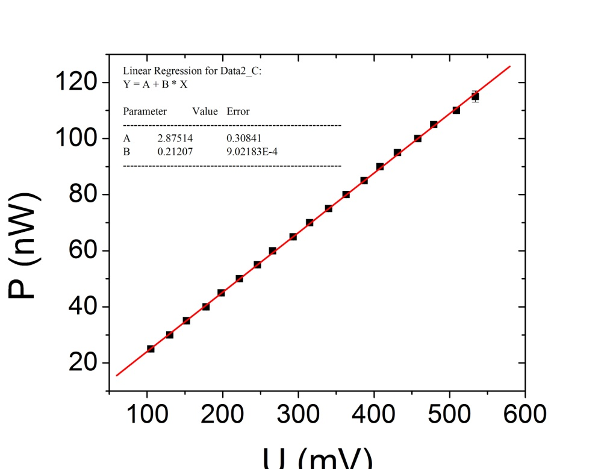
To measure the number of atoms in the MOT, voltage readings were taken from the power meter using the oscilloscope. For the trials where the MOT was loaded from the background pressure, both the ⁸⁵Rb source and the UV LEDs were switched off. A software program on a PC was used to control an NI DAQ board. This was utilized to switch the magnetic fields of the trap on for 90s on and off for 500ms. For three trials data was collected.

For the trials where the UV LEDs were used, the ⁸⁵Rb source was switched off. The PC was used to switch the magnetic field on simultaneously with the UV LEDs. Both were switched off for 500ms before repeating the trial two more times.

For the trials where the ⁸⁵Rb source was switched on continuously, the source and the magnetic field were switched on simultaneously. A current of 3.5A was passed through the source for a period of 100s. Both the field and the source were switched off for a brief period before repeating the experiment.

There were two separate sets of trials for the pulsed sources. One was set in an attempt to model the timing schemes used by Arlt et al¹: a 10A pulse for 2s, followed by a period of time sufficient for the source to cool and the background pressure to drop back to ~2x10⁻¹⁰ Torr (18s with our current apparatus setup). The magnetic field is held constant throughout the timing cycle. The Arlt group was capable of higher currents and shorter rest periods than our apparatus currently allows. The other timing scheme was selected by our group: a 5A pulse for 4s, with a 16s loading period where the magnetic field is on but the source is not. Three trials were conducted of each timing scheme.

CALCULATIONS
Using the measured power, P, we were able to calculate the power emitted by the MOT and then the number of atoms inside of it using the following equations:

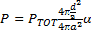
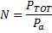

Variable | Description
a = | lens focal length
d = | lens diameter
α = | reduction factor of glass
P = | measured power
P_{a} =  P_{TOT} = | power per atom (constant)  power emitted by MOT
N = | number of atoms in MOT

The values a, d, α, and P_{α} are all constants that can be measured directly or obtained from reference materials. Once all power measurements (P) had been made, P_{TOT} was solved for. The obtained value for P_{TOT} was then used to calculate the number of atoms in the MOT.
If more time had been available, the density could have been calculated by dividing the number of atoms, N, by the volume of the MOT (measurable with a ruler, CCD camera, and software).
RESULTS
The following chart shows curves for the UV LIAD, constant source, and background pressure loading methods. The loading rate for the MOT from the background pressure (with sources and UV LEDs switched off) is the lowest. It takes a minimum of 80s for the trap to load, and the number of atoms trapped is very small (less than 1x10⁷). The MOT loading rate utilizing the UV LIAD method was faster, and more than doubled the number of atoms trapped (2x10⁷). This method had approximately the same loading time as the continuous source method; however, the continuous source method trapped a much larger number of atoms (6x10⁷).
The lower chart depicts the curves from the two pulsed source timing schemes. The 4s, 5A pulse had a much faster rate than any of those mentioned above, but trapped a smaller number of atoms (less than 4.5x10⁷). The 2s, 10A pulse had both the fastest loading rate and the largest number of atoms trapped of all methods tested (6x10⁷atoms in 4s).
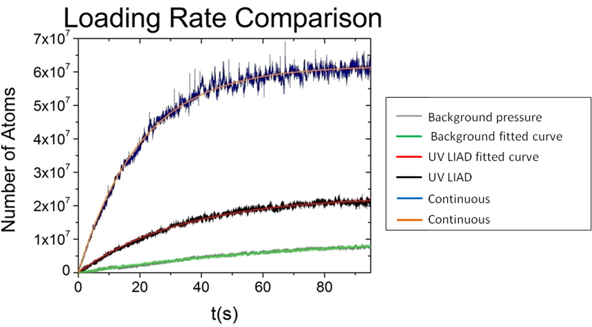
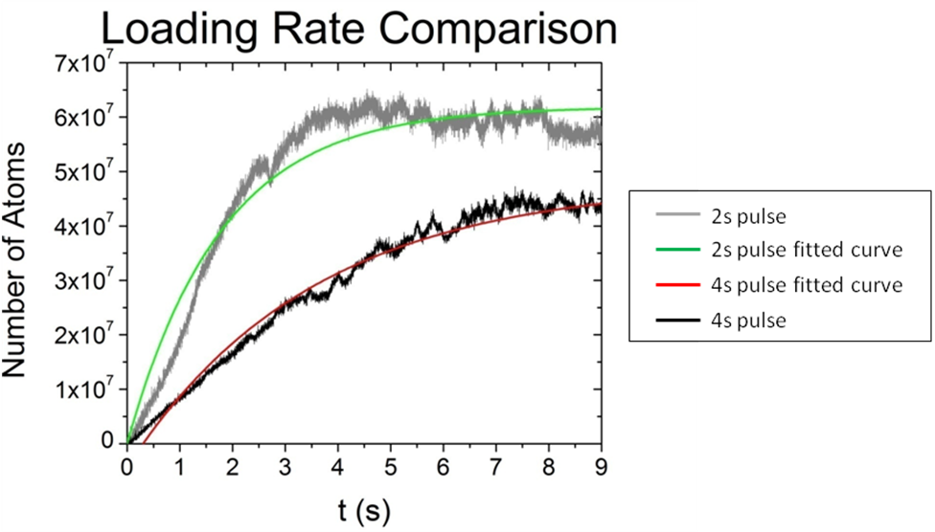
CONCLUSIONS
The 2s, 10A pulse and the continuous source MOT loading methods provide the highest atom number, while both pulsed source methods provide a much faster loading rate than the others. The 2s pulse appears to be the best method for MOT loading if big and fast are one’s goals. If stability is desired in the loading rate, then the continuous source MOT loading method would be preferable to the others. It had the steadiest loading rate of them all. The UV LIAD method doubled the number of atoms trapped. For future trials, it would be interesting to use UV LIAD in conjunction with other loading methods to see if it consistently doubles the number of atoms trapped, or if there is a different relationship.
Loading rate and current applied to the ⁸⁵Rb source appear to have a direct relationship. The higher the current applied, the faster the MOT loads.
Possible sources of error in this experiment include noise from the building (which creates noise in the laser signal), irregular ambient light, and improper alignment or placement of the power meter.
ACKNOWLEDGEMENTS
Arne Schwettmann for being in charge, giving guidance, and being the expert. To Jonathan Tallant for explaining concepts and helping me find everything. Herbert Grotewohl for translating graduate-speak to an undergrad level. Richard Overstreet for the advice, many explanations, and teaching the ropes. Adrienne Wade for electronics guidance.
REFERENCES
¹Arlt, J. , “Ultraviolet light-induced atom desorption for large rubidium and potassium magneto-optical traps,” Physical Review A, 73, 013410, pp 1-6, (2006).

