|  |
| --- |
| InSb Based Heterostructures for Electronic Devices |
| Physics Capstone with Professor Santos |
| Amanda Baldwin |

**InSb Based Heterostructures for Electronic Devices**

My capstone research has been in large part analyzing InSb based heterostructures. I learned how x-ray diffraction gives information about the crystal structures and how to use simulation to give more insight into the crystal structure. Using a software program, I was able to simulate x-ray diffraction based on the layer structure using the ideal conditions such as a heterostructure without defects, the x-ray detector perfectly aligned on the sample, or growth of each layer exactly as planned. Another area that I learned about was analyzing the electronic properties of a sample using the Hall Effect Measurement and the Van der Pauw method for determining the resistivity of the sample. I will begin by discussing the fundamentals that I learned about the field of Solid State Physics and how those concepts are incorporated in this project. Furthermore, I will discuss the different measurement techniques that I learned through this process to aid in the research of InSb based heterostructures in electronics; how x-ray diffraction works, how to make a simulation and compare experimental data with the simulation, and how the Hall Effect measurement is used to determine properties of the crystal structure.

A heterostructure is defined as a multiple layer crystalline structure that is incorporated into a single structure. These structures lead to heterojunctions, which is defined as junctions involving two different semiconductors according to the Modern Physics textbook (Bernstein, Fishbane and Gasiorowicz 2000). This setup is used to create nanostructures that can be incorporated into electronic devices. The different materials, grown one on top of the other, can lead to a quantum well if a narrower band gap semiconductor material is sandwiched between a larger band gap material. The quantum well arises in this fashion because energy levels are quantized on the atomic level. This just means that only discrete energy levels are allowed, and this is normally depicted in an energy diagram for a quantum system (Taylor, Zafiratos and Dubson 2004, 146). There are two types of band gaps that are most commonly observed, they are direct and indirct band gap. A direct band gap is a band gap where the top of the valence band lines up directly with the bottom of the conduction band. If these do not align, then it is an indirect band gap. The thickness of the band gap, resistivity of the material, and carrier concentration gives the semiconductor its electronic properties. The electronic properties of a material can be used to determine the best material for an application based on the energy required for an electron to go from the valence band to the conduction band.

The research group that I was working with wanted a narrow band gap material for the quantum well and to incorporate these heterostructures into electronic devices. This research group is working on better IR devices as well as faster, lower operating voltage computer components. InSb has a 0.17 eV band gap and a high electron mobility at room temperture (Weng and Goldman 2000). The crystal structure of InSb is known as face centered cubic with a two atom basis. The two atom basis is the elementary structure of the crystal and the two atoms are Indium while the other is Antimonite. This crystal structure is commonly known as zinc-blend.

[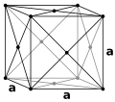](http://en.wikipedia.org/wiki/File:Lattice_face_centered_cubic.svg)Face-centered cubic (http://en.wikipedia.org/wiki/Cubic_crystal_system)

InSb is known as a III-V compound. This comes from the fact that this binary compound has one element in column III of the periodic table (In atomic number 49) while the other element is in column V (Sb atomic number 51). Since InSb has such a small band gap for the III-V binary compounds, it is suitable for many electronic devices for IR sources as well as magnetoresistive sensors (Weng and Goldman 2000, 6276).

The heterostructures that I helped to analyzed were all grown in the Molecular Beam Epitaxy. The MBE operates at an ultra high vacuum so that the atoms present in the chamber during the growth process come from the Effusion Cells. This is important so that contaminants to not get incorporated into the crystal structure. The MBE controls what elements are found in the chamber by shutters that allow the contents of the Effusion Cells to go into the growth chamber. In the chamber, a substrate is placed which allows crystal growth epitaxially. The growth process happens layer by layer. The layer of each crystal structure takes the orientation of the one below it. This will cause strain on the crystal structure if the bottom layer’s lattice spacing (the distance in Angstroms between atoms) is not the same as the material being grown on top. As the layer thickness increases, the crystal structure will relax from it stained state of trying to match the dissimilar layer below it to it natural atomic spacing; this process causes defects in the Epilayer such as threading or misfit dislocations (Weng and Goldman 2000, 6280-6283). The temperature in the effusion cells and growth chamber can be adjusted to allow optimum growth conditions. These conditions are based on the type of atoms that will be incorporated into the heterostructure and parameters that are based on those atoms physical properties. The MBE allows for real time monitoring of the growth process by using the RHEED system. The RHEED system can show the atomic layers as they are grown, and this helps so that layer structure and thickness can be monitored.

The bulk of my time was spent learning, using, and analyzing measurements taken of these MBE grown heterostructures with x-ray diffraction. X-ray diffraction on periodic crystal structures works in the same way a diffraction grating works. The grating in this setup is the periodic structures of the individual atoms in the crystal structure. When electromagnetic radiation (x-rays) is directed at a sample, the radiation is scattered in all directions when it hits an atom (Taylor, Zafiratos and Dubson 2004, 132). A phase change occurs because of this collision, and most of the reflected radiation interferes with other reflected radiation from other planes of incidence destructively, i.e. they cancel each other out. The reflected radiation that is of interest is when the reflected rays interfere with each other constructively and create a diffraction pattern that is plotted as position (degrees) versus intensity. The constructive interference happens when Bragg’s Law is met (Taylor, Zafiratos and Dubson 2004, 132-133).

http://www.eserc.stonybrook.edu/ProjectJava/Bragg/

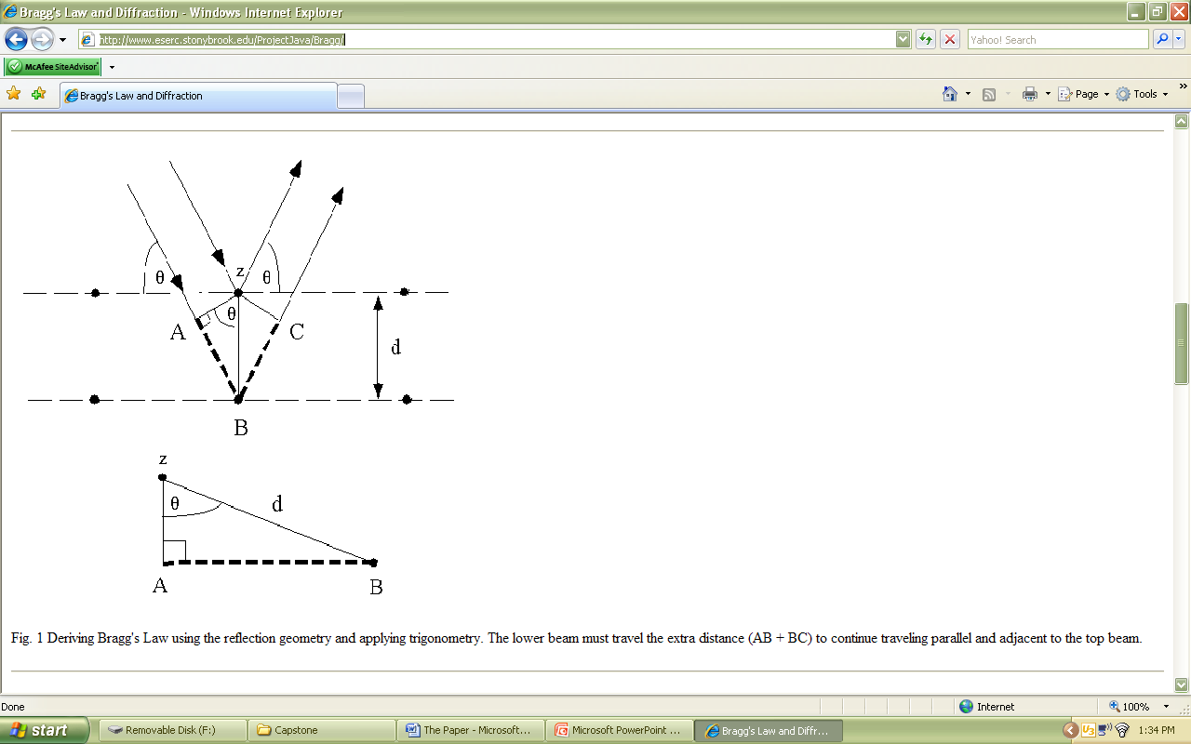

Bragg’s Law is stated in the following way: $2dSinθ=nλ$ where d is the spacing between planes, λ is the wavelength of the applied radiation (the wavelength of the x-rays), and θ is the angle of incidence (Taylor, Zafiratos and Dubson 2004, 133). From the x-ray defractometer, the angle (which is the diffraction pattern peak obtained from the experimental data), wavelength, and n can be obtained (n is the order of the diffraction maximum (Taylor, Zafiratos and Dubson 2004, 133)). One uses this experimental data to calculate d of the crystal sample and see if it matches the accepted values.

One of the tools that I learned in this capstone project to analyze experimentally obtained x-ray diffraction patterns with the use of simulation software from the manufacture of XRD. The “Philips X’Pert Epitaxy” simulation software allows for direct incorporation of experimental data files onto the same plot as the simulation data. This software allows the user to obtain peak angles, separation between angles, and peak widths while also allowing simulation data to be displayed. The layer structure can be varied, stress added to individual epilayers independent of other layers, and convolution parameters that can simulate noise in the simulation. This was a good tool to analyze experimental data and see if it matched what was predicted under the conditions supplied to the software. The simulation software allows for some parameters to be introduced where the simulation is run based on non-ideal conditions. These parameters are stress of the Epilayer and convolution. From this simulation, one can change the layer structure of the heterostructure to get the simulation to match the experimental data. This is useful especially in complex crystal layers to help decide if the structure that was planned was actually obtained, or perhaps what parameters had to be adjusted to obtain continuity between simulation and data. This will also give a good indication of the amount each layer is stressed or relaxed by matching the simulation with the data. The stress of an epilayer occurs because it is grown on top of a dissimilar crystal structure. The epilayers match the crystal structure of what is below it until the atomic forces on the atoms in the crystal is too great to allow it any further; this is a result of layer thickness (Weng and Goldman 2000, 6285). Then the layer is said to be strained some percentage until it obtains its’ natural crystalline spacing of atoms. At this point, the layer is said to be fully relaxed. On the opposite side, if the layer matches the dissimilar atomic spacing of the layer below, then it is said that the layer is fully strained.

I also learned how to conduct the Hall Effect Measurement during this capstone. The Hall Effect that is measured is a result of the Lorentz Force on a charged particle through a magnetic field (Wikipedia, Van der Pauw Method 2008). The measurement is set up using the following principles: a current is run through a sample, and that means that the electrons flow in the opposite direction of the current by convention. If a magnetic field is applied perpendicularly on the sample with respect to the current flow, the charged particles begin to move. This generates an Electric field and the free charged particles (electrons) congregate to one side of the sample, and this creates a potential difference across the sample. This potential difference can be measured using a voltmeter. Another measurement technique that can be employed to give information about the electronic characteristics of a sample is to use the Van der Pauw method. This method requires that a current be applied to contact points along one edge at the corners of a square sample; a voltage is then applied to the opposite set of contact points with a varying magnetic field (Wikipedia, Van der Pauw Method 2008). The data obtained from this measurement is the varying magnetic field versus the Hall Resistance. I only noted a linear relationship when I took this measurement. A positive slope indicates that the charge carrier is n-type (electrons). If the slope of the linear relationship is negative, then the charge carrier is p-type (holes).

**Procedures**

This section will give the procedure followed for using the x-ray defractometer. For power up procedures, please follow the instructions at the XRD and software initiation is in Appendix 1; this procedure is current as of this paper (May 18, 2009).  
**Symmetric Scans**

1. In the log book located at the XRD computer, record the following information: filter pressure, flow rate, full counts, ½ counts, and what generic file name you will be using (ex. SampleName-DateOfScan-XX where XX is the scan number).
2. Input the layer information and what hkl values needed for the scan (usually start with the substrate). The software will automatically calculate the Bragg Angle. Perform an omega scan with a wide range of 2 or more degrees, with a course step size of 0.01°, and time per step 0.50.
3. If a peak is found, right click on the scan data and select peak mode. Record the peak position, counts (intensity), and full-width-half-maximum FWHM. If a peak is not found, conduct a wider scan.

**Note:** Save the current scan before starting a new scan, if not the scan data will

not be available for analysis.

1. Before exiting out of the Peak Mode, select move to, and this will center the detector positioning on the scanned peak position.
2. Perform a longer scan over a smaller range on this peak. For example the parameters 0.02° scan range and a step size of 0.002°. Again, right click on the scan data and record the peak position, counts (intensity), and FWHM. Select the move to option to center the scan on the new peak position.
3. Perform Psi optimization program, the values for the peak will automatically be entered into the fields for the peak if the move to option is selected.
4. Repeat steps 2-5 for each layer in the sample and the psi optimization if needed.
5. Perform the scans for Phi 0°, 90°, 180°, and 270° saving each scan along the way.

**Asymmetric Scans**  
I got the following procedure from the BobH-explains-XRD document located in Appendix-2. Bob Hauenstein explains “Asymmetric peaks are often hard to find. They are best found by doing pure rocking curves scans with detector *fixed* at the theoretical 2theta value with no slit in place. (Such an operation will need to be performed *separately* for epi and substrate in your samples due to their widely separated peaks!) One would pair-optimize (PSI, PHI) on, e.g., * just the substrate *, in order to establish a common plane of incidence for a set of measurements (all of a common nominal phi value). I have had good results with the following sequence, where typically the *substrate* is chosen for optimization for each nominal PHI value desired:

1. Optimize Psi using the symmetric reflection for the peak
2. Optimize Phi using the asymmetric reflection
3. Without changing Phi, re-optimize Psi on the symmetric reflection
4. Perform steps 2 and 3 until good consistent and adequate intensity is obtained
5. Record data for peak position, counts, and FWHM for the scan data.
6. Use the same optimized Psi angle for all peaks corresponding to the optimized Phi value.
7. Perform steps 3-5 for optimized Phi + 180°.

Furthermore, Bob Hauenstein comments, “It is the *change* in epi-to-substrate separations for a **given** set of asymmetric planes, i.e., a **specific** (hkl) – not to be confused with other equivalent {hkl} – when compared for two azimuths (e.g. phi=0 and 180 deg), that **directly** (after correcting for any relative tilt as determined from symmetric reflections) gives evidence of biaxial strain due to lattice mismatch. (That is, if the peak separations are identical, then the epilayer is strictly cubic; otherwise, there is a biaxial strain present, and the latter is quantifiable from the measurement.)”

This section will describe the procedures followed for creating a scan simulation.

1. Click on the Sample tab and then select New Sample
2. Enter the substrate, primary hkl values (uses spaces between each value), offset angle if any, layer thickness in μm, and click set layer.
3. Click add layer or superlattice depending on the layer structure of the sample that is being analyzed.
4. Enter the structure (Zinc Blend or Diamond for example), elements, layer thickness in μm, relaxation percentage (best to start off with either 100% or 0% and adjust to experimental data), and click set layer.
5. Repeat steps 3 and 4 until the entire layer structure is entered for the sample.
6. Click save as and type in a filename for the sample.
7. Close the sample data window if it does not close automatically.  
   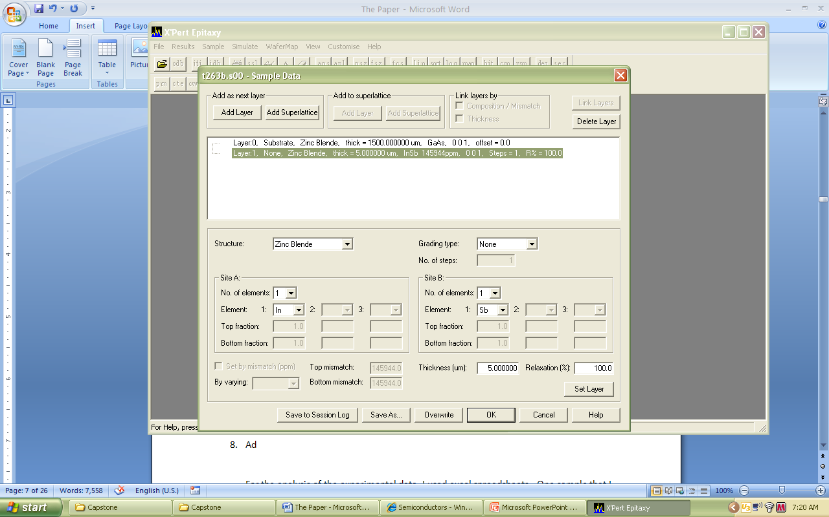
8. Click on the Simulate tab and select Simulate to new window. The new sample file should be brought up. From this window you can change the scan range, the intensity, the step size, and the hkl values for the scan.
9. Setup the scan to your experimental parameters and click OK.
10. When the simulation is done running, you may wish to add in experimental scans for comparison. Click the edit tab and select insert scan from file.
11. Choose the file path of your experimental scans; note that the scan file does not have to be in the expert sample file. You may choose an external drive path for example. You may add more than one scan file at a time by holding the ctrl key while clicking on scan files.
12. Click OK, and the scans will be inserted into the active simulation window.
13. If the scan data does not match the experimental data then the simulation parameters need to be adjusted. If you want to remove the simulation scan from the window before editing, select the simulation scan on the right of the window, click on the edit tab and select remove scan. The software will give you the option to save the simulation before removing it, save if you want.
14. Edit the simulation parameters until you get a good representation of the experimental scans.
15. Save the Sample file and scan data.
16. The simulation scan data can be exported into an excel file if you wish to plot the simulation on some other software program.
17. Click file and select open from file
18. Find you scan data and copy the file. Paste the file to your desired location. The data file will give you the first angle, step size, and data points which are all that is needed to make a plot of the simulation data. The data may be shifted as needed by adding the same angle over all scan points if needed. The same can be done with experimental data if needed.   
    All of these methods help to analyze the experimental scans and structure of the sample.

The following is the procedure used to conduct the Hall Effect experiment:   
Follow the power turn-on procedure for the instrument as directed in the user’s guide. Per form each of the following procedures for 300°K, 250°K, 200°K, 175°K, 150°K, 120°K, 100°K, 77°K, 65°K, 50°K, 40°K, 32°K, 25°K, and finally 20°K.

1. Select the desired current to test the sample and set this in the software field for the current.
2. Within the software fields, select the folder path and data folder path of where you would like you saved files to be located. Come up with a naming system that will allow you to distinguish between measurements.

**Note:** The contact leads are designated in the following way:

A

C



B

D

1. Run the Hall Effect measurement first. Do this by connecting the leads in this manner where V stands for voltage and I stands for current.

|  |  |
| --- | --- |
| A | -V |
| B | -I |
| C | +I |
| D | +V |

Select the Ramp start 0, Ramp Stop 2.5, Ramp End 25, and Field Control 25. This measurement will give varying magnetic field versus Hall Resistance.

1. Next perform the Van der Pauw Method measurements. Start by changing the filename for this measurement so that it may be distinguished from other measurements performed. Connect you leads in the following way:

|  |  |
| --- | --- |
| A | +V |
| B | -V |
| C | +I |
| D | -I |

1. Again, change the filename for this measurement and connect your leads in the following way:

|  |  |
| --- | --- |
| A | -I |
| B | +V |
| C | -I |
| D | -V |

1. Again, change the filename for this measurement and connect your leads in the following way:

|  |  |
| --- | --- |
| A | -I |
| B | +I |
| C | -V |
| D | +V |

1. Again, change the filename for this measurement and connect your leads in the following way:

|  |  |
| --- | --- |
| A | -V |
| B | -I |
| C | +V |
| D | +I |

1. Repeat steps 3-7 for all desired temperatures
2. Turn off the instrument as directed in the operating manual.

**Calculations**  
The following are the equations used to analyze the XRD data (This data set is for t263b): Δω is the angular separation between the substrate peak and the epilayer peak. These formulas were obtained from Weng and Goldman paper page 6280 and in the PC-MRD User Guide pages 6-5 through 6-6.

|  |  |  |  |  |  |  |
| --- | --- | --- | --- | --- | --- | --- |
| θ | Δω | Strain/ Relaxation (Symmetric) | | | Equations (Asymmetric) | |
| 0 | -4.85926 | dInSb004 = | SinθB | *dGaAs004 | 2Sinθ = | (2H2/a2 + L2/c2)1/2 |
| 90 | -4.91647 |  | Sin(θB+ΔωAvg) | λ |  |
| 180 | -4.44783 | θB= | Bragg angle of GaAs | |  |  |
| 270 | -4.39192 | d= | Lattice spacing | | CosΦ = | L/c |
| 360 | -4.85926 | θB | 33.02302° |  |  | (2H2/a2 + L2/c2)1/2 |
| **ΔωAvg** | **-4.694948** | dGaAs004 | 5.65325Å |  |  |  |
|  |  | **Calc. dInSb004** | **6.48405Å** |  | ΔΩ1= ΔΩ0˚  - ΔΩ180˚ | |
|  |  | Actual dInSb | 6.4794Å |  | ΔΩ2= ΔΩ90˚ - ΔΩ270˚ | |
|  |  | **0.072% Strained, 99.9% Relaxed** | | |  |  |
|  |  |  |  |  | c = | λL |
|  |  |  |  |  | 2(Sinθ)(CosΦ) |
|  |  |  |  |  | a = | c(√2H) |
|  |  |  |  |  | L |
|  |  |  |  |  | λ = | 1.54056 Å |

The following are the formulas used to analyze the Hall Effect measurements:

1. Plot the data (easiest in excel, but choose your plotting program that you are most familiar) of the changing magnetic field versus the Hall Resistance
2. Obtain a linear regression of the data and annotate the slop obtained for the line as “m”.
3. Average the resistance obtained for all the Van der Pauw measurements, for example;

|  |  |
| --- | --- |
|  | Resistance |
| AB | 0.123 |
| BD | 0.136 |
| DC | 0.118 |
| CA | 0.136 |
| Ravg | 0.128 |

$$R_{avg}=\frac{R_{AB}+R_{BD}+R_{DC}+R_{CA}}{4}$$

1. Sheet Resistance RS = (this gives the sheet resistance in ohms)
2. Sheet Density $n_{s}=\frac{1}{q_{e}m}×\frac{1}{100}×\frac{1}{100}$ (this gives the sheet density in cm-2.
3. Carrier Mobility $μ=\frac{1}{q_{e}n_{s}R_{S}}$ (this gives the carrier density in cm2/Vs)

**Analysis**

For the analysis of the experimental data, I used excel spreadsheets. One sample that I measured with x-ray diffraction on both a symmetric plane and asymmetric plane was t263b. I obtained the following results:

|  |  |  |  |  |  |  |  |  |  |  |  |  |  |  |  |
| --- | --- | --- | --- | --- | --- | --- | --- | --- | --- | --- | --- | --- | --- | --- | --- |
| t263b 5.0μm InSb on 1.5mm GaAs (0 0 1) with uniform Si Doping Measurement taken on 03/05/2009 | | | | | | | | | | | | | | | |
|  |  | | | |  | | |  | | |  | | |  | |
| GaAs 004 | Ω – Scan | | | |  | | |  | | |  | | |  | |
| **Ψ (in deg)** | **Φ (in deg)** | | | | **Peak – omega** | | | **Offset (in deg)** | | | **Counts** | | | **FWHM** | |
| 1.874 | 0 | | | | 32.10628 | | | -0.919 | | | 2647.83 | | | 0.0054 | |
| 2.321 | 90 | | | | 31.89382 | | | -1.13075 | | | 93.86 | | | 0.0189 | |
| -0.625 | 180 | | | | 34.20323 | | | 1.17875 | | | 1992.54 | | | 0.0057 | |
| 2.399 | 270 | | | | 34.40519 | | | 1.38075 | | | 1509.5 | | | 0.0190 | |
|  | Average Angle | | | | 33.15213 | | |  | | |  | | |  | |
| GaAs 004 | Ω – 2θ Scan | | | |  | | |  | | |  | | |  | |
| **Ψ (in deg)** | **Φ (in deg)** | | | | **Peak – omega** | | | **Offset (in deg)** | | | **Counts** | | | **FWHM** | |
| 1.874 | 0 | | | | 32.10573 | | | -0.9185 | | | 2666.1 | | | 0.0054 | |
| 2.321 | 90 | | | | 31.89293 | | | -1.1315 | | | 93.37 | | | 0.0191 | |
| -0.625 | 180 | | | | 34.20241 | | | 1.17875 | | | 1896.98 | | | 0.0058 | |
| 2.399 | 270 | | | | 34.40452 | | | 1.38075 | | | 1495.41 | | | 0.0182 | |
|  | Average Angle | | | | 33.1513975 | | |  | | |  | | |  | |
| InSb 004 | Ω – Scan | | | |  | | |  | | |  | | |  | |
| **Ψ (in deg)** | **Φ (in deg)** | | | | **Peak – omega** | | | **Offset (in deg)** | | | **Counts** | | | **FWHM** | |
| 3.347 | 0 | | | | 27.24702 | | | -1.15300 | | | 4142.1 | | | 0.0752 | |
| 2.250 | 90 | | | | 26.97735 | | | -1.42275 | | | 398.71 | | | 0.0759 | |
| -0.944 | 180 | | | | 29.7554 | | | 1.35550 | | | 2875.01 | | | 0.0757 | |
| 2.371 | 270 | | | | 30.01327 | | | 1.61325 | | | 4633.23 | | | 0.0752 | |
|  | Average Angle | | | | 28.49826 | | |  | | |  | | |  | |
| InSb 004 | Ω – 2θ Scan | | | |  | | |  | | |  | | |  | |
| **Ψ (in deg)** | **Φ (in deg)** | | | | **Peak – omega** | | | **Offset (in deg)** | | | **Counts** | | | **FWHM** | |
| 3.347 | 0 | | | | 27.24585 | | | -1.15325 | | | 4156.11 | | | 0.0751 | |
| 2.250 | 90 | | | | 26.97678 | | | -1.42132 | | | 394.28 | | | 0.0767 | |
| -0.944 | 180 | | | | 29.75459 | | | 1.3555 | | | 2883.85 | | | 0.0757 | |
| 2.371 | 270 | | | | 30.01259 | | | 1.61257 | | | 4573.15 | | | 0.0758 | |
|  | Average Angle | | | | 28.4974525 | | |  | | |  | | |  | |
| Asymmetric Scan Data (115) | | | | | | | | | | | | | | |
| measurement taken on 03/24/2009 | | | | | | | | | | | | | | |
| GaAS | | |  | InSb | | |  | | |  | |  | | |
| Φ (deg) | | | Ω (deg) | Φ (deg) | | | Ω (deg) | | | ΔΩ (deg) | | ΔΩx/2 (deg) | | |
| 0 | | | 28.28907 | 0 | | | 21.12049 | | | 7.16858 | | 0.20653 | | |
| 180 | | | 30.54248 | 180 | | | 23.78696 | | | 6.75552 | |
| **Avg. Ω (deg)** | | | 29.415775 | **Avg. Ω (deg)** | | | 22.453725 | | | 6.96205 | |  | | |
| 90 | | | 28.55347 | 90 | | | 21.33272 | | | 7.22075 | | 0.257815 | | |
| 270 | | | 30.26738 | 270 | | | 23.56226 | | | 6.70512 | |  | | |
| **Avg. Ω (deg)** | | | 29.410425 | **Avg. Ω (deg)** | | | 22.44749 | | | 6.962935 | |  | | |
| Asymmetric Scan Data (115) | | | | | | | | | | | | | | | | | | | |
| measurement taken on 03/24/2009 | | | | | | | | | | | | | | | | | | | |
| Substrate | | | | | | | | | | Epilayer | | | | | | | | | |
| θs (deg) | | | Φs (deg) | | a (Å) | | c (Å) | | | θL (deg) | | | | ΦL (deg) | | | | a (Å) | c (Å) |
| 45.0697 | | | 15.7932 | | 5.6535 | | 5.6535 | | | 38.10765 | | | | 15.99973 | | | | **6.4040** | **6.4922** |
|
|  | | |  | |  | |  | | |  | | | |  | | | |  |  |
| 45.0697 | | | 15.7932 | | 5.6535 | | 5.6535 | | | 38.106765 | | | | 16.051015 | | | | **6.3842** | **6.4940** |
|  | | |
|  | | |  | |  | |  | | |  | | | |  | | | |  |  |

The average peak angle is used to average out some of the error induced if the sample was misaligned on the goniometer for the measurement. It is hard to tell the sample’s orientation if a square sample is given, and so this procedure helps to minimize the error induced by that. If the sample was perfectly aligned on axis of the crystal structure, then the diffraction pattern would be the same for all values of Phi. When this is not the case, the average peak value gives a better indication of where the peak actually is for this particular sample.

These are plots of the experimental data that I obtained that I used to get the values for the parameters of the data spreadsheet posted above the x-ray diffraction plots.

I also took data for the Hall Effect. The following is my calculations and analysis of this data set:

|  |  |  |  |  |  |  |
| --- | --- | --- | --- | --- | --- | --- |
| 300k(1e-4)-20081212 | | |  |  |  |  |
| Resistance | Hall Probe Voltage | Field B(kG) | Calculations | |  | Resistance |
| 0.014054 | 3.59E-05 | 0.0041 | m(dRH/dB) | 0.6038 | AB | 0.123 |
| 0.025026 | 0.0001709 | 0.0196 | nS (cm-2) | 1.03E+15 | BD | 0.136 |
| 0.032066 | 0.000308 | 0.0353 | μ (cm2/Vs) | 1.04E+04 | DC | 0.118 |
| 0.042892 | 0.0004456 | 0.0510 | RS (Ω) | 0.581275188 | CA | 0.136 |
| 0.053304 | 0.0005845 | 0.0670 |  |  | Ravg | 0.128 |
| 0.064228 | 0.0007223 | 0.0827 |  |  |  |  |
| 0.072626 | 0.0008605 | 0.0986 |  |  |  |  |
| 0.0819 | 0.0009991 | 0.1144 |  |  |  |  |
| 0.094472 | 0.0011365 | 0.1302 |  |  |  |  |
| 0.099158 | 0.0012729 | 0.1458 |  |  |  |  |
| 0.107264 | 0.0014087 | 0.1614 |  |  |  |  |

This is the room temperature measurements. Data was also taken to see how decreasing temperature affected the measured resistance of the sample. This is also for sample t-263b. The following plots show the temperature dependence and mobility of the charge carriers. This is used is deciding if this sample has the desired characteristics that is needed for electronic devices.

My experience in capstone has given me valuable understanding as well as application of the ideas and concepts that I have been learning throughout my study of physics. This has given me the chance to be a part of a research team and contribute to the group goals and overall project. I did this by taking measurements using the XRD and Hall Effect instrument, and I was able to apply my physics knowledge along with the help of Professor Santos and Dr. Debnath to give information about the sample using the collected data. I also was able to provide insight for the data that was obtained using x-ray diffraction by using the simulation software. The simulation software was also very useful to see if the information that was calculated about the in-plane spacing was correct. The stress or relaxation percentage of the Epilayer was calculated from the diffraction data and compared to that of accepted values for the spacing between planes of atoms for that crystal structure. The simulation data can be used to check if that calculated value put into the simulation parameters shows a diffraction pattern that is similar to the experimental data. I used all of these skills that I learned to help the research effort of Professor Santos’ team research InSb heterostructures to be used in electronic devices.

# Works Cited

Bernstein, Jermey, Paul M. Fishbane, and Stephen Gasiorowicz. *Modern Physics.* Saddle River: Prentice Hall, 2000.

Taylor, John R, Chris D Zafiratos, and Michael A Dubson. *Modern Physics for Scientists and Engineers.* Upper Saddle River: Printice Hall, 2004.

Weng, X., and R. S. Goldman. "Evolution of Structural and Electronic Properties of Highly Mismatched InSb Films." *Journal of Applied Physics* 88, no. 11 (December 2000): 6276-6286.

Wikipedia. *Cubic Crystal System.* http://en.wikipedia.org/wiki/Cubic_crystal_system (accessed January 2009).

—. *Van der Pauw Method.* November 4, 2008. http://en.wikipedia.org/wiki/Van_der_Pauw_method (accessed November 24, 2008).

**Appendix 1**

Philips X-Ray Defractometer

Software and Scanning Procedures (X’Pert)

After system Startup  
**Software Initialization:**

1. Open WinNT Virtual machine under the Virtual PC icon in the Start menu. You will receive an *Event Error* message once Windows NT starts. You can safely dismiss this dialog box.
2. From the Window NT Virtual machine menu, go to the *Action* tab and select *Ctrl+Alt+Del* to get to the login prompt. The user “SPM” does not have a password, just hit return.
3. Open X’Pert Organizer and logon using username: “Xray” and password: “ou812”
4. From within the X’Pert Organizer environment, open X’Pert Data Collector either with the icon or under the *Modules* tab.
5. Select the *Control!* Tab, select *Santos Config.* And press *OK*. Select *OK* again for the assumptions (usually involving the monochromater) and the software will go online to connect to the Xray.
6. Within the Control(Configuration1) window, set the kV and mA values to those used (40kV and 30mA usually).
7. Also from this menu, adjust the Goniometer position using the *Change Position* option to 0 for all angles and determine the count rate in the lower section of the window for sample mounting and alignment instructions.
8. After mounting and alignment, do not close the *Control!* Menu, minimize it and move on to measurement and data collection.

**Sample Mounting:**

1. Remove back of sample plate from the goniometer.
2. Mount the sample in the center of the aluminum disc on the larger sample plate using a small piece of double-sided tape. Sample alignment is eased if a major sample axis is vertical. Take care in ensuring that the sample is flat against the holder.
3. Place the sample plate back onto the goniometer aligning a major sample axis vertically. Use the lines scribed into the aluminum and black sample plates to assist you.

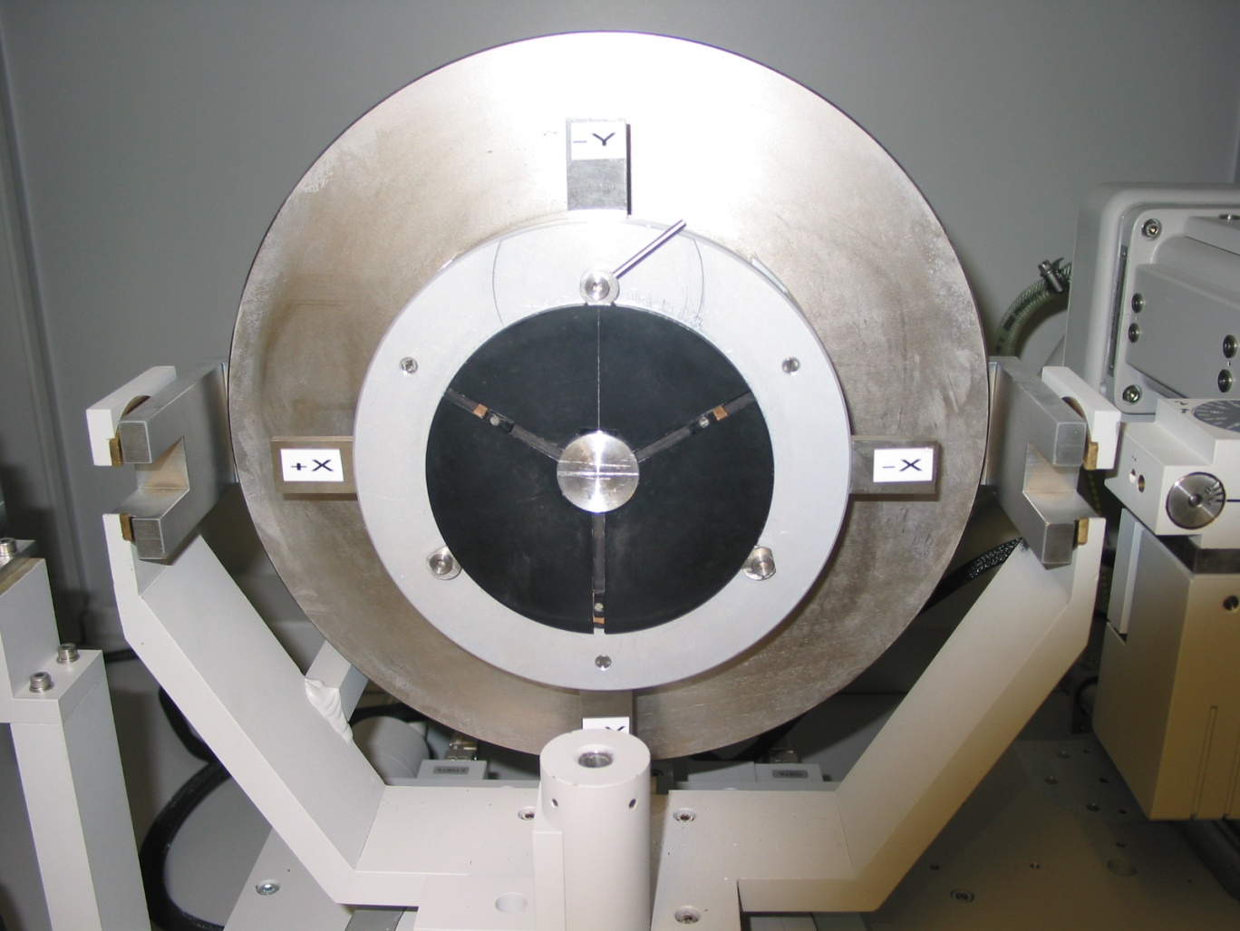

**Sample Alignment:**

1. With the system at operating voltage and current, begin sample alignment. System should be stable for 30 minutes after bringing up to operating conditions.
2. Set Omega and 2-Theta to 0.0 from the *Control!* Menu or from the *Measure>Manual Scan* tab.
3. Move sample back (into the cabinet) so that the full beam flux will strike the detector.
4. Insert the smallest aperture (.045mm) in from of the detector aligning the scribe marks on the aperture holder with those on the aperture itself.
5. Close the sliding doors, open the shutter and take note of the full beam intensity in cps (located on the lower portion of the *Control!* Or *Manual Scan* windows).
6. Close the shutter and move the sample back into the beam until the intensity is approximately ½ the full value. (Note, if comparing intensity readings for two different samples, set these values as close to each other as possible. i.e. 164k cps)
7. This should provide a stable beam position on the sample during rotations. For a more accurate alignment, see alignment document.

**Sample Scanning/Data Collection:**

* 1. Minimize the *Control* window and move to *Measure>Manual Scan* tab to determine the substrate peak position.
  2. Remove the 0.45 mm aperture.
  3. Move the detector (2) and substrate () into position for a symmetric scan of the substrate. The software can determine these angles for you automatically by entering your material and desired h k l (be sure to leave spaces between h k l values).
  4. Perform a quick  scan over several degrees using a coarse step size, 0.01° is sufficiently small. The scan can be very short (< 0.5 minute).
  5. You should be able to locate the substrate peak with this scan. Change  to center the scan about this peak. This is done with a right-click *Peak Mode*.
  6. Perform a higher resolution scan of this peak: 0.1° range, 0.002° step. Using the cursor find and center  on this position.
  7. Next, under the *Measure>Program* tab, select Psi optimization program. Enter the Omega value for your substrate peak and run the program. If the Optimization does not find the optimal value within range, adjust the starting value up or down until the optimum is determined.
  8. Psi and Phi optimizations can be run from the symmetric or asymmetric planes, unit cell parameters from the old DOS-based software have been input into the X’Pert programs and should yield similar calculated values for Omega and 2Theta for all symmetries.
  9. Once optimized, decrease the step size and collect data scans of higher resolution for saving. Save files under the *File>Save As* menu and develop a logical naming system for your needs. For example:

Sample# symmetry Phi

T0000 004 90

* 1. Spaces and dashes appear to be acceptable under the file system. Files will be accessible with the X’Pert Graphics software. This should also be accessed from within the X’Pert Utilities environment.
  2. After scanning the substrate peak, adjust 2 and  for your layer and repeat steps 4 to 9 initially using the substrate  value.
  3. Repeat the measurements for a  value of 90°, 180° and 270° (-90°). Sometimes you cannot reach 180° due to the physical limits of the drive system. Use -180° instead.

This will allow you to calculate the Bragg angle of the layer using the substrate peak, which then allows you to find the ‘c’ lattice constant. You will also get substrate/layer miscut/tilt information from this data. To find the in-plane lattice constant, you will need to perform asymmetric scans. See BobH-explains_XRD.doc for some details on this. Formulas are in the MRD documentation.

**Graphics and File Location:**

1. Open the X’Pert Graphics software and select *File>New Graph*. In the New Graph window, select the scan type used and your data should appear. Select and open.
2. Basic analysis can be done from here while the Epitaxy software allows for much more in depth analysis.
3. Before closing, it is suggested that you export your data files if you wish to access them and transfer them to another computer. Within the X’Pert Organizer environment, select *Database>Export>Scans*. Your data should be listed, select and press OK. On the *Export Scans* menu, be sure to note the destination folder and file name. Destination folder should be *D:\Xray Data\__(group name)__*. (Group folders are: Santos, Johnson, Shi, McCann) Also be aware that the software will attempt to simplify your file name and you may have to manually enter your chosen name again from this menu before exporting your data.
4. Once exported, you can access your data on the WinNT D: drive in the folder noted above. You may also choose to create your own folder within the Xray folder so that your data is separate and easy for you to find.

**Notes on the New Software:**

1. Programs can be developed under *File>New Program* menu. If the optimization programs provided are not adequate for your needs or if you need to adjust scanning range, angles etc. a program can be written to meet your needs. Once written you can save it and use it on future projects.
2. Other programs available are Omega/2-Theta scans over a 6 and 8 degree range, but oftentimes a manual scan can be set up as quickly as a previously developed program. Learn to take note of scan axis, range, step size, symmetry and unit cell values. The software has some quirky interdependencies that can only be learned through trial and error.

**Appendix 2**

Bob Hauenstein’s XRD Analysis Guide

The following are emails between Joel Keay at OU and Bob Hauenstein at OK State concerning X-Ray measurements of MBE grown InSb on (001) and (111) oriented GaAs substrates. The questions put forth in the first email are reproduced within the body of the reply. They are denoted by ‘>’ as the first character.

# JK 23 Feb 2001

I've been taking measurements on samples similar to the one's that a left at OSU, and I would like confirmation on a few points. I am interested in determining defect densities/types if possible from pairs of (111) and (001) samples grown together. From AFM we see stacking faults and threading dislocations. Our typical x-ray analysis just looks at the widths of the reflections, but I know that we should be able to take this a step further.

1) First lets take an (001) material with an epilayer whose lattice constant is much larger than the substrate's lattice. I first want to measure the tilt, but I cannot perform a standard rocking curve (Omega scan) and see both the layer and the substrate because the separation is too large, (004) reflection. So I perform an Omega/2Theta scan after a Psi optimization. I then rotate by 90, 180 and 270 and taking a scan at each position, however if there is a large enough tilt, Omega and 2Theta are not in a position syncronous with the Bragg condition, so I align Omega with the substrate so that I've maximized my signal with the same detector position as in the 0 deg scan. Then using the standard formalism I should be able to calculate the substrate tilt, and the epilayer tilt w/r to the substrate. Is this correct? I assume that this is also correct for a (111), I'm using the (333) reflection. The spacing of the c axis is also extracted and in the case of (111) material I picture this as the hexagonal lattice constant c. From (2) I should be able to get **a**.

2) Rotation to an asymettric reflection: (115) or (331) for (001) and (111) respectively. Optimize Phi/Psi for the substrate. Scan the layer/substrate peaks then rotate by 180 deg. I have had mixed luck with this. Either I can find no peaks w/ open detector performing Omega scans over large > 6 deg ranges and then stepping in 2Theta by less than the acceptance angle repeatedly over large ranges, or I find weak reflections which do not optimize or I get suitably strong reflection (so far 001 substrates only). In any event I can calculate the in-plane lattice constants easily from this (at least for the (001) material. In the case of (111) materials it is possible that the sample x-y position is no longer optimal - samples are the approx the same size as the beam spot - but no success with this optimization or a plane is distorted, though I would expect from symmetry that they would be the same. Any thoughts?

3) Area scans of asymmetric reflections: I should be able to reproduce the values found in (2) from the difference of the substrate/layer peak rlp, yet this produces significantly different values from (2) and from 0, 180 deg area scans.

Do you see this as a valid methodology for analysis or could you recommend a better solution?

**BH Reply:**

I’ve looked in detail at your sample S739 and have confirmed that the epilayer is fully relaxed and that the epilayer and substrate [111] directions (the nominal surface normal) are nearly parallel (though the substrate itself is vicinal by about ~0.5deg). I have not yet gotten to the [001] sample yet but can look at it next week if you wish. I’ll start sending you the data once I get it better organized.

Now let me respond to your actual questions:

>

>1) First lets take an (001) material with an epilayer whose lattice

>constant is much larger than the substrate’s lattice. I first want to

>measure the tilt, but I cannot perform a standard rocking curve (Omega

>scan) and see both the layer and the substrate because the separation is

>too large, (004) reflection. So I perform an Omega/2Theta scan after a Psi

>optimization.

Yes; this is correct!

Note that in this mode, w/o a slit in the detector, you essentially are doing a “rocking curve measurement” with effectively a very large acceptance-angle detector (provided that the individual peaks are all small compared with the true acceptance angle of the detector).

>I then rotate by 90, 180 and 270 and taking a scan at each

>position, however if there is a large enough tilt, Omega and 2Theta are not

>in a position syncronous with the Bragg condition, so I align Omega with

>the substrate so that I’ve maximized my signal with the same detector

>position as in the 0 deg scan.

Correct!

The instrument’s theoretical 2theta should be adequate w/o adjustment for each type of peak. However, the actual omega values will differ in each azimuth due to tilt, as you observe.

>Then using the standard formalism I should be able to calculate the substrate tilt,

>and the epilayer tilt w/r to the substrate. Is this correct?

Yes!

Thus, you can determine the tilts directly. (Note that an overall absolute tilt of sub+epi may be superimposed if the sample is not mounted flush on the goniometer, but relative epi-substrate relative tilt will be unaffected by this).

Moreover, **if** you have an accurate instrumental calibration for omega, you can also determine **absolute** Bragg angle (theta) by taking the average of your four omega readings for e.g., the epi peak. (Note: this is not necessary if you wish to use the substrate peak as a “known” reference Bragg angle.)

>I assume that this is also correct for a (111), I'm using the (333) reflection. The spacing of the c axis is

>also extracted and in the case of (111) material I picture this as the hexagonal lattice constant c.

>From (2) I should be able to get **a**.

I think it’s actually trigonal, but I believe that you are essentially correct (since triginal can be viewed as hexagonal w/ a basis).

Technically, it might be best to regard symmetric reflections as directly giving the perp. lattice parameter (your **c**), and the asymmetric reflections as most directly giving a **ratio** of perpendicular to in-plane lattice parameters, i.e., **c**/**a**. Thus, combining the two, both **a** and **c** are determined.

BTW, I know that (333) is much weaker in Si than (111); you may wish see to see if this holds also for the III-Vs, and if so use the (111) for better signal-to-noise. [I used (111) on your S739 specimen and got clean, intense peaks.]

>2) Rotation to an asymettric reflection: (115) or (331) for (001) and (111) respectively. Optimize

>Phi/Psi for the substrate. Scan the layer/substrate peaks then rotate by 180 deg. I have had mixed

>luck with this. Either I can find no peaks w/ open detector performing Omega scans over large > 6 deg

>ranges and then stepping in 2Theta by less than the acceptance angle repeatedly over large ranges, or I

>find weak reflections which do not optimize or I get suitably strong reflection (so far 001 substrates only).

>In any event I can calculate the in-plane lattice constants easily from this (at least for the (001) material.

>In the case of (111) materials it is possible that the sample x-y position is no longer optimal - samples are

>the approx the same size as the beam spot - but no success with this optimization or a plane is distorted,

>though I would expect from symmetry that they would be the same.

>Any thoughts?

******* Answer to second question **************

I’d stick with a set of (hkl) planes with normals lying in the * same plane *. Then, all measurements may take place in a single plane of incidence; thus only a single (PSI, PHI) optimization pair will be needed for the entire set, for, e.g., a given nominal phi value (phi=0, say). Repeat the optimization procedure for the second nominal phi value (180 deg from first one), then take the second set of asymmetric scans. (Appropriate scan pairs – actually 4 scans for your samples – are discussed further below.)

Life is easiest if you can use larger specimens, or, for smaller specimens, if, prior to scans, you first VERY CAREFULLY CENTER * the small specimen in the X-ray beam.

*This includes

1. insuring that the incident beam itself is correctly aligned with respect to the goniometer stage (i.e., see beam-steering procedures in the Philips manual if needed);
2. at omega = 0 positioning your specimen so that it reduces the unobstructed direct beam intensity by very nearly 50%;
3. finding a peak and optimizing X and Y translations for max. signal iteratively as needed. Then, you should be least likely to encounter artifacts of the sample wandering out of the beam (e.g., during large phi rotations or other large-scale movements).

Asymmetric peaks are often hard to find. They are best found by doing pure rocking curves scans with detector *fixed* at the theoretical 2theta value with no slit in place. (Such an operation will need to be performed *separately* for epi and substrate in your samples due to their widely separated peaks!) One would pair-optimize (PSI, PHI) on, e.g., * just the substrate *, in order to establish a common plane of incidence for a set of measurements (all of a common nominal phi value). I have had good results with the following sequence, where typically the *substrate* is chosen for optimization for each nominal PHI value desired:

1. First, optimize PSI, using a **symmetric** reflection.
2. Next, optimize PHI, by using the desired **asymmetric** reflection (found via omega scan per above).
3. Now, with PHI unchanged, go back and re-optimize PSI on the symmetric reflection.
4. Iterate as needed (until you convert to acceptable results for both peaks); the plane of incidence (cross-section through reciprocal space) is thus established and the sample is now properly oriented.

Note: use the SAME optimized (PSI, PHI) values on all scans corresponding to a given nominal PHI value (e.g., the “phi = 0” scans).

(Note that the above procedure might be overkill, or might be necessary, depending upon the sample: substrate vicinality, initial-mounting alignment, material quality and peak sharpness, etc.)

Slight PHI misalignments can cause a sharp asymmetric peak to be missed (but possibly not a broader epi peak)! They are there though, and definitely worth a careful look, for both film and substrate! It is the *change* in epi-to-substrate separations for a **given** set of asymmetric planes, i.e., a **specific** (hkl) – not to be confused with other equivalent {hkl} – when compared for two azimuths (e.g. phi=0 and 180 deg), that **directly** (after correcting for any relative tilt as determined from symmetric reflections) gives evidence of biaxial strain due to lattice mismatch. (That is, if the peak separations are identical, then the epilayer is strictly cubic; otherwise, there is a biaxial strain present, and the latter is quantifiable from the measurement.)

Suggestion: Consider {422} or {440} – type reflections as these are nominally very strong and sharp in diamond and zinc blende structures. I obtained good results for S739 with (224) on the (111) substrate, for both phi=0 and 180. Comparison of [omega(epi) – omega(substrate)] between the phi scans – they were identical – **directly** shows that the InSb in S739 was cubic (i.e., not trigonally distorted).

Also see the earlier comments about sample positioning in the beam. This can make a big difference. Easiest is to use larger specimens if possible.)

Note that (based on looking at your S739 sample) each asymmetric “scan” will probably need to be **two separate scans**: one for the epi, one for the substrate. In each case, center omega and 2theta as appropriate for that respective peak; then do an omega scan withoug a detector slit present.

Thus, a complete asymmetric set of, e.g., the (224) reflection on a (111) sample would involve **four** omega scans (since peaks are so far separated on your samples).

ADDITIONAL SUGGESTIONS FOR ASYMMETRIC SCANS:

1. Initially mount a good specimen cleave edge on the goniometer as being perfectly horizontal (or vertical). This forces the computer’s “phi=0” to correspond accurately to a low-index crystallagraphic direction as it implicitly presupposes in the software.
2. The actual (hkl) peak may **not** be at the phi determined by the software! Use the software to calculate omega and 2theta, but assume that the computer determined phi might be off by a crystallographically appropriate increment (e.g., 30 deg multiples on the (111), and hunt appropriately for the actual peak.
3. For the acutal (asymmetric) measurement set (e.g., (224), you must look at epi and substrate (224) peaks via rocking curves in a series of four separate scans as follows:

First “scan” of “scan” pair

1. Go to the theoretical 2theta, and the actual omega, and do a rocking curve for the SUBSTRATE (224).
2. Repeat for the EPI (224).

Second “scan” of “scan” pair: (input and output beams interchanged)

1. Rotate PHI by 180°.
2. Keep the same 2THETA, but manually change to a **new** OMEGA according to (NEW OMEGA = 2*THETA- OLD OMEGA).
3. Re-optimize (PHI, PSI)
4. Again take a SUBSTRATE (224) rocking curve, again take a (224) EPI rocking curve.

ANALYSIS:

Compare the epi to substrate peak separations for the first two and latter two scans. Apply any corrections for the epi-substrate tilt as previously found from symmetric-reflection data.

Any remaining residual tilt differences is due to biaxial distortion. (You can use the theory to quantify this, getting a **c**/**a** ratio directly).

No tilt difference direclty means the epilayer is strictly cubic!

The above is (in my opinion) one of the best ways for **quantitatively** assessing the epitaxial strain state – far more efficient than recipocal-space mapping, provided the peaks themselves are sufficiently sharp.

If you really want to be convinced, you could repeat the above on other asymmetric reflections sets, e.g., (044). The two different sets should give consistent results.

>3) Area scans of asymmetric reflections: I should be able to reproduce the values found in (2)

>from the difference of the substrate/layer peak rlp, yet this produces significantly different

>values from (2) and from 0, 180 deg area scans.

>Do you see this as a valid methodology for analysis or could you recommend a better solution?

Area scans [reciprocal-space maps (G-maps)] vs. rocing-curve scans of asymmetric Bragg reflections:

G-maps are time-consuming. Taking a few is good to illustrate qualitative characteristics, but, for routine or for more quantitative analysis, the rocking curve method I described above I much prefer.

If your peaks of interest (epi & sub) are sufficiently sharp, the rocking curve method I described is **far** more efficient in time **and** can give more quantitatively precise information about the extent of lattice-mismatch strain relaxation. Just looking at a single G-map is never conclusive: peaks may be misaligned from the ideal not merely due to strain effects, but also du to relative epi/substrate tilt. Thus one would have to look at multiple epi/substrate G-maps, which is very, very time consuming to collect.

If your peaks are highly irregular e.g., mosaic tilt spread is excessive, and/or, the G-map – if you took it – would have and odd profile (due genuinely to the sample rather than limited instrumental resolution of slit-mode), then in this case you might do better with the area scans (better yet, grow more samples because if they are this bad then they are probably not worth analyzing)!

I myself would use the G-maps (of asymmetric reflections) only for occasional consistency check (or publication figure), but would employ rocking curve scans for routine and/or quantitative work.

Also, keep in mind that, unless your reciprocal-space features are large compared to the instrumental resolution (w/o triple axis cpability), then what you observe is a instrument-resolution-convolved version of the true G-map.

NOTE: Such resolution limitation is **not** a limitation for the asymmetric rocking curve scan pairs described above! The latter actually essentially achives accurate reciprocal space localization by means of intersection of **two** Ewald spheres (since you are doing and comparing results from two separate scan geometries in this method); hence, is not limited by the 2THETA resolution of the instrumentation and indeed works just fine w/o a slit in place!)

To summerize, I prefer the rocking curve method and would use the G-map infrequently, and merely to confirm results, interpretations and assumptions.

Hope the above comments are of help. I am happy to answer further inquiries.

# JCK: 25 Feb 2001

Thanks for the information and looking at the samples. I still see a

slightly larger lattice constant for the InSb (what value do you get?) I

would think that this would be related to the defect density of the

material with the possiblility of excess Sb incorporation. This is deduced

from simialar measurements made on GaAs, though the book I was reading did

not go into great detail and was referencing a dissertation.

This leads me to my next question: can you quantify the defect density?

Or do you take the width of an optimized peak and use that for qualitative

comparisons?

BTW with the procedure you outlined I've measured another (001) sample and

see no distortion either, but I used the (115) for the asymmetric

measurement and the (004) for the symmetric measurement. The reason is

historical, usually we are measuring buffered InSb (9%AlInSb) and the (004)

gives better peak separation.

# Bob H. Reply

I get a0 = 6.483 and 6.482 Angstrom for samples S736 and S739, respectively.

I vaguely recal a formula from the proc of a Si MBE Meeting (ECS, Honolulu. 1987), relating dislocation density to x-ray FWHM:

d.d. = (FWHM)^2/(3*b)^2, where

FWHM is in radians;

b is the appropriate Burger’s vector (e.g., a0/Sqrt(2));

d.d. is the threading dislocation density.

NOTES: (1) I may be recalling the above formula incorrectly; I may be off by a factor of 3 (e.g., correct expression is the above times 3)

(2) Since many separate mechanisms contribute to FWHM, attributing it entirely due to d.d. (per above formula) is probably wrong: at best, the above formula may give an **estimate** of the upper limit of the true d.d.