Photometry of Type Ia Supernovae: Search for the Second Parameter

Type Ia supernovae are interesting and useful events that can tell us a lot about stellar evolution and cosmology. A large part of what makes them so useful is how bright they are. Supernovae in general are extremely luminous events, and are frequently as bright or brighter than their host galaxy; type Ia supernovae tend to be the most luminous type, with peak absolute magnitudes of around -19.3 magnitudes. Because of their extreme brightness, type Ia supernovae can be seen at very great distances, and are among the most distant individual objects that can be seen.

If they were merely bright objects, however, they wouldn’t be quite as useful; we could tell they were in distant galaxies, but we wouldn’t be quite sure how distant they were. What makes type Ia supernovae so special is that their peak brightness is very consistent. By observing type Ia supernovae in nearby galaxies, to which we can determine distance using other methods such as main sequence fitting and Cepheid variables, it was shown that type Ia supernovae have only a tenth of a magnitude of variation in their peak brightness. Thus, if the extinction is known, the distance to a supernova and its host galaxy can be determined with great accuracy. These measurements, along with cosmological redshift measurements, can be used to determine cosmological parameters such as the curvature of the universe and the Hubble constant. Furthermore, type Ia supernovae give us some idea of the composition of their progenitors, and thus an idea of the composition of galaxies at different times in the history of the universe.

The reason for the consistency in peak brightness of type Ia supernovae is an interesting one. The consistent brightness implies a consistency in supernova progenitor, and the leading candidate is a white dwarf with a mass around the Chandrasekhar limit. White dwarfs are the remnants of dead stars, a compact cinder of inert carbon and oxygen that was once the core of an intermediate mass star. Rather than being supported by gas pressure at its core, like main-sequence and giant stars, white dwarfs have collapsed until they are supported by electron degeneracy pressure. This electron degeneracy pressure results when matter becomes so dense that the Pauli Exclusion Principle comes into play; that is, though the electrons are being forced into their lowest energy states, there are so many electrons in such a small space that the lowest empty energy states are states that still have a great deal of energy. The electron velocities, and thus the pressure, therefore remain high. This degeneracy pressure has a limit, however, which is known as the Chandrasekhar limit, and which is approximately 1.44 solar masses for carbon-oxygen white dwarfs. Above this limit, electron degeneracy can no longer support the star against gravitational collapse, causing the star to become unstable and explode.

There are two major theories as to how a white dwarf might gain mass to surpass this limit. The first of these has a white dwarf in a binary system with a giant companion. As the companion evolves, it expands to the point where it fills and overflows its Roche lobe; that is, some of the material on the giant becomes more gravitationally attracted to the white dwarf companion, and thus begins to fall on it until the white dwarf exceeds the Chandrasekhar limit. The second scenario also involves a binary system, this time with two white dwarfs. General relativity predicts that as two massive, compact objects orbit one another, they will emit gravitational radiation; therefore, the binary system will bleed off energy through this gravitational radiation until the white dwarfs merge, with the result exceeding the Chandrasekhar limit. The first mechanism provides progenitors that have roughly the same mass, around 1.44 solar masses, and roughly the same composition, mostly carbon and oxygen. The second method could result in a higher combined mass, but is thought to be significantly less common. Both situations are thought to occur, however.

The mechanism for the explosion itself has long been debated. It is thought that as the white dwarf’s mass approaches the Chandrasekhar limit, the increasing central pressure causes fusion to ignite near the star’s core and burn through the star in a matter of seconds. This burning front could propagate in a few different ways. It could propagate supersonically, as a detonation; but if this were the case, the star would remain at high density, and if the star remains dense, essentially the entire star would be burned to nickel and helium, with no intermediate-mass elements like silicon and sulfur. This was shown to be inconsistent with observations from early on, and so was quickly ruled out. Alternatively, the burning front could propagate subsonically, as a deflagration. This would allow the star to pre-expand, making it less dense and allowing some intermediate-mass elements to be produced along with the nickel. Computer models have shown, however, that deflagration would leave some of the carbon and oxygen near the center unburned. This is also inconsistent with observations.

Having ruled out pure detonation and pure deflagration as the explosive mechanism, researchers have turned to a compromise between the two: perhaps the explosion starts as a deflagration, allowing the star to pre-expand, and then turns into a detonation, burning all of the remaining material and sphericalizing the explosion. This delayed detonation is occasionally observed in terrestrial situations, but is always seen in a confined setting which allows the burning front to be reflected and focused; how this transition could occur in a white dwarf is not well understood. Delayed detonation, using the density at which the deflagration transitions to a detonation as a free parameter, has been shown to be a good fit to the data.

As the burning front propagates through the star, carbon and oxygen are fused into heavier elements, mainly nickel-56. The energy released from this fusion all goes into kinetic energy, which unbinds the star, rather than electromagnetic radiation that we see. The light comes instead from the nickel-56, which is radioactive and has a half-life of only around 7 days. When the nickel-56 decays, it gives off gamma rays, which interact with the electrons in the cloud of exploding material, heating them up. Through collisions, these hot electrons pass some of their energy to colder material, bringing the cloud to thermal equilibrium. This thermalized cloud is very hot because of all the radioactive nickel-56 produced, and at first the cloud is so hot and dense that it is optically thick, but it expands and becomes optically thin after a few days. This is why it takes some time for the supernova to reach maximum light.

The amount of energy released during the explosion, while generally very consistent between supernovae, does allow for some variation due to slight variations in progenitor properties. Importantly, the amount of kinetic energy produced and the luminosity of the supernova remnant are also decoupled, and are due to different progenitor properties. A more energetic explosion with more kinetic energy is produced when the white dwarf has a higher C/O ratio. This is because the difference in binding energy between carbon and nickel is slightly higher than between oxygen and nickel, and so more energy is released in fusing carbon to nickel. The C/O ratio can be affected by many factors, but the most important factor is the progenitor mass; lower mass stars will not have as high central temperatures as higher mass stars, and thus will not fuse as much carbon to oxygen during their lifetime.

Luminosity of type Ia supernovae is controlled by the amount of nickel-56 produced. The primary contributing factor to nickel-56 production is the central density of the progenitor; denser progenitors create less nickel-56. This is because as the density increases, a decay mode known as electron capture becomes energetically favorable. Electron capture turns one of the protons in a nucleus into a neutron, and so contributes to the formation of neutron-rich isotopes, which tend to be stable. Nickel-56, however, has an equal number of protons and neutrons and is highly unstable, and thus gives off a lot of radiation.

The homogeneity of type Ia supernova light curves is one of their defining characteristics, but there remains some variation. Some of this variation has been accounted for using something known as the stretch method. The key to the stretch method comes down to the observation that brighter supernovae decline more slowly, and dimmer supernovae decline more quickly. If the peaks of two supernovae are lined up and the narrower one is stretched out in time by a factor based on its decline rate, the light curves will match up very well. This relationship can be explained physically by looking at the amount of nickel produced in the explosion. As noted previously, larger amounts of nickel lead to brighter supernovae. This brightness will also cause the cloud of material to be more opaque, which slows down the release of photons, which causes the brightness to decline more slowly.

Through application of the stretch method, determination of the intrinsic brightness of type Ia supernova has been made even more accurate, but the possibility remains that there could be yet more factors to be accounted for in type Ia supernova populations. To this end, I analyzed data from the Carnegie Supernova Project, consisting of light curves with data before and after maximum light, for evidence of a second parameter of variation in intrinsic brightness. This as-yet unpublished data is particularly useful because of its homogeneity; all of the light curves were taken on the same telescope using the same filters. Therefore, only one set of filters must be corrected for.

Most of the analysis involved looking at the stretched residuals of the light curves with respect to different reference light curves; that is, the difference in brightness between a supernova and the reference. Using the residuals highlighted any differences between the supernovae. The analysis was based on modeled residuals (figures 1 and 2) provided by Peter Höflich, the theory of which is outlined in the 2001 paper “Constraints on the Progenitors of Type Ia Supernovae and Implications for the Cosmological Equation of State.” Specifically, the analysis focused on the pattern shown by 7.0 M_{solar} progenitors relative to the 5.0 M_{solar} reference, where the supernova with the massive progenitor is relatively dim than before maximum light and relatively bright after maximum light.
Object | Δm15
2005iq | 1.26
2005al | 1.19
2005A | 0.98
2004eo | 1.52
2004ef | 1.47
2005el | 1.36

Looking at the residuals of all the supernovae in the V band plotted against a single reference template gave an idea as to the shape of the residual curve of the reference relative to the other supernovae. Looking at these plots using each supernova as a reference, six clearly show deviation from the norm after maximum light. Supernovae 2005iq, 2005al, and 2005A (figures 3, 4, and 5, respectively) are particularly bright after maximum light, whereas 2004eo, 2004ef, and 2005el (figures 6, 7, and 8, respectively) are particularly dim after maximum light. Thus, based on Höflich’s model, we can conclude that the first set are likely supernovae with high-mass progenitors, whereas the second set are likely supernovae with lower-mass progenitors. Furthermore, the first set all decline at an average rate, whereas the second set are fast decliners. This implies a possible connection between progenitor mass and decline rate, such that fast decliners are from lower-mass progenitors and average decliners are from higher-mass progenitors. Slow decliners are not well-represented, which seems to imply that slow decliners are generally intermediate mass, or that variations in the light curves of slow decliners are not accounted for primarily by progenitor mass variations. One last point of interest is a strange V-shaped feature that seems to appear at around 6 days on all of these residual plots. This is probably just an artifact of the data processing, as it seems like it shouldn’t be possible for this feature to be V-shaped on all of the plots, but it is interesting and may warrant further attention.

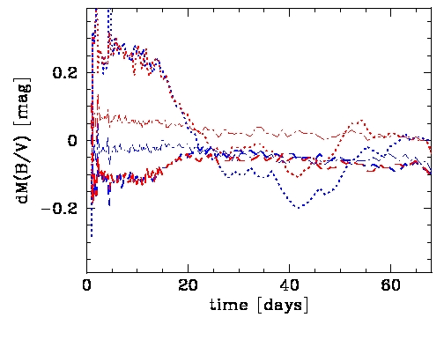
Figure 1. Modeled residuals for variations in progenitor main sequence mass, provided by P. Höflich. Times are given relative to the explosion date, with maximum light at approximately 18 days.
1.5 M_{solar}/0.02 (slash)
5.0 M_{solar}/0.02 (reference)
7.0 M_{solar}/0.02 (dotted)
5.0 M_{solar}/0.00 (slash-dot).
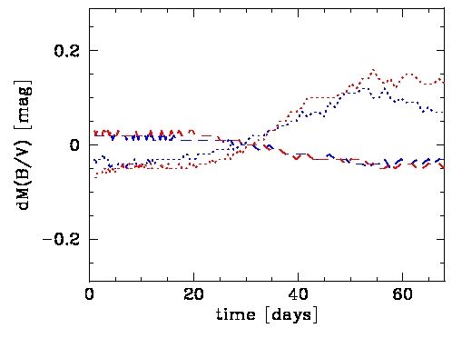Figure 2. Modeled residuals for variations in progenitor central density, provided by P. Höflich. Times are given relative to the explosion date, with maximum light at approximately 18 days.
1.5E9 g/ccm (slash)
2.0E9 g/ccm (reference)
6.0E9 g/ccc (dotted)

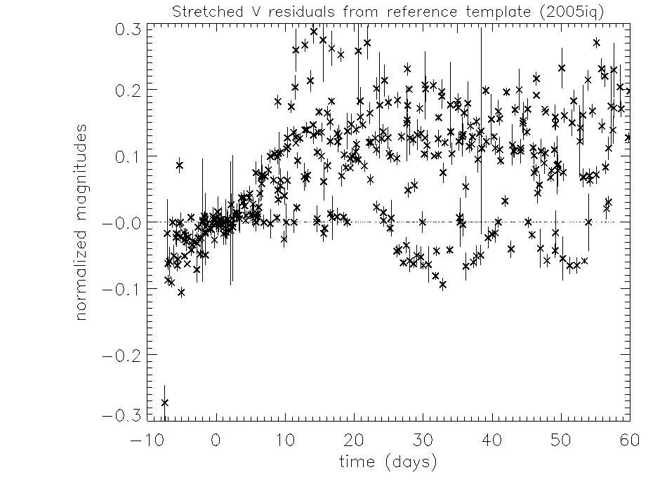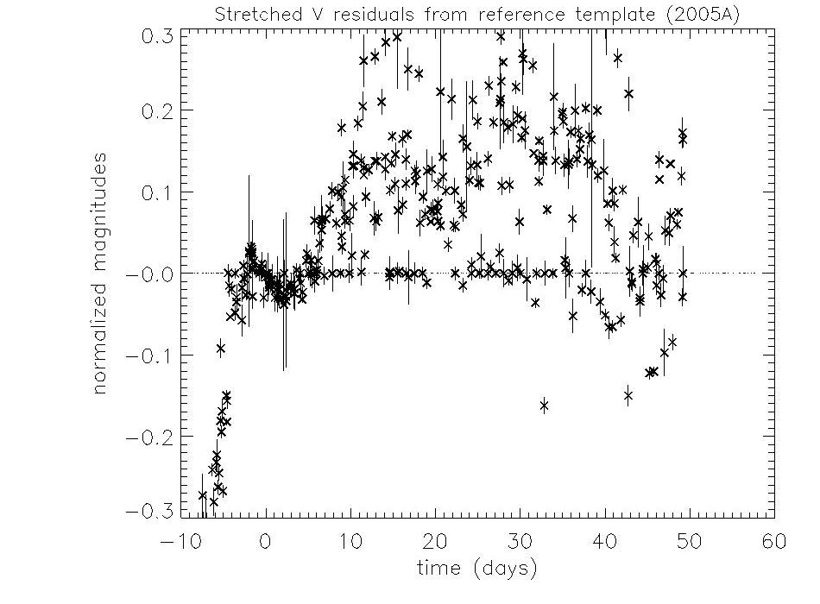
Figure 3. Reference template 2005iq. Figure 4. Reference template 2005A.
Times relative to maximum light. Times relative to maximum light.

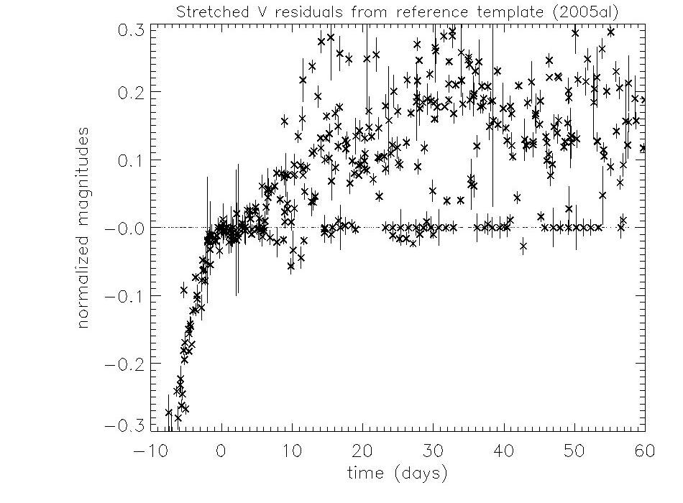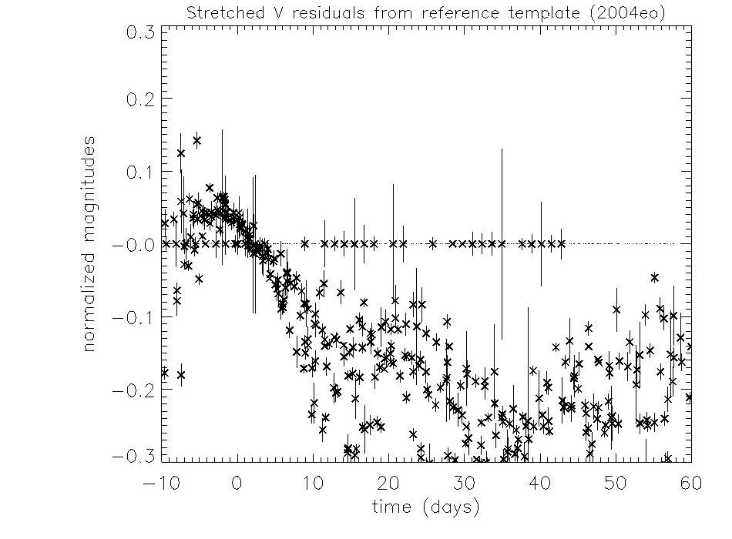
Figure 5. Reference template 2005al. Figure 6. Reference template 2004eo
Times relative to maximum light. Times relative to maximum light.

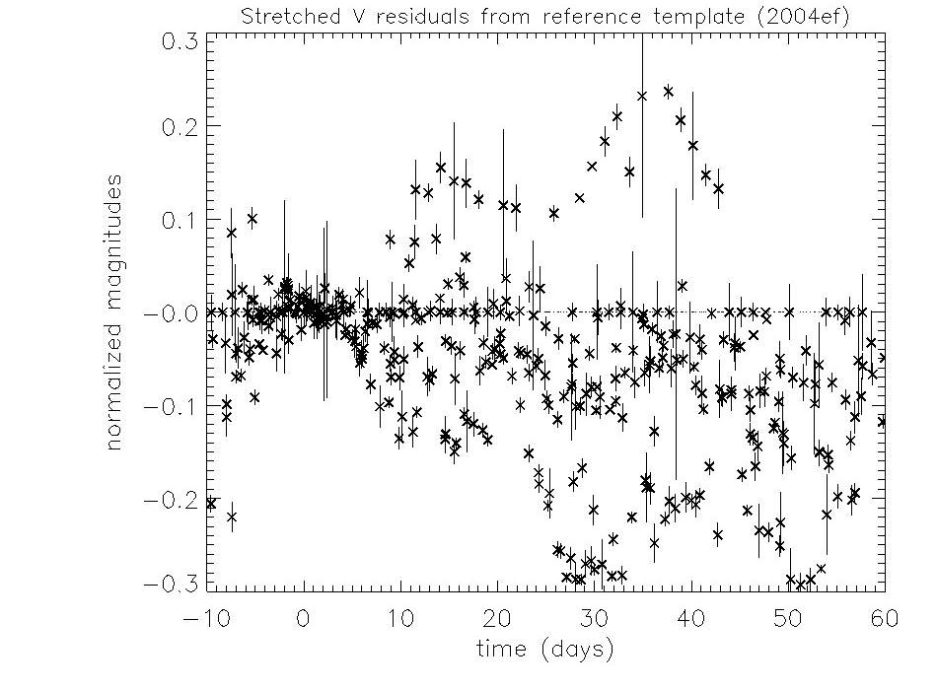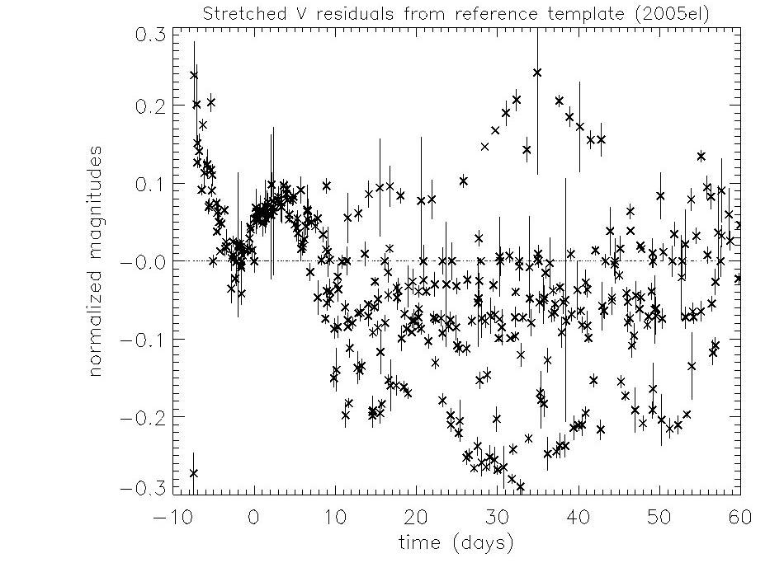
Figure 7. Reference template 2004ef. Figure 8. Reference template 2005el.
Times relative to maximum light. Times relative to maximum light.

The stretching is accomplished by dividing the time coordinates of the light curve data by the factor:

