Studies of Flat Gold Nanoparticles and Polyethylene Glycol Layers
Ernie Sanchez
Physics 4300 Capstone
Abstract
Two primary projects were carried out during my activity in SPM lab. The first is a collaboration with Schmidtke Group, chemical engineers at OU. The primary focus of the portion I aided in was to topographically analyse Polyethylene Glycol (PEG) layers deposited on substrate. Through usage of optical, scanning electron, and atomic force microscopy as well as ellipsometry, the method of sample production was improved and a thickness of PEG 500 was found to be on average 2 nm. Further investigation with protein added to the samples found the thickness to be about 6 nm. Further experiments may result in similar results for the PEG 5000 also used in experiment.
The second project is a collaboration with Min Zhou Group, mechanical engineers at UA. Initially samples of patterned Ni nanodots were analysed mechanically with the tribo-indenter, AFM, and SEM. More recently a project to determine the effects of nano-scale mechanical stresses on gold crystal structure was begun. Through repeated attempts important information was gleaned on parameters for the equipment to achieve the desired result. Flat gold nano-particles are applied on a transmission electron microscope grid and imaged with the TEM. Mechanical stresses are introduced to the gold crystals by the tribo-indenter, and subsequent TEM images are taken to determine the effects on crystalline structure. Initial results were obtained, however, for a particle not imaged before indention. A repeat sample was generated, and is currently being subjected to mechanical stresses, results pending.
Introduction:
The PEG project is designed to analyse particle flow in blood vessels and the interaction with the vessel wall that results from flow. In general the hope is to develop clean (smooth and clear) uniform surfaces of patterned PEG and protein. These surfaces will act as a simulation of blood vessel walls that have scattered interaction proteins and regions of non-interacting wall. The PEG does not interact with many proteins and patterning a surface with this and the protein allows for a good simulation, provided the thicknesses of the two layers (PEG and protein) are similar. This is where SPM lab enters the procedure. Utilising equipment available to SPM, we are able to charaterise the thicknesses of the layers involved. The primary tool used was the atomic force microscope (AFM). With this, we were able to achieve excellent results towards the goal of modeling blood flow.
A result of this research could be improved understanding of what parameters affect cell and blood vessel wall interactions. This knowledge may lead to breakthroughs in medical fields that deal with cardio-vascular pathologies, for example atherosclerosis. Aside from that, the experiment gives important information on flow factors for micron scale structures.
The second project utilizes the tribo-indenter equipment that UA has. This is an ongoing collaboration that has resulted in several papers. Up to this point the combined efforts have focused patterned surfaces of Ni nanodots. The idea, which has been supported by the findings thus far, is that computer hard drives might be greatly improved in efficiency by replacing the currently flat platters that store data, with patterned Ni nanodots to store the information on. Previous experiments focused on factors like frictional interactions and moduli of the nanodots. The current project is an extension of this study, designed to hopefully give information on optimizing crystal hardness. In the absence of this result, the information gained concerning crystal damage introduced by mechanical stresses may prove invaluable in itself.
Apparatus and Design
The PEG project utilized photolithography to generate patterned lines and a removable sphere procedure to generate dot patterns in PEG monolayers. These aspects of the project were done by chemical engineers, but were optimized by feedback provided with imaging by microscopy. The photolithography used a mask with lines of varying thicknesses, and allowed PEG to be patterned on both glass and Silicon slides.
Optical, Atomic Force, and Scanning Electron microscopes were all used in analysis of these samples. Optical microscopy uses a conventional light microscope. Light is emitted onto or through the sample (depending on substrate) and lenses focus the light and magnify the image. The optical microscope magnifies from 10x to 100x, and was mostly used to determine dust contamination and cleanliness of the sample.
Topographical information was supplied mainly by the AFM. The Atomic Force microscope uses a Si cantilever driven at a resonant frequency to interact in the attractive regime of the Van der Waals force. A laser is bounced off the cantilever onto a detector. A feedback system keeps the signal at a constant by adjust the height of the scanner with piezo electrics. The alterations in scanner height are used to generate images of the sample in high precision resulting in 3D data. The cantilever is raster scanned over the sample to image the full area. The AFM can also scan in the repulsive regime of the Van der Waals by coming in direct contact with the surface and image in that fashion, however, it is less sensitive not the preferred approach.
The scanning electron microscope uses an electron beam scattered off of a sample to image the topography of the sample and its composition. The electron beam is focused by electromagnetic lenses to a sharp point. Finally the beam is raster scanned over the surface to image. Secondary electrons give topography images, however, this is 2D as opposed to AFM. Backscatter electrons can give composition information of the sample. The SEM requires conductive samples to operate properly.
The gold nano-particle study also utilized optical, AFM, and SEM analysis. In addition Transmission Electron microscopy and the UA Tribo-indenter were key to the desired results. Optical microscopes were used to check that shipped samples were not damaged in transit. The AFM will be used to characterize surface effects of the mechanical stresses, and possibly reproduce the experiment on a small scale. The SEM allowed us to identify target particles on the TEM grid.
The TEM uses a high energy electron beam transmitted through a sample to image the internal structure of the sample. The electron beam penetrates the sample and passes through it. However, some of the electrons are diffracted off at given angles related to the crystal structure and orientation they encounter. The resulting images serve as a type of ‘X-ray’ of the sample, allowing one to see the inside and get information about the crystalline structure. This requires both very thin samples and thin supports for the samples to be placed on. The supports are in the form of TEM grids available commercially. The ones used in the study were primarily Silicon nitride grids about 50nm thick.
Another key component for the study is the UA tribo-indenter. The tribo-indenter operates similar to the AFM in the repulsive regime to raster scan the sample. However, the tribo-indenter is designed to deliver large mechanical stresses on the the nano-scale. The tip used is about 30 nm in radius of curvature, and is connected to a plate betwixt two capacitor plates. This system measures the capacitance across the plate to detect displacements. It is able to deliver from 0.5 to 100s of micro Newtons.
Procedure
Initially samples of PEG patterned surfaces on glass slides were analysed. The patterning was achieved through both photolithography and a process involving removable beads. Photolithography was mostly employed on the samples of PEG 500, while beads were employed on PEG 5000. Refinements in cleaning and curing the samples were developed throughout the project with subsequent samples. In each case samples were provided to SPM lab to characterize. A key refinement made was to begin optical microscopy of new samples as an initial step to check the cleanliness of the sample.
Primary analysis was done with the AFM. Preliminary scans were complicated by a lack of communication regarding the pattern of lines. After clarification, scans were made easier by better navigation to get scans of the large (20 micron) and small (2 micron) lines on each sample. A series of scans started returning the same value after uniformity was achieved with refined synthesis. Around this time SEM and elipsometry were added to the procedure to further characterize and measure thickness respectively.
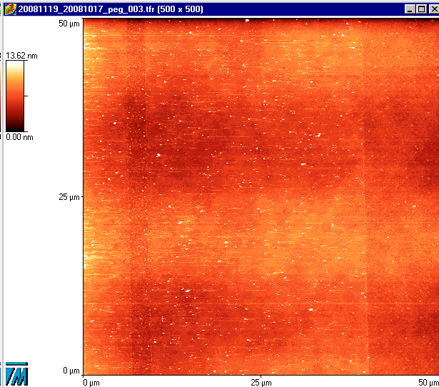
Sample AFM scan of PEG on Si 2 and 20 micron lines
Finally AFM data was imported to Matlab where it was quadratically leveled and sections were averaged into in a single contour line for analysis. The results for PEG thickness have consistently been about 2 nm. The process was repeated with samples that had protein applied to the bare substrate, and the resulting thickness was found to be about 6 nm.
Our initial procedure for the gold nano-particle project was to first reinforce the TEM grid. We believed it was important to reinforce the grid to withstand the large loads associated with the mechanical stresses. The requirement is then to TEM the particles, reinforce the grid, indent on them, remove the reinforcement, and image again. Initially we considered reinforcing the grid with either Barium Fluoride or super glue. We found, however, the reinforcement generated stresses on the grid itself. The complications arising from reinforcement caused us to try the experiment without reinforcement.
To that end we took a sample TEM grid out to UA to perform tests on it to see if we could indent without reinforcement. We gained important information on what settings to run the tribo-indenter on, and felt that it was not necessary to reinforce. Having gained the needed information on tribo-indenter settings, we proceeded to apply particles on a similar TEM grid. SEM was done to find suitable particles for the experiment. Initially we had troubles with the nano-particle solution, and had to reapply the solution several times. Finally we found usable particles, and mapped them out for UA collaborators. TEM images were taken of the candidate particles, and the sample sent off for indention.
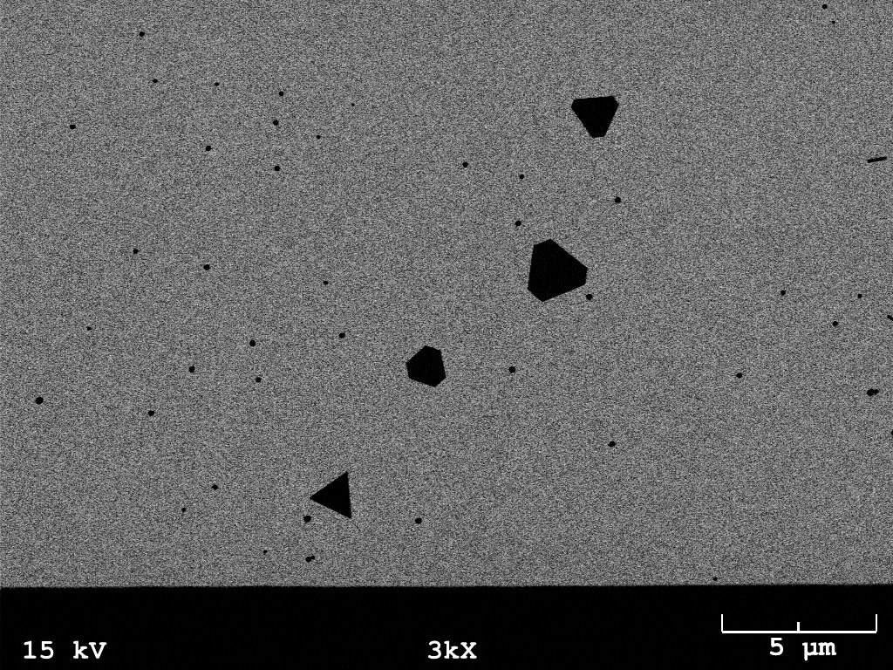
P1
P3
P2
SEM of Gold nano-particles on TEM grid with suggested indent locations in red
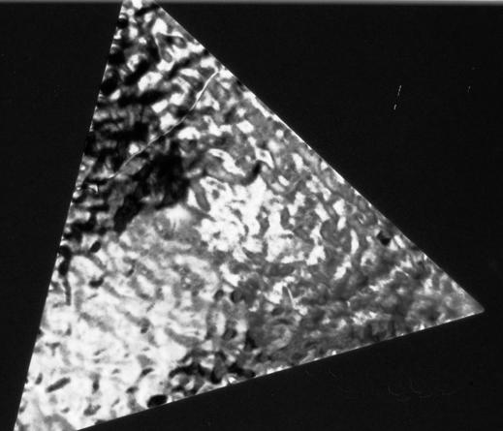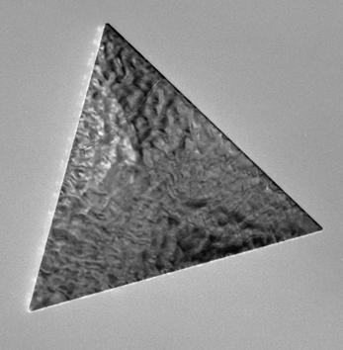
500 nm
TEM image of
Gold Nano-Particles
Bright and Dark Field
Unfortunately, we found out when they attempted to image, that the tribo-indenter could not image far from the edge. Reliable imaging can be done with the tribo-indenter within a 10 micron strip along the edge of the window. UA did tribo-indent on a particle they were able to image, but no pre-indent images were made.
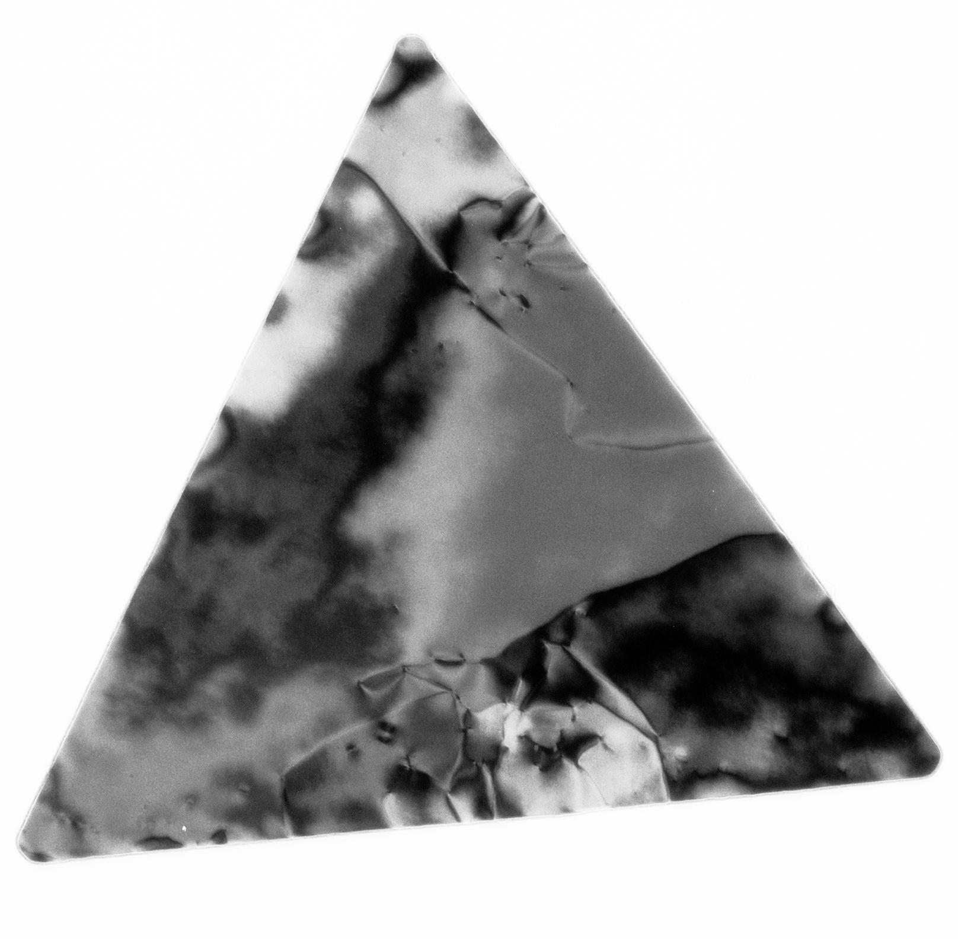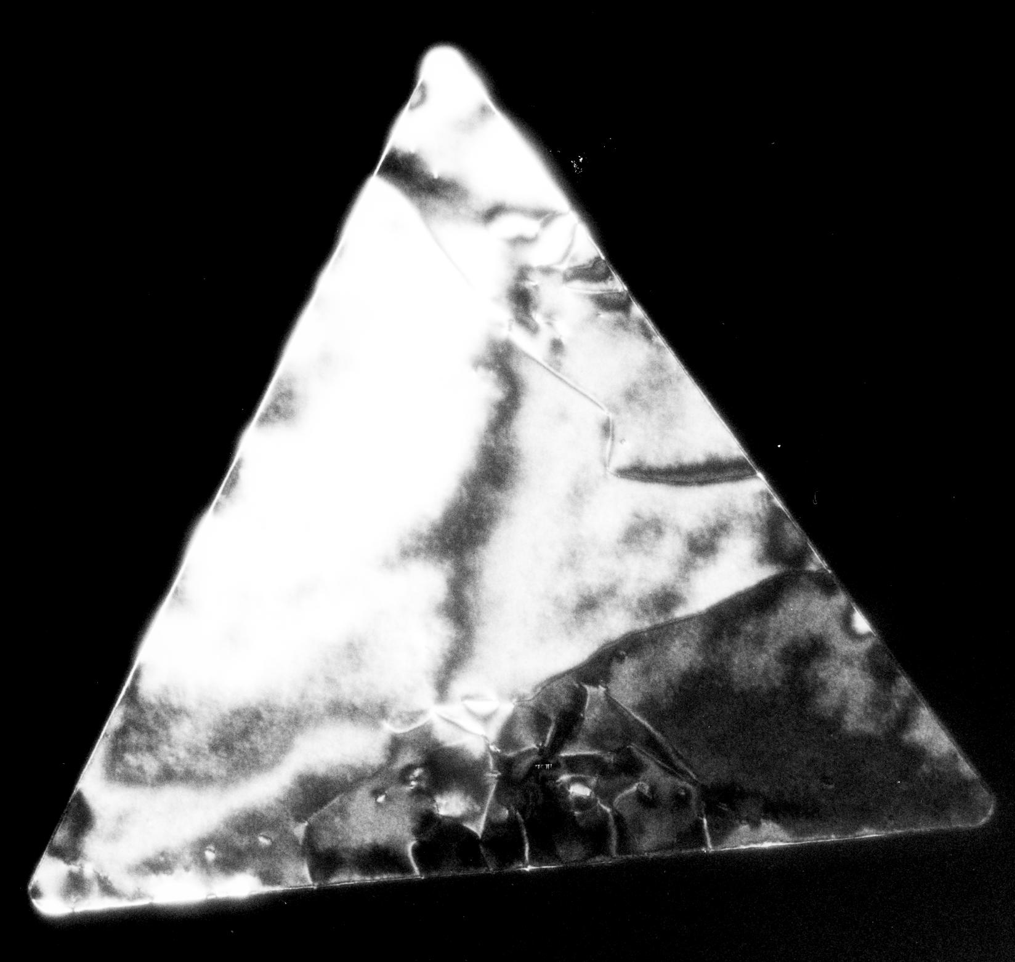
500 nm
11 μN (300 nm)
5.5 μN (150 nm)
500 nm
5.5 μN
(150 nm)
11 μN (300 nm)
TEM Bright Field TEM Dark Field
The results are promising, but we must repeat the experiment to get both before and after TEM images. The project is about halfway to completion of the first experiment. We have a new sample and have taken TEM images. It is currently in UA being indented, and will be returned presently for post indent imaging. If successful, the experiment will be repeated and may be reproduced with the AFM as the indenting tool. While the AFM can not generate as severe a load, it can generate high pressures as the contact area is much lower (tip radius of curvature 1/3 that of the tribo-indenter). The benefits are fast turn around, since no mailing is required.

Models and Calculations
Models employed include an excel spreadsheet using solid mechanics equations to model deflections of cantilevers and double fixed beams. These models were used to analyse the AFM cantilever and the TEM grid. The grid was simplified to a double fixed beam. Other calculations were employed in the Matlab analysis. Matlab flattened the raw AFM image data to remove curvature of the scan process (similar to the VECCO programme controlling the AFM) and to collapse the selected lines into one average line. Further averaging was done over sections of the line to get values for given intervals.
Results and Discussion
The overall results from the PEG project determined that the average thickness of a PEG 500 layer is about 2 nm. In addition the protein layer is about 6 nm thick. Thus the ridges formed with the PEG patterned surface are nominal compared to the micron scale particles that are used to study flow across the surfaces. The vertical resolution of the AFM is on the order of 4 Å.
0
4
Y [μm]
-4
0
4
0
10
20
30
40
50
60
70
X [μm]
Z [nm]
0
20
40
60
80
-4
0
4
X [μm]
Z [nm]
0
4
Y [μm]
PEG on Silicon PEG and Protein on Silicon
Final results on the gold nano-particle project are still pending, however, initial results are promising. Expanded crystal defects in the one particle properly indented lead us to believe that valuable results are forthcoming. Moreover, we have important results for what conditions the tribo-indenter can operate under. The tribo-indenter can only image within 10 microns of the edge, and is most reliable in displacement mode versus load.
Conclusions and Summary
The results gained for the PEG project have allowed the continuation of the chemical engineering experiment on flow parameters for neutrophils in blood. By verifying the difference in PEG and protein layer thicknesses is on nanometer scale, the results can be better understood. Furthermore, the refinements made in sample preparation from the trials performed will also allow for reliable results in future PEG studies. Finally the inclusion of other forms of microscopy to characterize the samples has proven so effective, that it is likely to be the standard approach from now on.
The gold nano-particle study is proceeding in good order and will have results of some kind very soon. Results gleaned thus far for the tribo-indenter and its application on samples such as the TEM grid make the indenter a more versatile research tool. The project has changed noticeably since its initiation. The exclusion of reinforcement and the resulting crystal deformation are the biggest changes thus far. We shall be in a position to further the project as soon as the sample is received.
Acknowledgements
Advisor Dr Matthew Johnson
Research Scientist Dr Joel Keay
Graduate Students Mark Curtis and Jeremy Jernigen

