Detecting Transits of Extrasolar Planets and their Moons

Alea Smith
Capstone Research Paper
12/19/2008

For the last twenty years, exoplanet discoveries have increased exponentially as detection techniques are improved and better understood. An extrasolar planet, also known as an exoplanet, is a planet in orbit around a star other than the Sun. Researchers are finding that there are many systems like our solar system in the universe. So far there have been over 300 exoplanets detected. There are a few methods for detecting exoplanets but my research focused on observing the transits of exoplanets. Transits give a lot of valuable information about the planet and the star it orbits. The purpose of the project was to gather more data on a planet known to transit its parent star with an amateur telescope. Larger telescopes can be very expensive to operate and are in high demand, so it is more difficult to get observing time. The second part of my research was to use information from transits to determine what types of moons exoplanets are capable of supporting.
It has been estimated that approximately one out of every ten main sequence stars have planets orbiting around them. Most of the planets that have been detected are much more massive than Earth. They are more similar in size to Jupiter, which is nearly 300 times more massive than Earth and has a radius close to eleven times larger than Earth. The exoplanets have been observed to orbit very close to their parent star. This is abnormal for such large, Jupiter-like planets. In our solar system, Jupiter formed far away from the Sun and its orbit has remained at a far distance. These star-exoplanet systems may not necessarily be more common. It is possible that they are only easier to detect because of their large size and short orbital period.
There are several ways to detect extrasolar planets. One method is using direct detections. However, this is not a very good method. Stars similar in brightness to the Sun are too bright for an orbiting planet to be seen. The light from the star overpowers the light reflected from the planet. A few images of extrasolar planets have been taken around Brown Dwarfs, which are cooler and smaller than typical stars. However, even these images are not particularly helpful because they give little information about the planet itself.
Another method is using indirect detection. The most common type is the Doppler Technique. Over 200 of the detected exoplanets have been found using this technique. As the planet orbits around its parent star, it causes the star to wobble around its center of mass. The star and the planet have the same center of mass which is not the center of the star. As the star moves in its orbit towards the observer the light detected is blue shifted and as the star moves away from the observer in its orbit the light is red shifted. When an observer detects this Doppler Shift, they can assume that something is causing the star to wobble around its center of mass. This shift could be due to an exoplanet.
With the resources available at the University of Oklahoma, neither of the preceding techniques is possible. Instead, I indirectly detected the exoplanet by observing a transit. A transit is when a planet passes in front of a star and blocks some of the light emitted from the star. This can be observed in the periodic dimming of the light curves from the star. A light curve is a graph of light intensity of a celestial object as a function of time. When the star is not in front of the planet, the light curve is flat. As the planet begins to transit, the light observed begins to decrease. When the planet is directly in front of the star, the amount of light emitted is at a minimum.

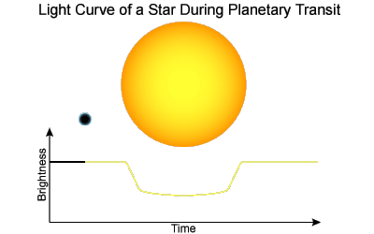
Jupiter is approximately 1/10th the radius of the Sun, so a typical exoplanet will block approximately 1% of the star’s light when the planet passes in front of the star. The larger the planet compared to its parent star, the greater the decrease in light observed from the star. To be able to observe a transit, the planet and the star must be in the same orbital plane as the observer. This occurs in approximately one out of every few hundred star-planet systems. Over thirty extrasolar planets have been detected using this technique.
The occurrence of the light curves’ smooth edges as the planet begins to transit the star instead of an abrupt vertical drop in the observed light can be explained by limb darkening. Limb darkening is due to a decrease in intensity from the center of the star to the edge, or the “limbs” of the star. This decrease in intensity is due to the decrease in density and temperature as the distance from the center of the star increases. This affect can be seen just after the planet is fully transiting and right before it stops transiting. When the planet blocks light from the edges, the light is not as intense as it is in the center so it will not be blocking as much light as it would be in the center even though the planet is fully transiting the star.
For my research I observed TrES-3b. It was first discovered by TrES, Trans-Atlantic Exoplanet Survey. They have three, four inch, low resolution wide-field survey telescopes located at Lowell Observatory, Mount Palomar, and the Canary Islands. The cameras are capable of discovering a decrease in brightness in one small area of the sky around a star. However, they are incapable of determining whether the dimming is due to a small decrease in brightness from the brightest star or a large decrease in brightness from a very faint star in the field. Telescopes similar to the University of Oklahoma’s telescope are able to focus on candidate stars and see what is causing the decrease in brightness.
The goal of my research project was to observe candidate stars when possible transits were expected to occur. Then, using differential photometry, the measurement of changes in the brightness of an object compared to other nearby objects, interpret the light curves compiled from the data for the object. To complete the research, I used the University of Oklahoma’s four meter LX 200 telescope with an AP7p charge-coupled device (CCD) camera.
TrES-3b was first detected in 2007. It is located 800 light years away in the constellation Hercules. It is 1.92 times the mass of Jupiter and has 1.295 Jupiter radii. It has a period of 1.306 days and reduces the light observed from the star by approximately 2.98%. Its parent star has 0.9 solar masses which is roughly the size of the Sun. The period of TrES-3b is incredibly short compared to planets in our solar system. It is very similar to Jupiter but Jupiter has an orbital period of twelve years while TrES3-b takes only 1.3 days. There are many exoplanets with orbital periods similar to TrES-3b even though this discovery was unexpected.
Once I observed the star field of TrES-3b and detected the transit I used IRAF, Image Reduction Analysis Facility, which is software used for image reduction and the analysis of data. Besides the image of the star field, it is also necessary to take a flat field image and a dark image. A flat field is an image of a uniformly illuminated surface. It records imperfections in equipment such as difference in sensitivity of pixels or dust on the CCD. A dark image is an image taken with the shutter closed. It records any noise in the CCD. To get the final calibrated image, subtract the dark image from the raw image and divide the combined image by the flat image.
To detect the transit, I took 110 images with 60 second exposures each for a total observation time of 1.83 hours. I used four other stars of similar magnitude in the star field to compare to the magnitude of TrES-3. I obtained two light curves. To get the light curve of TrES-3, I subtracted the magnitude of one of the stars of similar magnitude from TrES-3 to see the difference in magnitudes over time. This light curve shows a dip as the exoplanet passes in front of the star. I created the second light curve as a comparison. To obtain this light curve I subtracted two stars of similar magnitude in the same star field as TrES-3. Since neither star had a transiting exoplanet, their magnitudes were constant with time so subtracting them gives a flat light curve. The scatter in the plots is noise. There are several possibilities for the source of noise. The most likely possibility is that it is due to photon statistics.
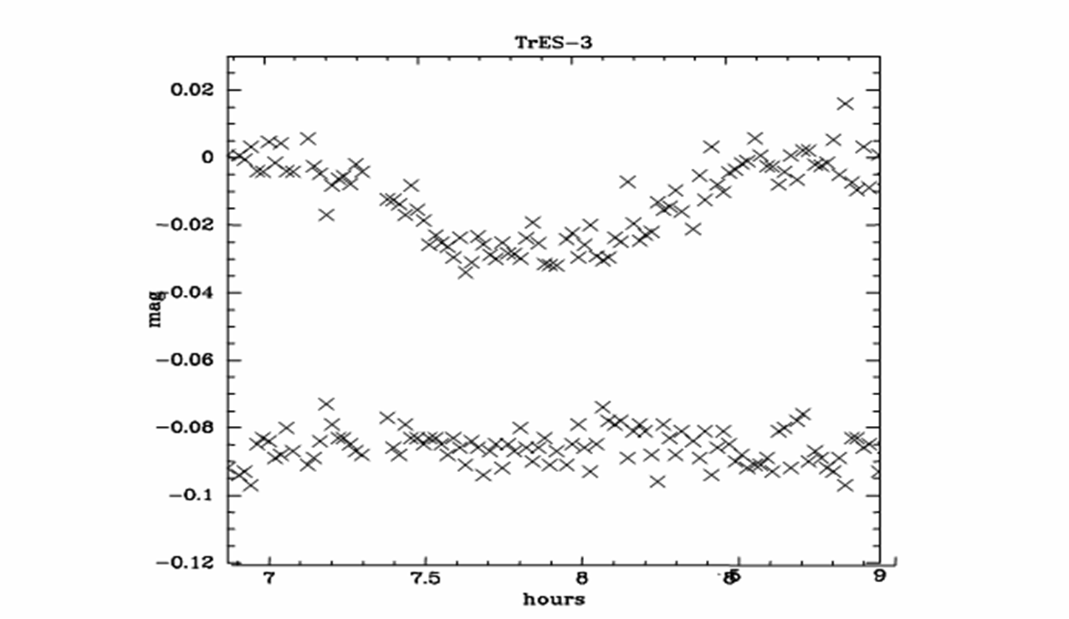
The second part of the project was to consider transiting exoplanets that also had a moon. Moons are too small for direct observation. To detect the moons, observers have to look at the timing of their transits. The goal was to determine limiting factors for being able to detect the moon of a transiting exoplanet. To do this I created a hypothetical star-planet-moon system. I varied one parameter at a time to see how it affected the limiting magnitude. The parameters I chose to vary, that made the most impact on the limiting magnitude, were the period of the planet, the period of the moon, the mass of the planet, the mass of the moon, and the mass of the star. The original system has a planet with a period of one year, a moon with a period of one month, a planet with a mass equal to Jupiter, a moon that is 1% the mass of the planet, and the mass of the star equal to the mass of the sun.
When a planet has a moon, it changes the center of mass of the planet and affects the transit time of the planet as it passes in front of the star. If a planet has a moon and the planet transits the star before the moon, then the transit occurs earlier than it would have if there had been no moon. This is because the center of mass of the system is no longer the center of the star but has been shifted towards the moon.
X_{cm}
XCM
In the reverse case, if a planet has a moon and the moon transits the star before the planet, then the transit occurs later than it would have if there had been no moon.
XCM
The first step in determining how large the difference in the transit time is compared to a planet without a moon was to calculate the center of mass of the planet-moon system. M_{p} is the mass of the planet and X_{p} is the position of the planet. M_{m} is the mass of the moon and X_{m} is the position of the moon.
$X_{\text{cm}}=\frac{M_{p}X_{p}+{\text{ M}}_{m}X_{m}}{M_{p}+{\text{ M}}_{m}}$ (1)
Setting X_{p}=0, X_{m} becomes the separation between the planet and the moon, a. The equation becomes:
$X_{\text{cm}}=\frac{M_{m}a}{M_{p}+M_{m}}$ (2)
Using Kepler’s Third Law to find a, with P being the period of the moon around the planet and G equal to the universal gravitational constant:
$a={\left[P^{2}G(M_{p}+M_{m})\right]}^{1/3}$ (3)
Plugging this into equation (2) gives the center of mass of the system.
The next step was to find the velocity of the planet-moon system in orbit around its parent star. An approximation had to be made that assumed that the orbits of the planet-moon system and the planet-moon-star system are circular. This means that the semi-major axis is equal to the separation between the planet and the star. One circle equals 2Π radians, so to determine the velocity I had to multiply by the separation and divide by the orbital period. The orbital velocity of the planet and moon around the star is given by:
$v=\frac{2πa}{P}$ (4)
Knowing the velocity and the center of mass allows us to calculate the difference in the change in the transit time compared to a planet with no moon:
$Δt=\frac{X_{\text{CM}}}{v}$ (5)
From this equation, it is clear that the change in transit time is directly proportional to the center of mass. So, as the change in the center of mass increases, the change in the transit time also increases.
Once the change in the transit time caused by the moon had been detected, the next step was to calculate the minimum number of photons needed for a given telescope to detect this change. A typical decrease in light observed from a star when a planet transits in front of it is approximately one percent. To be able to detect the change in a typical star, the maximum amount of error should be approximately half of a percent. If the error is greater than this it would be nearly impossible to detect the transit. Error is equal to one divided by the ratio of signal-to-noise:
$\text{Error}=\frac{1}{SN}$ (6)
An error of half of a percent corresponds to a S/N = 200. The number of photons detected per second is equal to the signal-to-noise squared:
$\text{min} \text{number} \text{of} \text{photons}={\left(SN\right)}^{2}$ (7)
The telescope needs to detect at least 40,000 photons over the duration of the difference in the transit time. To be able to detect the change in the transit time there needs to be at least two exposures taken during that change so that it can be resolved. To get the minimum number of photons needed per second to detect the change in the transit time, divide 40,000 by the change in transit time divided by 2:
$\text{min} \text{number} \text{of} \text{photons}\text{/sec}=\frac{\text{40},\text{000}}{Δt2}$ (8)
After finding the minimum number of photons needed per second to detect a change in transit time, the next steps was to determine the limiting magnitude for the system. This means that for a given star-planet-moon system using the University of Oklahoma’s telescope, I wanted to find the faintest stars that an observer would still be able to detect moons around. These calculations allow observers to establish whether or not certain telescopes are capable of detecting the change in transit time and therefore, a moon around stars of different magnitude.
To do these calculations, I used an equation that relates the number of photons received from Vega, P_{Vega}, to the star being observed. There are 970 photons detected per cm² per Angstrom per second from Vega. I assumed a telescope with an aperture of 40 cm like the University of Oklahoma’s telescope. The CCD camera detects approximately 80 percent of the incoming photons, Q. I used a V-filter with a width of 800 Angstroms, Δλ. The terms r^{n} and t^{m} are correcting factors for the fraction of light reflected from metal in the telescope and light passing through the glass. Both r and t can be approximated as 0.9 and n and m can be approximated as 2. The extinction coefficient, k, is approximately 0.2 for the V passband and the airmass, X, is approximately 1. Using these values and knowing the magnitude of the star, the following equation allowed the number of photons/ sec for a specific telescope to be detected:
$\text{Photons}\text{/sec}=P_{\text{vega}}{\text{QA}}_{\text{tel}}{Δλr}^{n}t^{m}{\text{10}}^{−0\text{.}4\text{Xk}}{\text{10}}^{−0\text{.}4(\text{mag})}$ (9)

Inserting equation (8) for the minimum number of photons needed per second into equation (9) and solving for the magnitude, mag, gives the faintest magnitude that the telescope is able to detect and still see the change in the transit time caused by the moon:
$\text{Limiting} \text{magnitude}=\left[{\text{log}}_{\text{10}}\left(\frac{\text{min} \text{of} \text{photons}\text{/sec}}{P_{\text{Vega}}{\text{QA}}_{\text{tel}}{Δλr}^{n}t^{m}{\text{10}}^{−0\text{.}4\text{Xk}}} | \right)\right]\left(−0\text{.}4\right)$ (10)
To better understand what types of values we are dealing with, I first did these calculations using a planet with a mass and radius of Jupiter, a 10th magnitude star, and a moon with one percent the mass and radius of the planet. The period of the planet I set to be one year and the period of the moon equal to thirty days. Using these values, I determined that the center of mass of the system lay right outside of the planet, approximately 1/100th of the total separation between the planet and the moon. Finding the separation, a, between the planet and the star I was able to calculate the velocity. From this I determined that for these values, the change in transit time is approximately fifteen and a half minutes. This gave a limiting magnitude of approximately 16.7.
These values allow observers to know whether or not their telescope would be able to detect a transiting planet’s moon if one existed. The next step was to create a spreadsheet of all different limiting magnitudes for certain situations. I only changed one variable at a time to see what affected the limiting magnitude the most.
In the first two scenarios I varied the periods. As the period of the objects increases, the change in the center of mass also increases. When there is a greater change in the center of mass, the change in transit time is also greater.
In the first scenario, I varied the period of the planet. Exoplanets have been found with a period as short as one day to periods greater than Jupiter at eleven years. I changed the original value of one year and varied the period over the range of one day to twelve years. The graph of the period verse the limiting magnitude showed that fainter stars are seen when planets have a longer period. The limiting magnitude changed from 10.7 to range from 8.5 to 11.6 magnitudes.
In the second scenario, I varied the period of the moon. I changed the original value of thirty days to a range from one day to nine years. The graph showed that fainter stars are seen when moons have longer periods. The limiting magnitude changed from 10.7 to a range from seventeen 8.2 to 14 magnitudes.
For the next calculation, I varied the mass of the planet. It had an original value equal to the mass of Jupiter because most exoplanets discovered have been similar to the mass of Jupiter. Earth is approximately 1/300th the mass of Jupiter. Although no exoplanets have been discovered as small as Earth, it is possible that they exist. So I varied the mass of the planet to range from 1/300th the mass of Jupiter to ten times the mass of Jupiter. The data shows that fainter stars can be seen with planets of smaller mass. Analyzing this information using the center of mass and Kepler’s Law shows why this is true. As the mass of the planet gets smaller and the mass of the moon is kept constant, the change in the center of mass of the system increases and there is a greater amount of time difference detected during the transit. The limiting magnitude changed from an initial value of 10.7 to a range of 9 to 14.
Next, I determined how changing the mass of the moon changed the limiting magnitude. The original value of the mass of the moon was equal to the mass of the Earth’s moon. I varied the mass over a range from 10^21 kg to 10^24 kg. This showed that fainter stars can be seen as the mass of the moon increases. Again, considering how the center of mass changes as the mass of the moon increases, moons around fainter stars can be observed as the mass increases and the change in transit time increases. The limiting magnitude changed from an original value of 10.7 to a range of limiting magnitudes from 6 to 13.5.
Nearly all of the exoplanets that have been discovered have been in orbit around a star on the main sequence. The mass of main sequence stars range from 1/10th of a solar mass to forty solar masses. I changed the original value of one solar mass to this range of masses to determine how the limiting magnitude can vary. The graph showed that moons around fainter stars can be observed as the mass of the star decreases. The planet will be larger compared to its parent star so it will block more light as it transits. The original value for the limiting magnitude changed from 10.7 to a range from 9.3 to 11.5.
From the information I have gathered, using the University of Oklahoma’s telescope, by varying one parameter at a time, moons can be observed around stars as faint as 14 magnitudes. These equations allow observers to determine, for a given star-planet system, whether or not they would be able to observe moons around the planet. Determining these relationships and gathering a better understanding of transits allows people to learn more about the exoplanets and moons in our universe.

Bibliography

Gary, Bruce. Exoplanet Observing for Amateurs. 1st ed. St. Louis, MO: Mira Digital Publishing, 2007.

Romanishin, W. An Introduction to Astronomical Photometry Using CCDs. Norman, OK: Univeristy of Oklahoma, 2006. 1-175.

