1. Define a Problem
- Discuss possible problems to address with your Advisor.
- What is the background of these problems?
- What is the motivation for their solution?
- Details of the problem may develop/change over the course of your Capstone.

Cerebral Palsy greatly inhibits motor control in infants, which in turn hinders the development of spatial reasoning and early cognitive development. The National Robotics Initiative research group at OU has developed the Self-Initiated Prone Progression Crawler (SIPPC), designed to help children with Cerebral Palsy learn to crawl. Kinematic reconstruction of the infant’s movements during trials is available, but this data doesn’t provide any dynamic information. We want to develop a dynamic model of an infant for simulation. This model should be able to provide dynamic information such as the forces and torques generated by the infant using the already available kinematic data.

2. Brainstorm
- With your Advisor brainstorm possible smaller “starter problems” and steps toward the full solution.
- Develop preliminary ideas.
- Present ideas in an open forum.
- Record all ideas.

- Choose a simulation environment for the project. See if any models have already been developed.
- Check to see if any work has been done previously on developing simulations of infant movement.
- Develop a model that can be simulated in Gazebo, as I already have experience with both ROS and Gazebo.
- Experiment with controller a simulated model in Gazebo. Develop a simple plugin for interfacing with the model in simulation. Try to move an arm up and down.
- Develop a code structure for passing in data to the simulated model.
- Develop code for reading and parsing kinematic data in preparation for use in controlling model.

3. Research
- Find good resources (text books, tutorials through papers) to introduce you to the background of the problem/ subject.
- Find resources directly associated with the problem itself.
- Are there solutions out there?
- Research solutions that may already exist (products available, patents etc.)
- Identify shortcomings and reasons why they aren’t appropriate to a given situation.
- Keep good notes/references, compile ideas and report findings to the team/Advisor.

- Research has been made into work done on developing dynamic models for infants. No papers over the subject were found. Papers were located on the mass and inertia of infant appendages though, which have been used in the project.
- Located a promising simulator for the iCub robot, but the iCub simulates a much older child than we need for this project. Unable to find a way to shrink the iCub model in simulation, so forced to develop own model.
- Read through John Craig’s “Introduction to Robotics: Mechanics and Control” in order to develop a better background on robot manipulator mechanics, coordinate conventions, rigid body transformations.
- Read through several theses, presentations put together by NRI researchers to get a better grasp of the SIPPC project and the techniques being explored for helping infants with Cerebral Palsy.
- Investigated methods used in robotics for control and movement learning. Investigated the types of controllers being used and how they function.
- Investigated machine learning algorithms and how they are used in robotic movement learning. Particularly learned about Feedback-Error Learning algorithms.

4. Identify Criteria and Specify Constraints
- Identify what the solution should do and the degree to which the solution will be pursued.
- Identify constraints: e.g., time/ cost/ size/ weight/ safety/ computation time etc.
- Make a brief summary.

- Want to develop a dynamic model of an infant. This model should be able to provide approximate dynamic information such as the forces and torques generated by the infant using the already available kinematic data.
- Developed system will utilize ROS Groovy and Gazebo version 1.9.
- Utilized ROS Groovy as it has improved communication between ROS and Gazebo
- Chose to use open source software as it is available free of charge and is widely available.
- Used free SVN hosting on Assembla.com to maintain project code.
- Worked with advisor to write preliminary abstract over what the goals of the research would be

5. Explore Possibilities
- Consider further development of brainstorming ideas with constraints and tradeoffs.
- Explore alternative ideas based on further knowledge.

- Considered using ROS Fuerte with a previous version of Gazebo, as the computers available on campus only had ROS Fuerte installed at the time.
  - Decided not to use Fuerte as there were several issues with ROS-Gazebo communication with Fuerte
- Investigated several different alternatives for implementing the Feedback-Feedforward controller system
  - Investigated using Cooper and Ballard’s method outlined in their paper “Realtime, Physics based Marker Following”
  - Investigated using Feedback-Error Learning for implementing learning system

6. Select an Approach
- Review brainstormed information and answer any lingering questions.
- Narrow ideas down using a decision matrix.
- Decide on final idea, sometimes through consensus.

- After working with the iCub simulator for about a month, realized that the iCub’s dimensions could not be readily altered.
  - Discussed this issue with advisor and together decided to forgo using the iCub simulator and instead develop a model to use with ROS and Gazebo
- After discussing the methods in Cooper and Ballard’s work with advisor and other members of his research group and speaking with a graduate student that works with Cooper and Ballard, decided that their methods would not be the best to use in this system
- Instead chose to focus on creating Feedback-Feedforward controller system to be used along with Feedback-Error Learning

7. Develop a Design Proposal
- Explore the idea in greater detail (sometimes with annotated sketches).
- Make critical decisions such as: material types, manufacturing methods, or software.
- Generate through computer models detailed sketches to further refine the idea.

- Created preliminary flow charts to visualize the flow of information in the overall system
- Created preliminary flow charts to visualize the flow of information in individual system components, such as the controller system and the feedback-error learning system
- Finalized decision to use ROS Groovy and Gazebo 1.9
- Developed sketches of infant model that was to be developed
  - Included coordinate frames, lengths of links, relative position and orientation
- Gave presentation to advisor and research group that outlined the proposed system
  - Received feedback on system and made changes based upon their recommendations
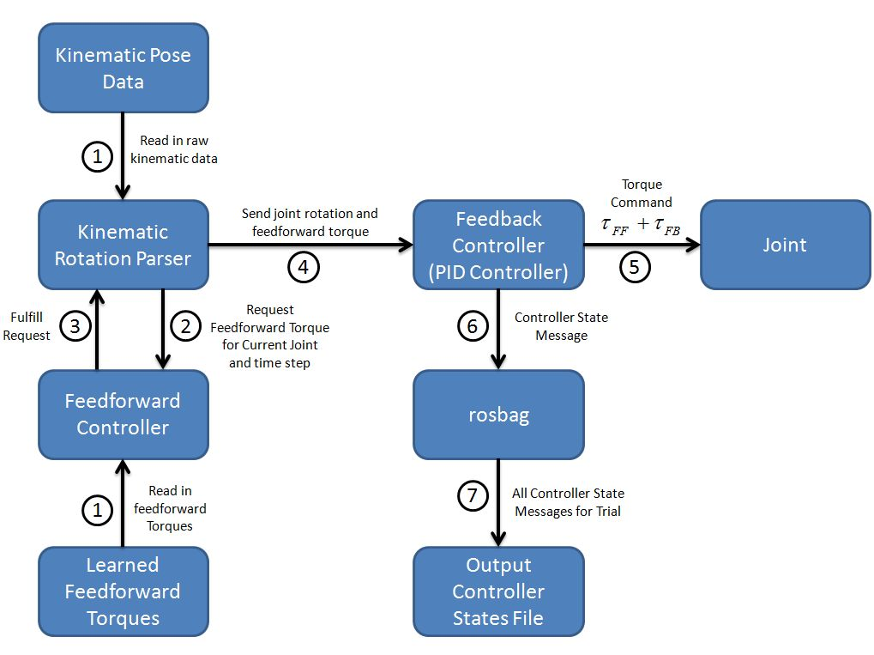
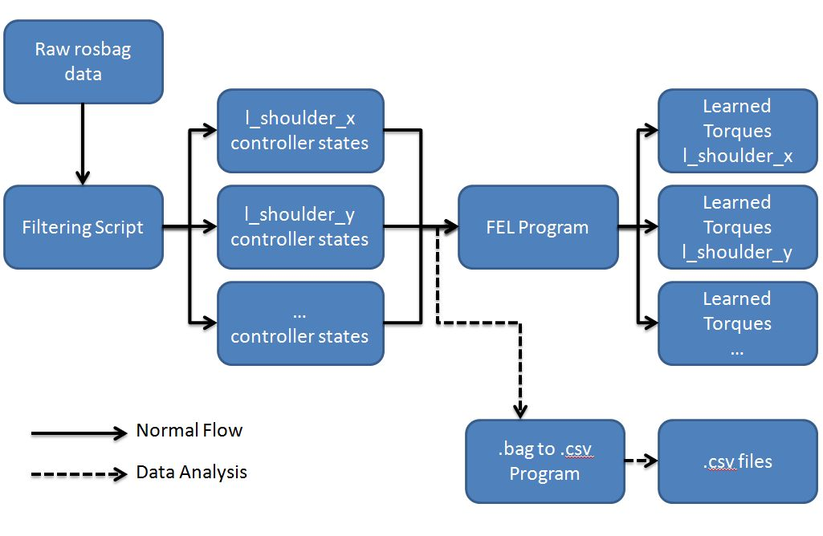
8. Make a Model or Prototype
- Make models to help communicate the idea, and study aspects such as shape, form, fit, or texture.
- Construct a prototype from the working drawings, so the solution can be tested.

- Developed early model for use with ROS
  - Familiarized myself with how to create models for simulation in Gazebo
  - Familiarized myself with how to develop models in URDF format
  - Visualized early designs in the program RVIZ
  - Used ROS packages to test the movements of the joints
  - Early model had very simplistic mass distributions for links
  - Could be spawned in Gazebo but not readily controlled
- Developed rudimentary communication programs to familiarize myself with how to communicate with Gazebo via ROS
  - Developed system for passing messages to Gazebo, commanding joints in Gazebo, getting feedback from Gazebo on how the joints moved
- Developed code necessary for implementing the Feedback-Feedforward controller scheme
- Developed .world files that would spawn the model in Gazebo
- Attached PID controllers to each joint of the model in order to move the joints in simulation

9. Test/Evaluate Design
- Design experiments and test the prototype in controlled and working environments.
- Gather performance data; analyze and check results against established criteria.
- Conduct a formal critique to flesh out areas of concerns, identify shortcomings, and establish any need for redesign work.

- Went through several iterations of testing model performance with RVIZ
- Looked through research papers to find method for better approximating the mass distribution for the model
- Received data from research colleagues that allowed me to fine-tune the lengths of the links in the model
- Tested overall system code and used collected data for analysis
- Obtained feedback on overall system design from advisor and research colleagues

10. Refine the Design
- Make design changes; modify or rebuild the prototype.
- Make refinements until accuracy and repeatability of the prototype’s performance results are consistent.
- Update documentation to reflect changes.
- Receive user’s critique to provide outside perspective to help determine if established criteria have been met.

- Corrected errors with infant model
  - Corrected errors where joints moved in incorrect directions
  - Corrected errors where model did not appear fully connected
  - Fine-tuned the position and orientation of links for the model so that the model would better resemble an infant
  - Oriented joint coordinate frames on model to be more consistent with how the frames are typically oriented in robotic systems
  - Put in more accurate figures for the link masses of the model
  - Fine-tuned the dimensions of the links of the model to better resemble an infant
- Corrected errors with controller system
  - Corrected errors where kinematic data was not parsed correctly
  - Corrected errors where feedforward torques were not being read correctly from file
  - Improved speed of system by eliminating the need to use the ROS package TF and by eliminating the need to make service calls between the kinematic rotation parser and the feedforward controller
  - Corrected issues with the feedback-error learning algorithm
- Developed shell scripts to help speed the data collection and testing process

11. Create or Make Solution
- Determine custom/mass production.
- Consider packaging.

- Corrected issues with system outlined above
- Functioning system available in the SVN repository on Assembla.com
- No plans for mass producing or selling the system

12. Communicate Processes and Results
- Communicate the final solution through media such as PowerPoint, poster session, technical report.
- What remaining work needs to be done.

- Wrote research report that outlined the developed system in detail and included the results of the research thus far
- Included section in report that outlines the limitations and issues with the current system and brainstorms how these issues may be rectified in the future.
- Presenting 30 minute PowerPoint presentation to research advisor and capstone advisor that provides an overview of the research completed

