Study Questions for Exam 1

1) The side of a cube is increased by 5%. The percentage increase of the surface area of the cube is,
a) 5%
b) 10%
c) 12%
d) 16%
e) 18%

2) The surface area of a sphere is increased by 8%. The percentage increase of the volume of the sphere is,
a) 5%
b) 10%
c) 12%
d) 16%
e) 18%

3) The length 4.221 cm is added to 0.01 cm. The appropriately rounded sum is, in cm,
a) 4.22
b) 4.2301
c) 4.23
d) 4.2
e) 4.21

4) A cube is 1.0 inch in length on the side. The volume of the cube is, in centimeter cubed,
a) 1.0 x 10
b) 8.4 x 10
c) 3.5 x 10
d) 1.6 x 10
e) 7.5 x 10

5) Two bricks are released from the top of a building. Brick A weighs twice as much brick B. Brick A is dropped and the brick B is thrown straight up into the air. Which statement is true regarding this situation.

A) Brick A accelerates faster than the brick B.
B) Brick B accelerates faster than the brick A.
C) The two bricks accelerate at the same rate during the entire time they are in the air.
D) The bricks have the same magnitude of acceleration but the accelerations are in opposite directions.
E) The two bricks have the same acceleration except for the instant when the brick B reaches its maximum height.

6) Which of the graphs of velocity versus time below shows the greatest constant positive acceleration?

A) B) C) D) E)
v v v v v

t t t t t

7) Two objects A and B accelerate from rest with the same constant acceleration. Object A accelerates twice as long as object B. Which statement is true concerning these objects at the end of their respective periods of acceleration?

A) Object A will travel twice as far as object B.
B) Object A will travel four times as far as object B.
C) Object A will travel eight times as far as object B.
D) Object A will be moving four times faster than object B.
E) Object A will be moving eight times faster than object B.

8) You drop a bowling ball from the top of a tall building. One second later, you drop a ping-pong ball from the same point. Neglecting air resistance, what can we say about the motion of the two balls?

A) The bowling ball will hit the ground more than one second before the ping-pong ball.
B) The bowling ball and the ping-pong ball will hit the ground at the same time.
C) The bowling ball will hit the ground exactly one second before the ping-pong ball.
D) The difference in their speeds will continually increase by 9.8 m/s every second.
E) The distance between the bowling ball and the-ping pong ball will remain the same until at least one of them hits the ground.

9) A train moves along a long straight track. The graph
to the right shows a plot of position (x) as a function of
time (t) for this train. The graph shows that the train x

A) doesn’t move at all.
B) speeds up all the time.
C) slows down all the time.
D) moves at a constant velocity. t
E) speeds up part of the time and slows down part of the time.

10) A 3.0 kg ball is thrown vertically into the air with an initial velocity of 15 m/s. The maximum height of the ball is,
a) 12.0 m
b) 11.5 m
c) 10.0 m
d) 9.5 m
e) 9.0 m

11) An object starts from rest with an acceleration of 2.0 that lasts for 3.0 seconds. It then reduces its acceleration to 1.0 that last for 5.0 additional seconds. The velocity at the end of the 5.0 seconds interval is,
a) 2.0 m/s
b) 3.0 m/s
c) 4.0 m/s
d) 5.0 m/s
e) 11.0 m/s

12) A ball is thrown straight up into the air. At its maximum height above the ground,
a) the velocity and acceleration of the ball are both zero.
b) the velocity is zero but the acceleration is not.
c) the acceleration is zero but the velocity is not.
- neither the acceleration nor the velocity is zero.

13) I decide to race you in a drag race. I get in an old Ford Pinto and you get in a new Camaro. We both start from rest and race for one quarter mile. My Pinto can only accelerate at half the rate as your Camaro. How much longer does it take for me to finish the race than you?

A) $\sqrt{2}$times longer.
B) 2 times as long.
C) 2$\sqrt{2}$ times longer.
D) 4 times as long.
E) Can only be determined if we know the values of the acceleration.

14) A ball is thrown vertically straight upward from the surface of the earth. Consider the following quantities: (1) the speed of the ball; (2) the velocity of the ball; (3) the acceleration of the ball. Which of these is (are) zero when the ball has reached the maximum height?

- 1 only
- 1 and 2
- 1, 2, and 3
- 2 only
- 1 and 3

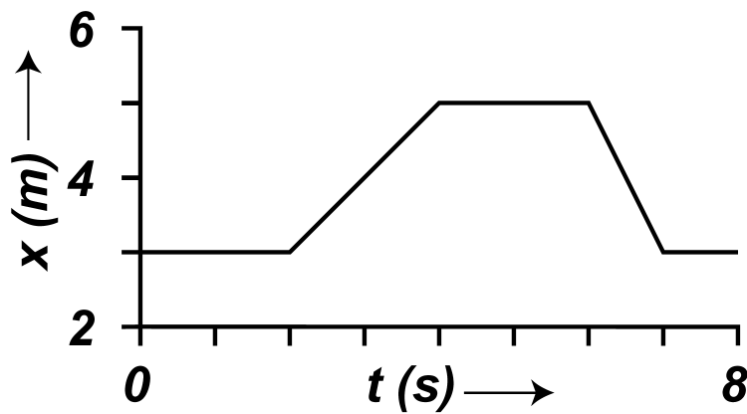
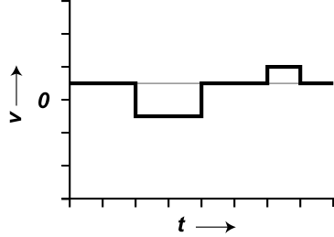
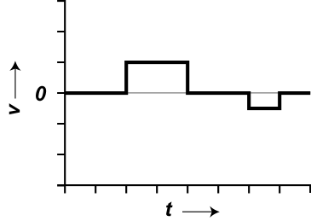
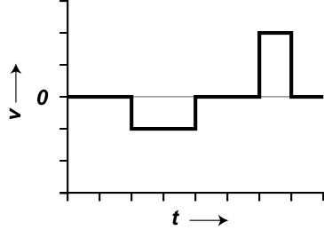
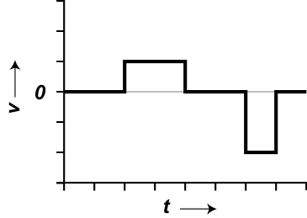
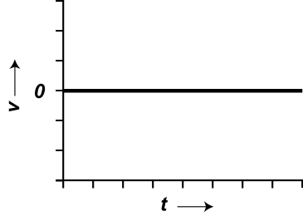
15) Which velocity vs. time graph corresponds to the following graph of position verses time
B.
D.
A.
C.
E.

16) Can an object's velocity change direction when its acceleration is constant?
- No, this is not possible because it is always speeding up.
- No, this is not possible because it is always speeding up or always slowing down, but it can never turn around.
- Yes, this is possible, and a rock thrown straight up is an example.
- Yes, this is possible, and a car that starts from rest, speeds up, slows to a stop, and then backs up is an example.
- none of the above.

17) A person standing at the edge of a cliff throws one ball straight up and another ball straight down. Both balls have the same initial speed. Neglecting air resistance, the ball that hits the ground below the cliff with the greater speed is the one initially thrown:
- upward
- they both have the same speed when they hit the ground.
- downward
- impossible to tell because they hit at different times
- none of these

18) To be dimensionally consistent, velocity [L/T], force [ML/T], mass [M], and length [L] must be related as follows:

  - Velocity squared ~ force length/mass
  - Velocity squared ~ force mass/length
  - Velocity squared ~ mass length/force
  - Velocity squared ~ force mass/length²
  - Velocity squared ~ mass /force

19) An object starts with an initial velocity of 4.0 m/s and accelerates with an acceleration of + 4.0 that lasts for 6.0 seconds. It then decelerates at 2.0 m/s² until its velocity is 4.0 m/s. The total distance covered is,
a) 96 m
b) 100 m
c) 188 m
d) 192 m
e) 288 m

20) A student undergoes three displacements. The first displacement is 20 meters at an angle of 30 degrees SOUTH of EAST. The second displacement is 35 meters at an angle of 40 degrees NORTH of EAST. The third displacement is 20 meters at an angle of 45 degrees SOUTH of EAST. The y component, (NORTH - SOUTH) of the total displacement is,
a) 1.64 meters SOUTH
b) 1.64 meters NORTH
c) 58.3 meters SOUTH
d) 58.3 meters NORTH
e) 22.5 meters SOUTH

21) A projectile is projected from the origin with a velocity of 15.0 m/s at an angle of 30 degrees above the horizontal. What is the location of the projectile 2.0 seconds later?
a) X = 4.6 m, Y = 9.6 m
b) X = 26.0 m, Y =26.0 m
c) X = 36.0 m, Y = 4.6 m
d) X = 26.0 m, Y = 4.6 m
e) X = 46.0 m, Y = 4.6 m

22) A projectile is projected from the origin with a velocity of 25.0 m/s at an angle of 50 degrees above the horizontal. What is the time of maximum height of the projectile?
a) 1.95 s
b) 2.03 s
c) 2.67 s
d) 3.01 s
e) 3.45 s

23) A projectile is projected from the origin with a velocity of 20.0 m/s at an angle of 30 degrees above the horizontal. The projectile lands on a roof that is 4.0 m height. What is the velocity vector when the projectile hits the roof?
a) Vx =13.2 m/s,Vy = 2.96 m/s
b) Vx =14.3 m/s,Vy = 3.23 m/s
c) Vx =15.2 m/s,Vy = 3.55 m/s
d) Vx =16.8 m/s,Vy = 3.95 m/s
e) Vx =17.3 m/s,Vy = 4.65 m/s

24) You drop a heavy steel ball from a certain height. At the same time you throw a light plastic ball horizontally from the same height. Neglecting air resistance, which ball will hit the ground first, and which one will have the greater velocity when they hit.

Hit First Greater Velocity
A) Hit at the same time Steel
B) Hit at the same time Plastic
C) Hit at the same time They have the same velocity
D) Steel Plastic
E) Steel Steel

